

User Guide  
Version 2016.09.05

Table of Contents

Introduction 3

Prerequisites 4

Concepts 4

Editor and Player 4

Tools, pages and components 5

Languages and categories 6

Indexation and searches 7

Publication, versioning and activities 8

Student Guide 9

Home page 9

Explorer 10

Searches 11

Details page 11

Player 13

Benefits of being signed in 14

User page 16

Author profiles 16

My profile 17

Teacher Guide 19

Home page 19

Retrieving a draft test 20

Editor 21

Adding, removing, duplicating and sorting pages 22

User instructions and explanations 23

Adding, removing, duplicating and sorting components 24

Moving, rotating, resizing and aligning components 26

Display attributes and test logic 27

Display attributes 27

Test logic 28

Styles 29

Labels 30

Images 32

Quizzes (or multiple choice questions) 34

Checkboxes 37

Textboxes 39

Connectors 42

Drop zones 46

Diagnostics and publication 49

Character Grids 51

Audio and video 55

Mathematic expressions 58

What other tools are coming next? 59

SEO indexing and social sharing 59

Advanced Guide 62

Position of correction ticks and crosses 62

Audio and video file formats 64

Audio 64

Video 64

Markdown 65

LaTeX and AsciiMath 65

CSS styles 66

Regular Expressions 68

JavaScript custom validations 69

# Introduction

Kidoju is a web-based community platform to produce, share and consume highly-interactive self-corrected knowledge tests or quizzes.

Kidoju is available at https://www.kidoju.com.

Quizzes are often assimilated to multiple choice questions. So we sometime refer to quizzes developed with the Kidoju rich toolset as “Kidoju quizzes” or simply as “Kidojus”.

This guide is divided into the following sections:

* The current introduction,
* Definitions and concepts underlying Kidoju,
* A student guide for consuming Kidojus.
* A teacher/publisher guide for producing Kidojus.
* An advanced guide.

This guide and subsequent versions can be found at https://cdn.kidoju.com/support/docs/user-guide.en.pdf

Assets used in the tutorials can be found at  
https://cdn.kidoju.com/support/docs/user-guide.en.zip

THE SOFTWARE AVAILABLE ON THE SITE KIDOJU.COM IS PROVIDED "AS IS" AND ANY EXPRESSED OR IMPLIED WARRANTIES, INCLUDING, BUT NOT LIMITED TO, THE IMPLIED WARRANTIES OF MERCHANTABILITY AND FITNESS FOR A PARTICULAR PURPOSE ARE DISCLAIMED. IN NO EVENT SHALL KIDOJU.COM, MEMBA SARL OR ANY OF THEIR CONTRIBUTORS BE LIABLE FOR ANY DIRECT, INDIRECT, INCIDENTAL, SPECIAL, EXEMPLARY, OR CONSEQUENTIAL DAMAGES (INCLUDING, BUT NOT LIMITED TO, PROCUREMENT OF SUBSTITUTE GOODS OR SERVICES; LOSS OF USE, DATA, OR PROFITS; OR BUSINESS INTERRUPTION) HOWEVER CAUSED AND ON ANY THEORY OF LIABILITY, WHETHER IN CONTRACT, STRICT LIABILITY, OR TORT (INCLUDING NEGLIGENCE OR OTHERWISE) ARISING IN ANY WAY OUT OF THE USE OF THIS SOFTWARE, EVEN IF ADVISED OF THE POSSIBILITY OF SUCH DAMAGE.

Copyright © 2013-2016 Memba Sarl. All rights reserved.

# Prerequisites

You need access to a web browser and an internet connection to follow the instructions in the current User Guide.

In line with several third party components used in the Kidoju software, we only support the current and previous versions of Chrome, Edge, Firefox, Internet Explorer, Opera and Safari on Android, iOS, Linux, macOS and Windows.

On laptops and desktops, we recommend using Google Chrome. On phones and tablets, we recommend using the native browser.

We recommend a screen of at least 5” to play Kidoju quizzes.

We recommend a screen of at least 8” to author Kidoju quizzes.

# Concepts

## Editor and Player

In Kidoju, knowledge tests or quizzes are edited and played like Microsoft PowerPoint® presentations.

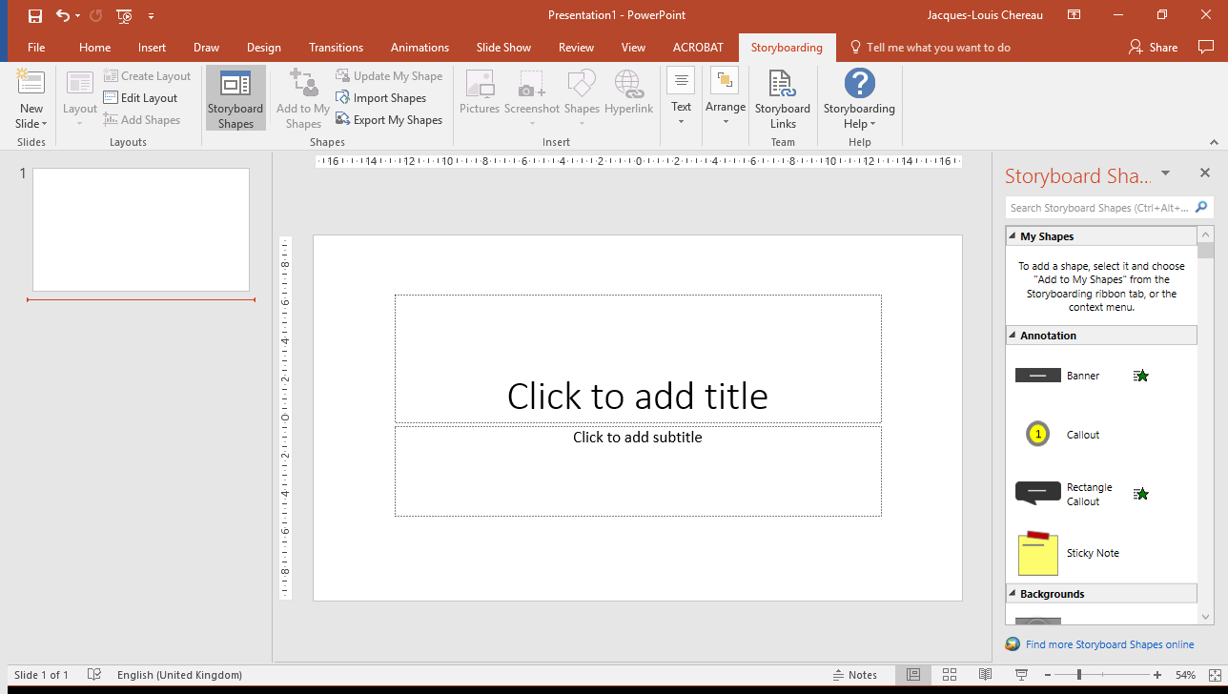

There is a web-based *Editor* (aka designer) to produce knowledge tests:

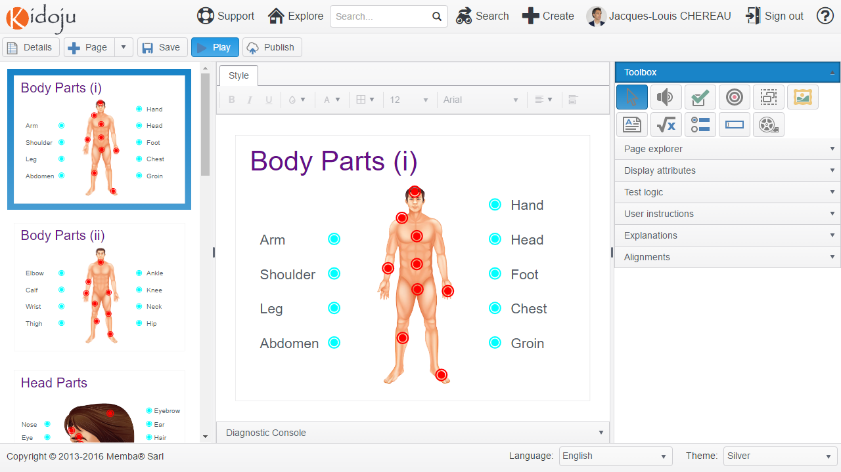

There is also a web-based *Player* (aka viewer) to play knowledge tests:

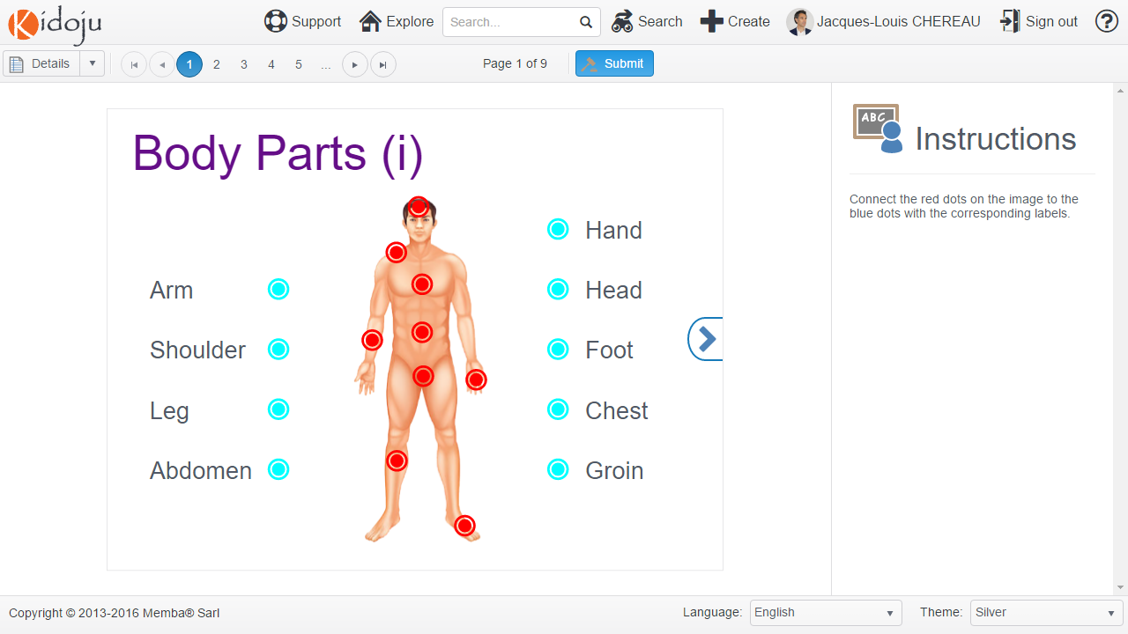

Note: contrary to the Editor which is only web-based, the Player also runs in the Kidoju mobile application.

## Tools, pages and components

The Kidoju web-based *Editor* provides tools to build knowledge tests. These tools include labels, radios, checkboxes, textboxes, images, audio, video, mathematic expressions, connectors, drop zones among others.

A Kidoju is divided into pages (aka slides in PowerPoint®). Each page comprises components.

The **Navigation** in the left pane of the *Editor* displays all pages in a Kidoju. Selecting a page in the navigation, displays the corresponding page in the centre pane of the *Editor*. The interactive area in the centre pane is called the **Stage**.

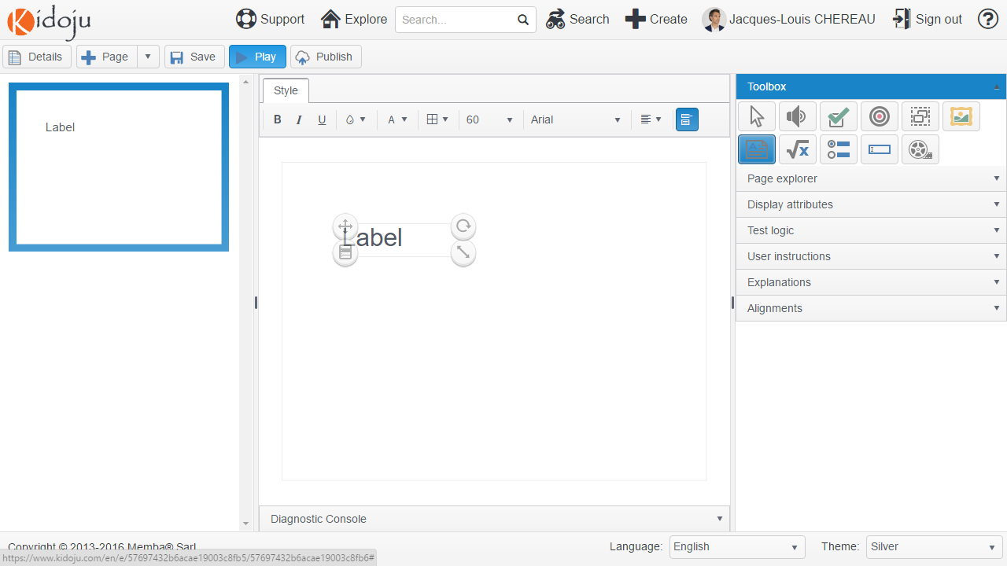

**Stage**

**Navigation**

A tool might be used to drop a component (aka element) onto the stage. For example, a label tool can be used to drop a label component onto the stage. In such a case, the term “label” might designate the tool from the toolbox or the corresponding component dropped on the stage. The tool defines a template. The component is an instance of this template on a page.

The previous screenshot shows both the label tool selected in the toolbox and a label component dropped onto the stage, where the first and only page is selected in the navigation for editing.

Note: for now, you only need to remember that a Kidoju is made of pages which comprise components created by tools.

## Languages and categories

Kidojus are organised in a hierarchy of categories (aka topics) for each language.

There are currently two languages to choose from in the footer of the web application: English and French. More languages will be coming soon.

Selecting a language in the footer redirects the user to an explorer with a tree of categories (aka topics) in the corresponding language. Clicking a category in this tree displays a list of Kidojus pertaining to the selected category.

Note: languages and categories classify Kidojus like operating systems use roots and folders to organize files on hard drives. Especially, Kidojus of a subcategory are not listed in the parent category unless such Kidojus explicitly designate such parent category.

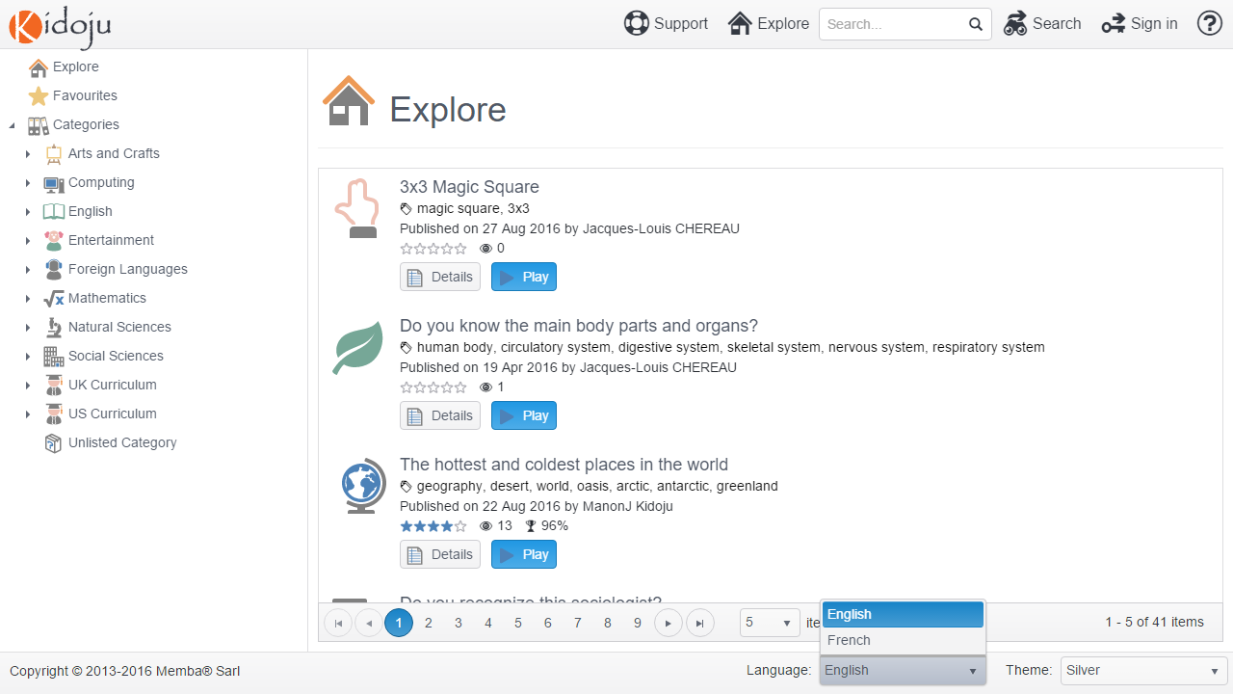

## Indexation and searches

In addition to a language and category, Kidojus also have:

* An author,
* A title,
* A description,
* Tags (aka keywords)

These are the only data that are indexed for full-text searches.

Note: versioned pages and components of Kidojus are not indexed for full-text searches.

The weight of each field in the full-text index is as follows:

* Author: 8
* Tags: 4,
* Title: 2,
* Description: 1

On the basis of a search on the word “steel”, Kidojus made by authors named “Steel” will be listed first, then Kidojus that have the word “steel” among their tags will be listed second, and so on.

As a consequence, an author who designs a Kidoju about Napoleonic Wars, should make sure that Napoleon is quoted in the title or amongst tags to make it findable in a search on “Napoleon”. To increase the ranking, this author can add the word Napoleon to the title, tags and description.

## Publication, versioning and activities

Kidojus are versioned. There is no limit to the number of versions a Kidoju might have.

When initially created, a Kidoju and its first version are in a draft state until they are published. Draft Kidojus do not appear in search results and can only be played by their author. In a draft state, activities including views and scores are not tracked.

Once a Kidoju is ready to be played by others, the author should publish it. The Kidoju and its first version progress from the draft state to a published state. Thereafter, published Kidojus appear in search results and activities, including views and scores, are tracked.

Pages and components of a published version cannot be modified. The icon, title, categories, tags, description of a Kidoju can be modified at any time.

When the pages of a published Kidoju need to be updated, the author creates a new draft version. The Kidoju remains in a published state and the latest published version prevails until the new draft version is published.

Versioning Kidojus allows users to view their scores and corrections at any time although a Kidoju might have been improved with new, updated or deleted questions.

# Student Guide

## Home page

Navigating to https://www.kidoju.com with a web browser displays the home page in your browser language.



The language can be changed in the footer. Changing the language not only changes the UI but also the data you have access to.



By the way, the theme can also be changed in the footer, especially for those who prefer a dark theme.



Click the  **Explore** menu item in the header to navigate to the explorer.

Wherever on the web site, clicking the Kidoju logo in the header navigates back to the home page.

## Explorer

In addition to the header menu and footer we have previously mentioned, the explorer has a tree of categories (aka topics) on the left and a list of Kidojus on the right.

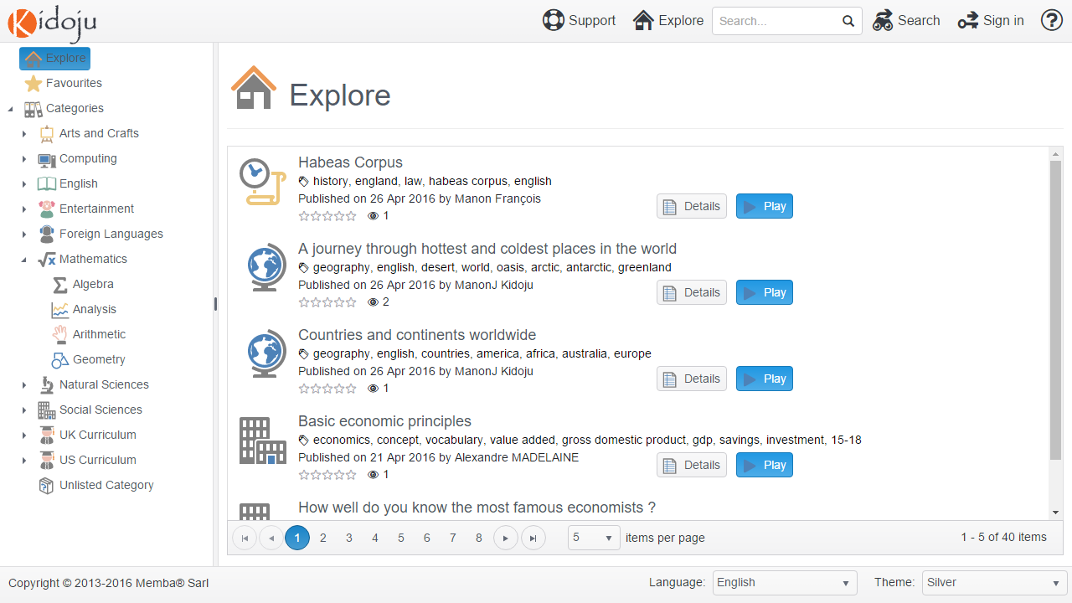

Navigating the tree brings relevant Kidojus into the list. For example, select “Mathematics” in the tree to display all Kidojus pertaining to the Mathematics category.

Note: categories do not aggregate subcategories. In other words, if a Kidoju has been classified in the Algebra category, but not in the Mathematics category, it would only be found by selecting the Algebra category. Categories work like Windows® and macOS® folders.

A Kidoju is listed with its icon, title, tags, publication date, author and metrics including average rating, total (authenticated) views and average score.

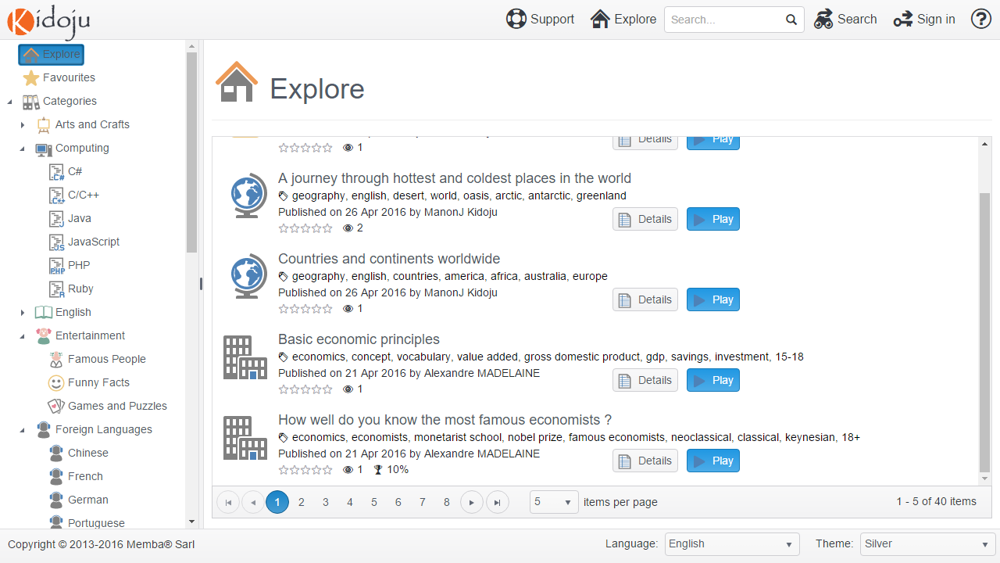

Note: Being authenticated is not required to view and play Kidojus and anonymous views are not counted.

Each Kidoju in the list has two buttons respectively entitled **Details** and **Play**.

Clicking the icon or title is the same has clicking the **Details** button.

Clicking any tag displays all Kidojus that have the same tag.

Clicking the author name displays a full author profile with a list of Kidojus by the same author.

## Searches

The quickest way to make a search is to type a word like “organ” in the **Search…** textbox of the header and to click the magnifier or simply press the **Enter** key.

There is also a  **Search** button that expands the advanced search panel, for complex searches like “organ” in the “Biology” category.

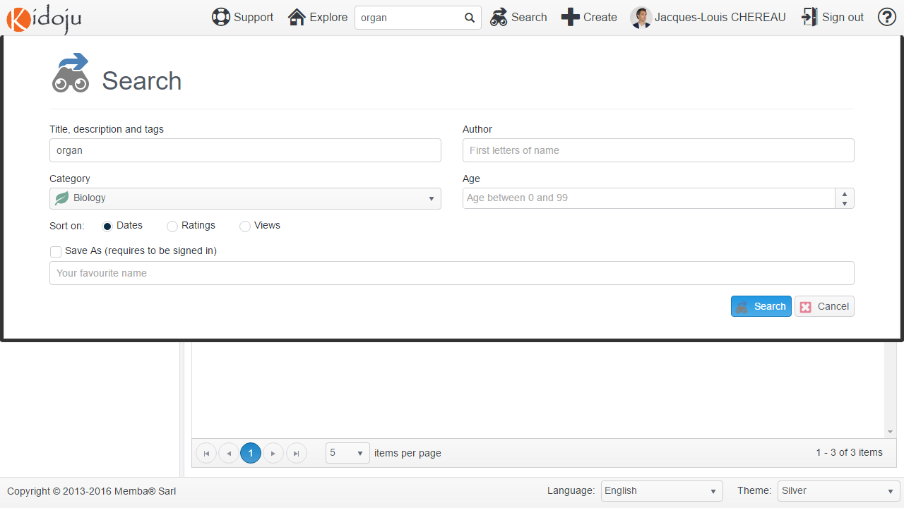

## Details page

The Details page is also called the summary page. It represents the detailed summary of a Kidoju. Think of it as an index card in a library catalogue as opposed to the book itself.

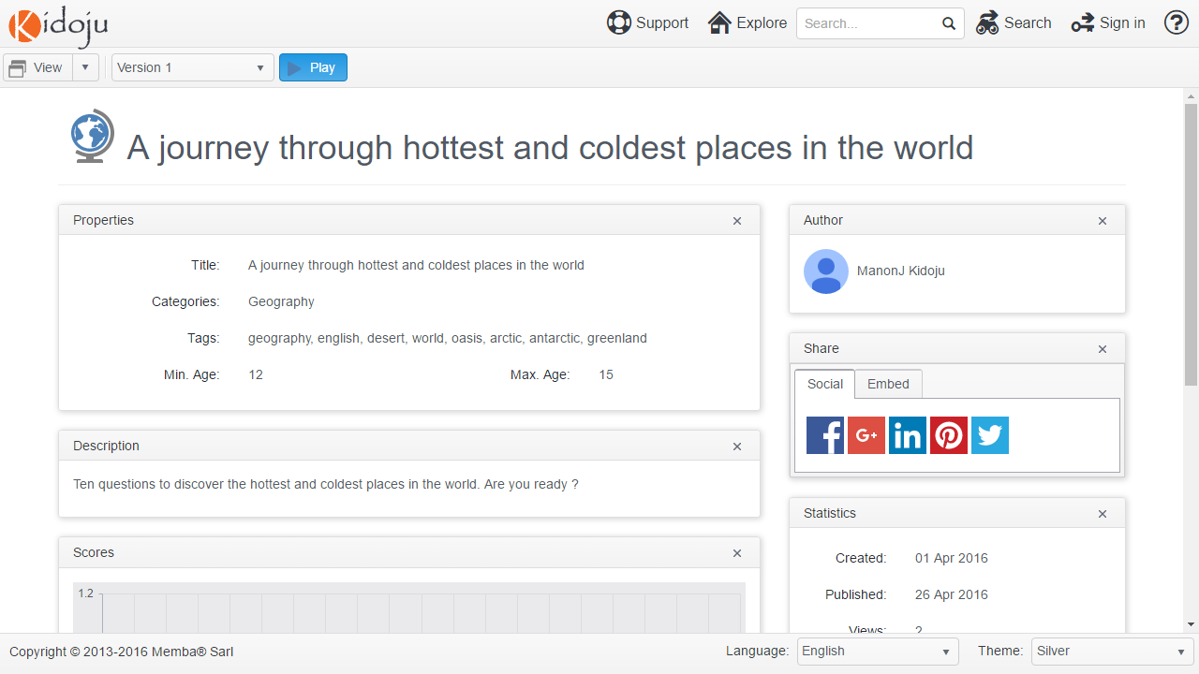

The Details page is divided into the following panels.

In the left (larger) column:

* The **Properties** and **Description** panels contain the fields that are indexed for full-text searches.
* The **Scores** panel displays a distribution of user scores in a histogram graduated from 0% to 100% with a step of 5%.
* The **Comments** panel displays a list of comments. A user needs to be signed in (authenticated) to add comments.

In the right (narrower) column

* The **Author** panel displays a short profile. The name is clickable to display a full profile in a *User page*.
* The **Share** panel displays a list of buttons to share Kidojus on social networks. The **Embed** tab is explained in the Advanced Guide.
* The **Statistics** panel displays statistics about the current Kidoju. A user needs to be signed in (authenticated) to rate a Kidoju by clicking any number of stars.
* The **QR Code** panel displays a machine-readable visual code which can be used to retrieve a Kidoju, especially with the Kidoju mobile application.

Search on “QR Code” in the Apple App Store or in the Google Play Store to find QR Code readers for your mobile devices.

As a guest (anonymous) user, there are only two use cases that can be completed from the details page of a Kidoju:

* Play a specific version of a Kidoju;
* Share a Kidoju on social networks including Facebook, Google and Twitter.

As a signed-in (authenticated) user, who is not the author, there are two more use cases that can be completed from the details page of a Kidoju:

* Rate a Kidoju;
* Comment a Kidoju.

In in addition to being authenticated, you are also the author of a Kidoju, you can:

* Edit a Kidoju.

## Player

Clicking the **Play** button from the *Details page* or from the *Explorer* navigates to the Kidoju player. Any version can be played from the *Details page* whereas only the current (latest) published version can be played from the *Explorer*.

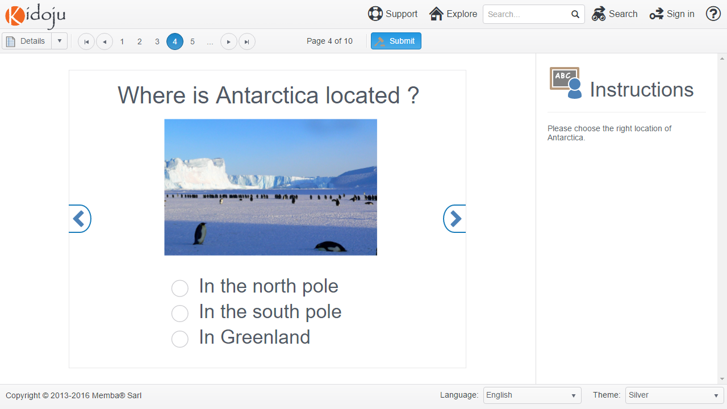

To move from page to page, either use the left and right arrows on the page or click the numbered buttons in the toolbar.

Note: navigating between pages stores user entries in the browser.

After having navigated all pages and answered all questions, click the **Submit** button to calculate your score.

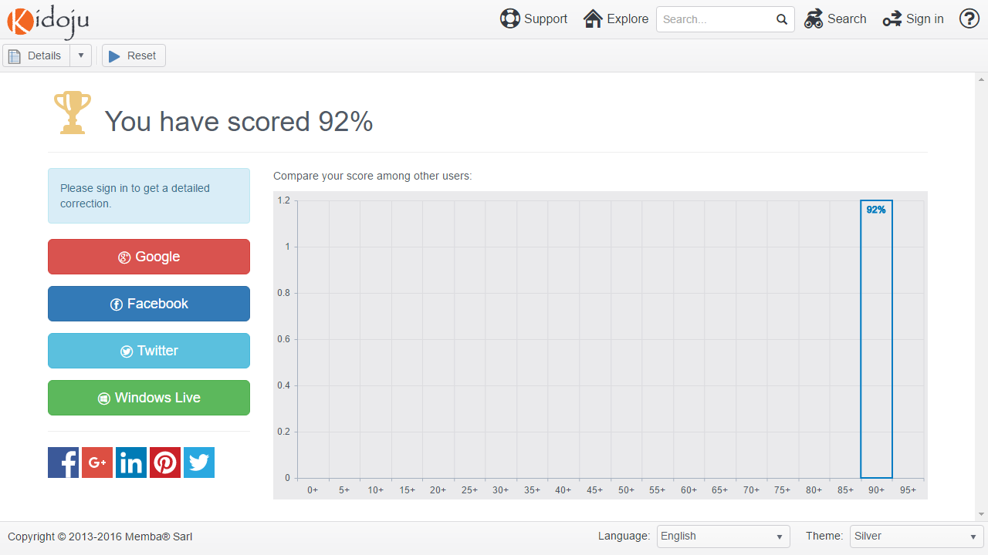

Click the **Reset** button to replay the current Kidoju from the beginning. If you are not authenticated your previous score is lost.

## Benefits of being signed in

Kidoju does not force users into being signed in to withdraw benefits from the platform. In particular searching and playing Kidojus does not require being authenticated.

The platform does not keep track of anonymous user activities. Especially view counts discard anonymous users.

Being signed-in as a student (or consumer of Kidojus) provides 3 additional benefits:

* Authenticated users can access corrections.
* Authenticated users can comment and rate Kidojus.
* Authenticated users can keep track of their activities and scores.

Signing in, using a Google, Facebook, Twitter or Windows Live account, after submitting a score, sends your answers to our servers, so that we can save them and display your detailed results in a grid below the score chart.

Note: the only information we get from this authentication procedure is your name, picture and email address. Kidoju does not read your social network contacts and messages. We also do not get any authorization to write to your wall or send messages to your contacts. Your name and picture are displayed in miscellaneous places. Your email address is never disclosed.

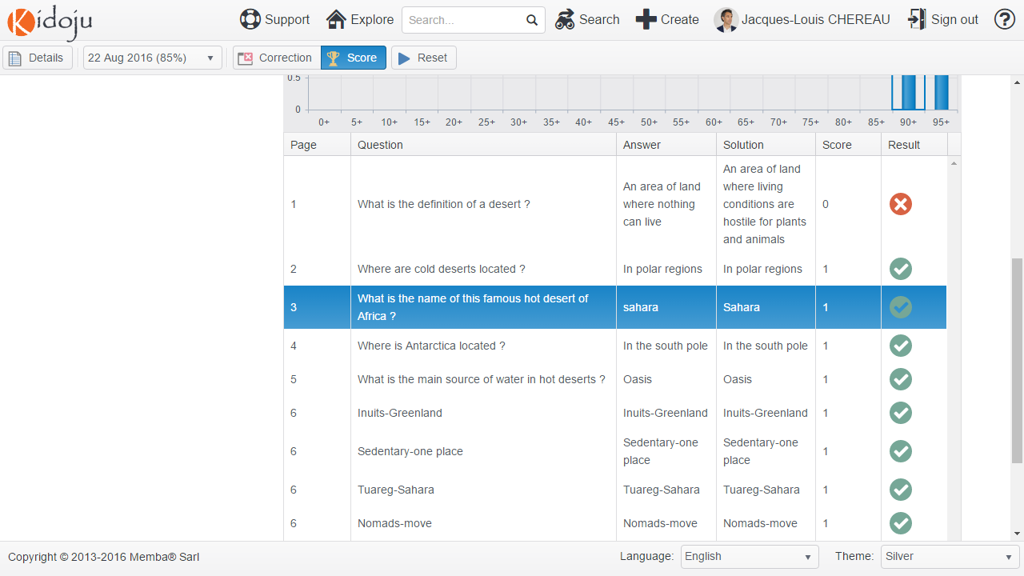

Clicking a line in the results grid sends you directly to the page with the correction displayed as a tick or a cross with explanations:

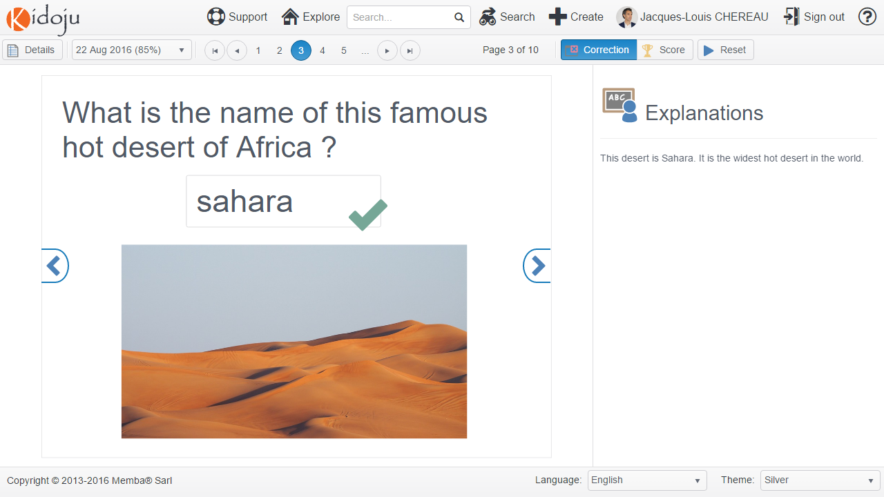

Note: Notice how instructions in play mode have turned into explanations in review (correction) mode.

You can always switch back to the score chart and results grid by clicking the **Score** button in the toolbar.

The **Reset** button replays the Kidoju from the beginning. If you are not authenticated your previous score is lost.

Assuming you have played a Kidoju several times as an authenticated user, therefore saving your score at each attempt, a dropdown list of scores in the toolbar gives you access to the history to check your progresses on each page.

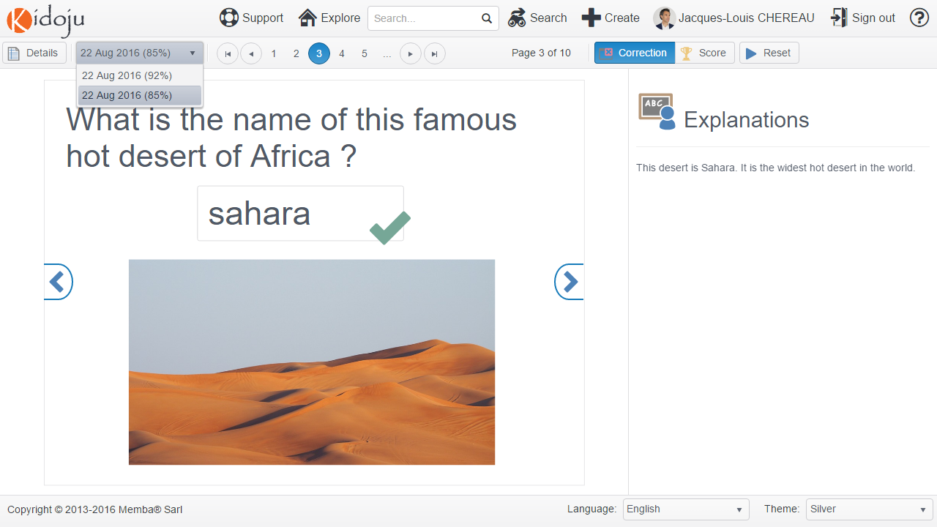

## User page

The User page displays a user profile. A profile has public and private fields. Private fields like emails and activities are only accessible to their owner. In other words, you do not see the same fields whether you display your own profile or someone else’s profile in a User page.

### Author profiles

Author profiles can be accessed when clicking an author’s name in the *Explorer* or on a *Details page*.

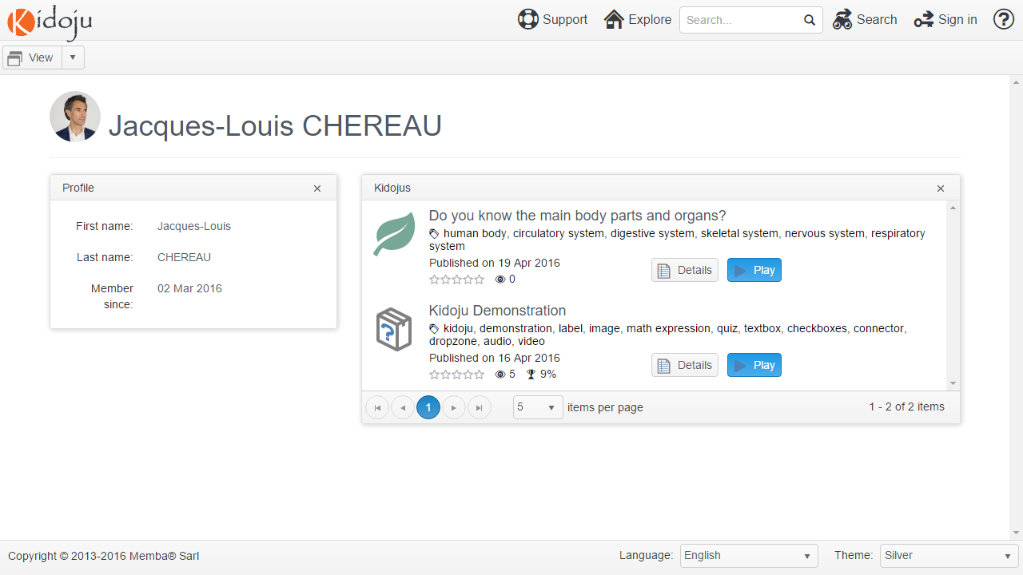

Author profiles display the full name, a picture and a list of contributions.

### My profile

You need to be signed in to display your own user profile by clicking your name in the site navigation at the top of the page.

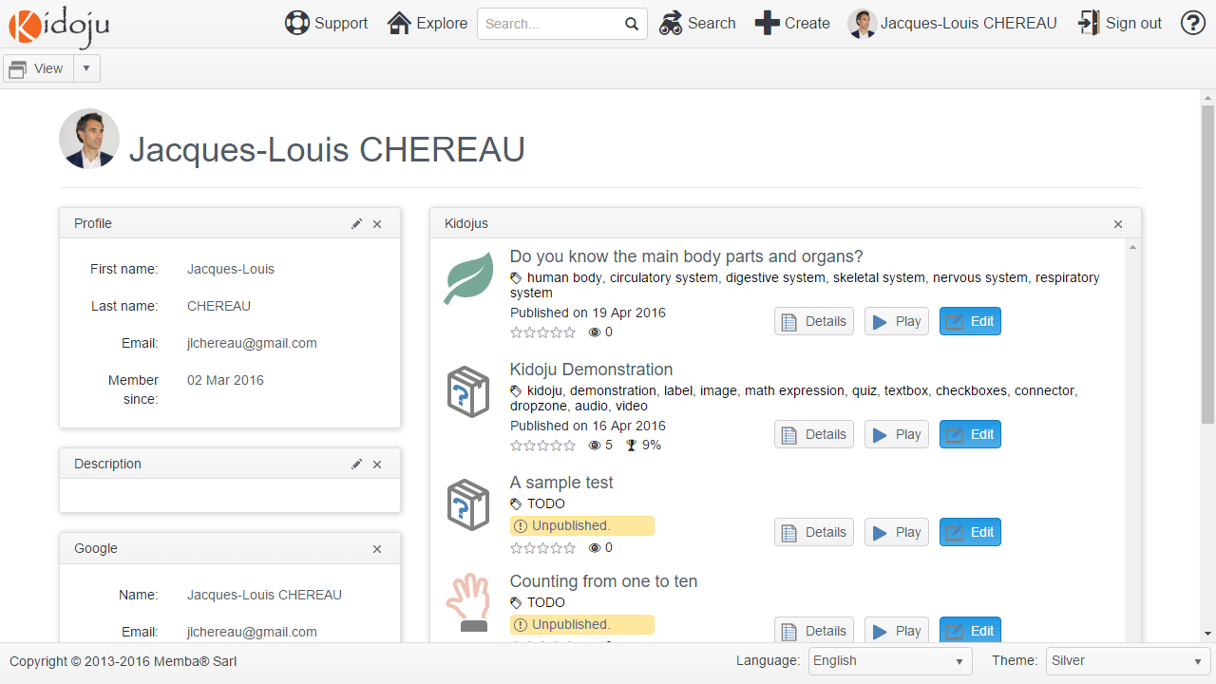

Your user profile gives you access to your list of activities including your recent scores.

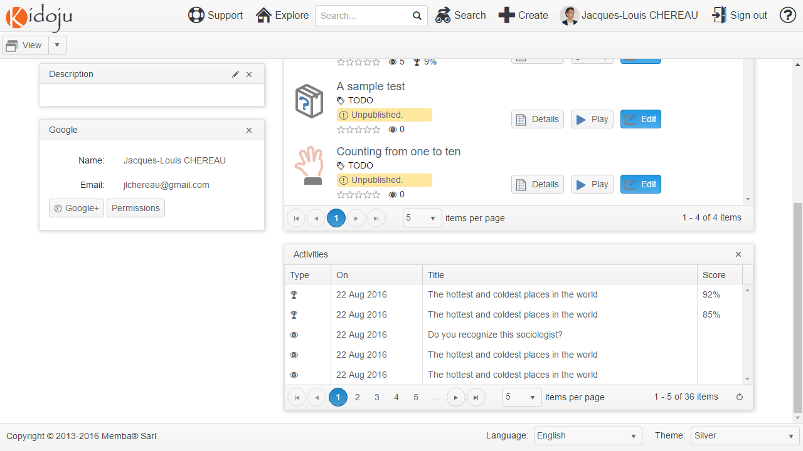

Clicking a score in the list of activities displays the corresponding detailed report which you can review at any time.

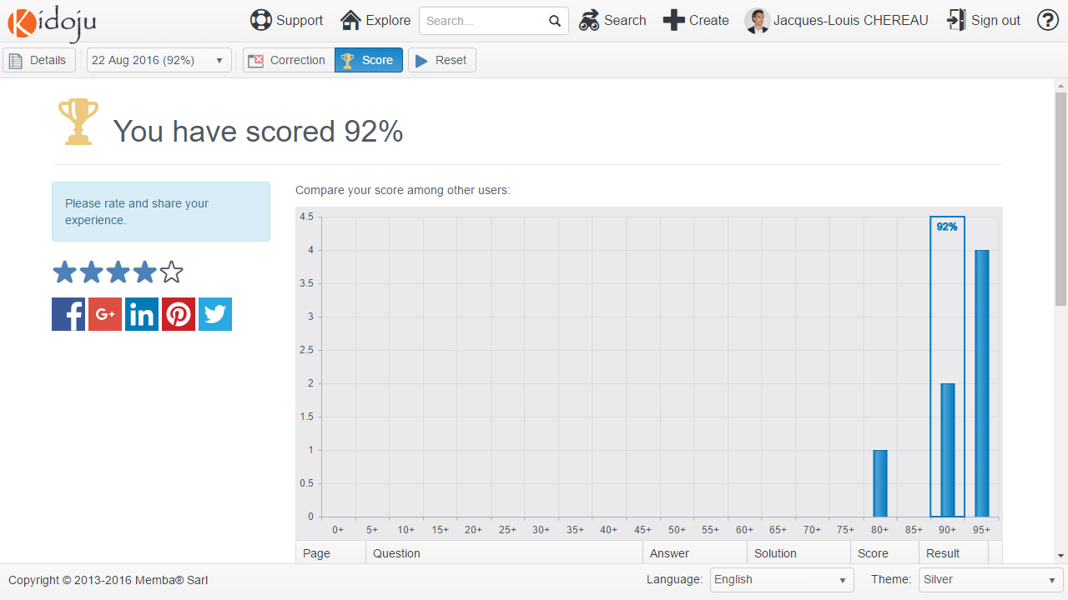

# Teacher Guide

Note: Please start with the student guide which includes features relevant to teachers (authors).

## Home page

Navigating to https://www.kidoju.com with a web browser displays the Home page in your browser language.



Authors need to sign in to create Kidoju quizzes. Click the  **Sign in** button in the site navigation at the top of the page, then choose an authentication provider amongst Google, Facebook, Twitter and Windows Live, enter your account name and password, and allow our application.

Note: the only information we get from this authentication procedure is your name, picture and email address. Kidoju does not read your social network contacts and messages. We also do not get any authorization to write to your wall or send messages to your contacts. Your name and picture are displayed in miscellaneous places. Your email address is never disclosed.

After signing in, click the  **Create** button which is now available in the site navigation at the top of the page. A dialog window is displayed. Fill the category and title. The category determines the default icon. These can be modified at any time when required.

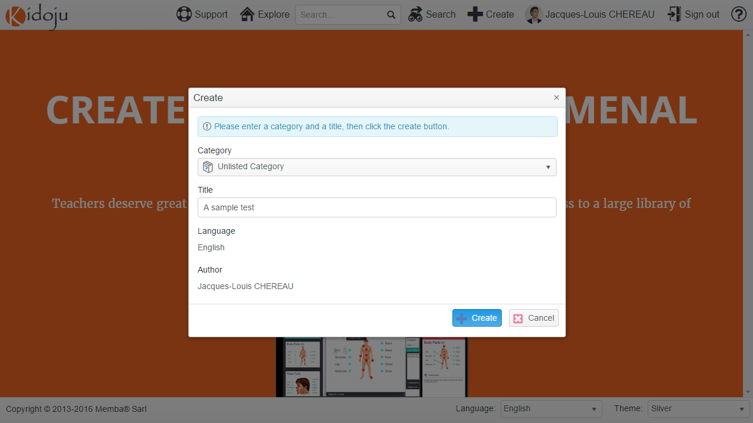

Once you are happy with your entries, confirm by clicking the **Create** button at the bottom right of the dialog window. You have just created a blank Kidoju and you are now redirected to the editor.

## Retrieving a draft test

Before we describe the *Editor*, you need to know how to retrieve a draft Kidoju in progress, considering only published Kidojus are listed in the search results of the *Explorer*.

After signing in from the *Home page* as explained above, click your name in the site navigation at the top of the page to access your profile in a *User page*.

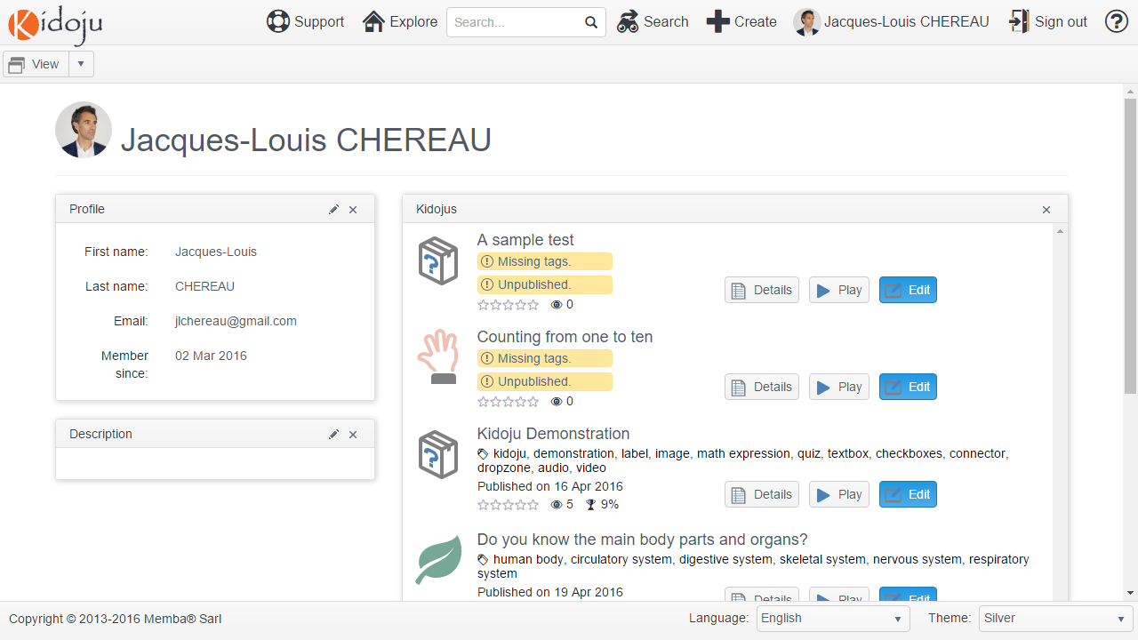

The Kidoju you have just created is first in the list. Click the **Edit** button to navigate to the *Editor*.

## Editor

The editor is organized like Microsoft® PowerPoint®.

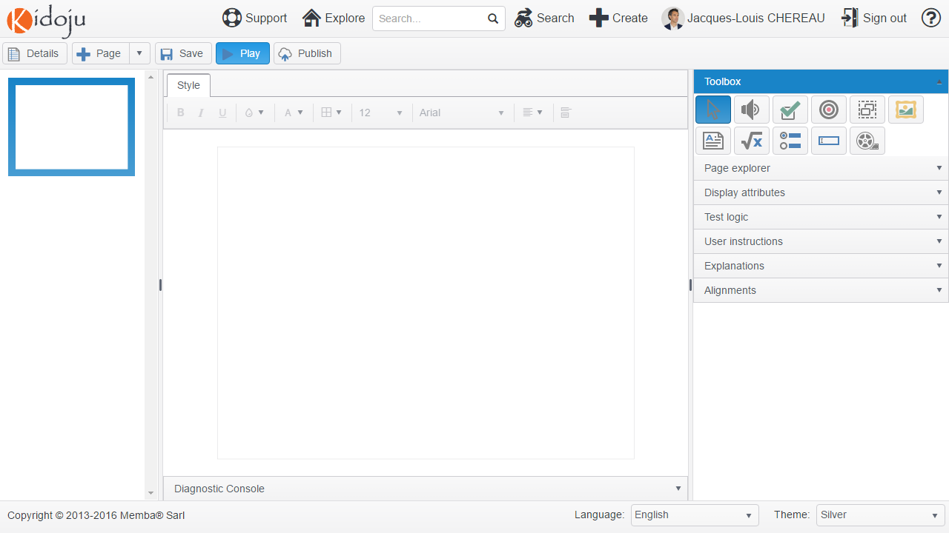

**Tools**

**Stage**

**Navi-gation**

The screen is divided into three panes between a header including the toolbar and a footer:

* On the left, the **Navigation** pane consists in a list of pages (aka slides in PowerPoint®), any of which can be selected by clicking it;
* In the centre, the **Stage** pane displays the selected page in design mode for editing;
* On the right, the **Tools** pane displays collapsible panels to select tools and assign values.

We like to say that Kidojus are PowerPoint® presentations with the ability to ask questions, record user answers and calculate a score. These answers can not only be plain values but also user interactions including clicks and drag and drop sequences.

Note: Contrary to PowerPoint®, Kidoju is web based software involving a complex architecture starting with your browser on your device, multiple nodes on the Internet which we have no control of, a firewall, a load balancer, web proxies, application servers and database servers. Although we do our best to give you the best experience, anything can happen at any location in the chain. Accordingly, please consider saving often.

## Adding, removing, duplicating and sorting pages

The **Page** dropdown button in the toolbar contains all actions pertaining to a page except sorting. These actions include adding pages, deleting pages and duplicating pages.

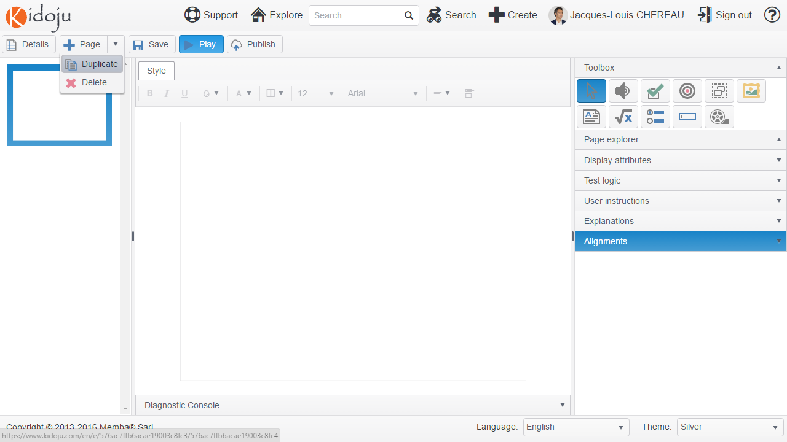

Sorting pages consists in dragging and dropping pages in the navigation pane as shown here below (we have added image components to make pages more visible in the following screenshot):

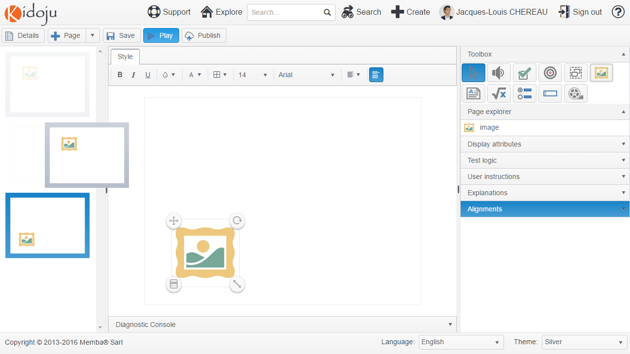

## User instructions and explanations

User instructions and explanations need to be set at the page level. Expand the corresponding collapsible panels in the tools pane and fill the text area as shown here bellow.

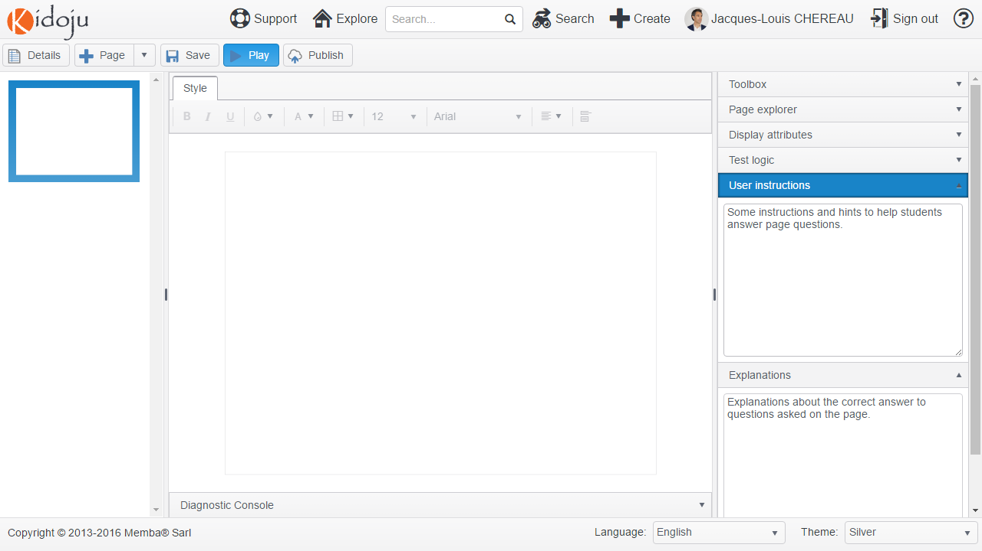

User instructions and explanations support markdown. For more information, see the Markdown chapter in the Advanced Guide.

User instructions are displayed alongside the corresponding page in the Kidoju player in play mode as in the example below.



Instructions are replaced with explanations in review (correction) mode.

## Adding, removing, duplicating and sorting components

To add a component to a page, expand the toolbox in the tools pane, click on the tool you want to use, then click on the stage in the middle pane to add the corresponding component:

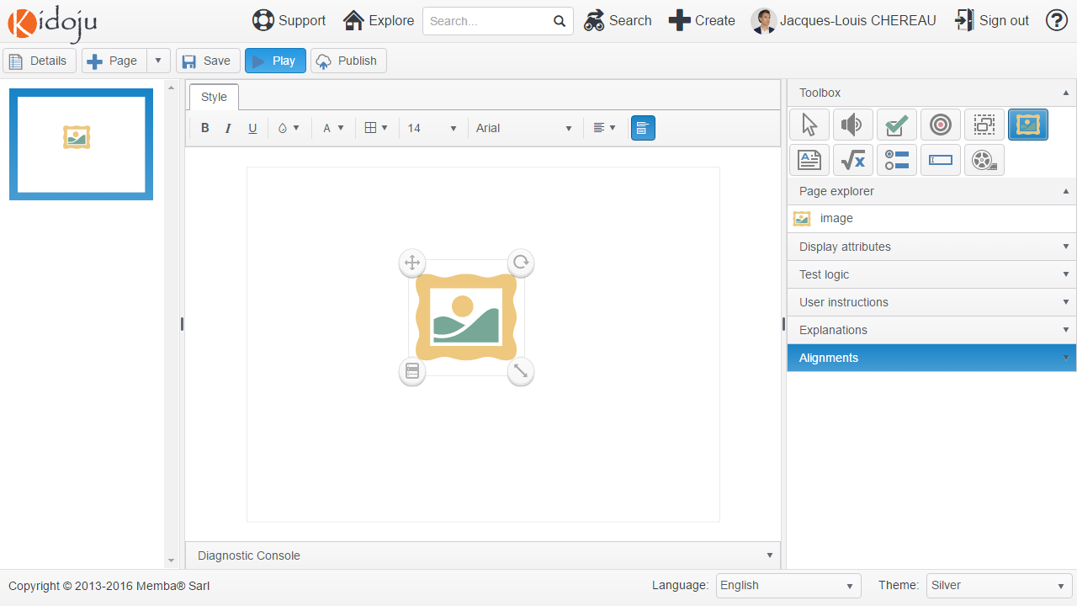

When a component is selected (simply click on the component to select it), it is displayed with a bounding rectangle and four handles located in the corners of that rectangle:

* The top left handle is the move handle;
* The top-right handle is the rotate handle;
* The bottom-right handle is the resize handle;
* The bottom-left handle is the menu handle.

Click the menu handle to display commands to **Delete** and **Duplicate** the component.

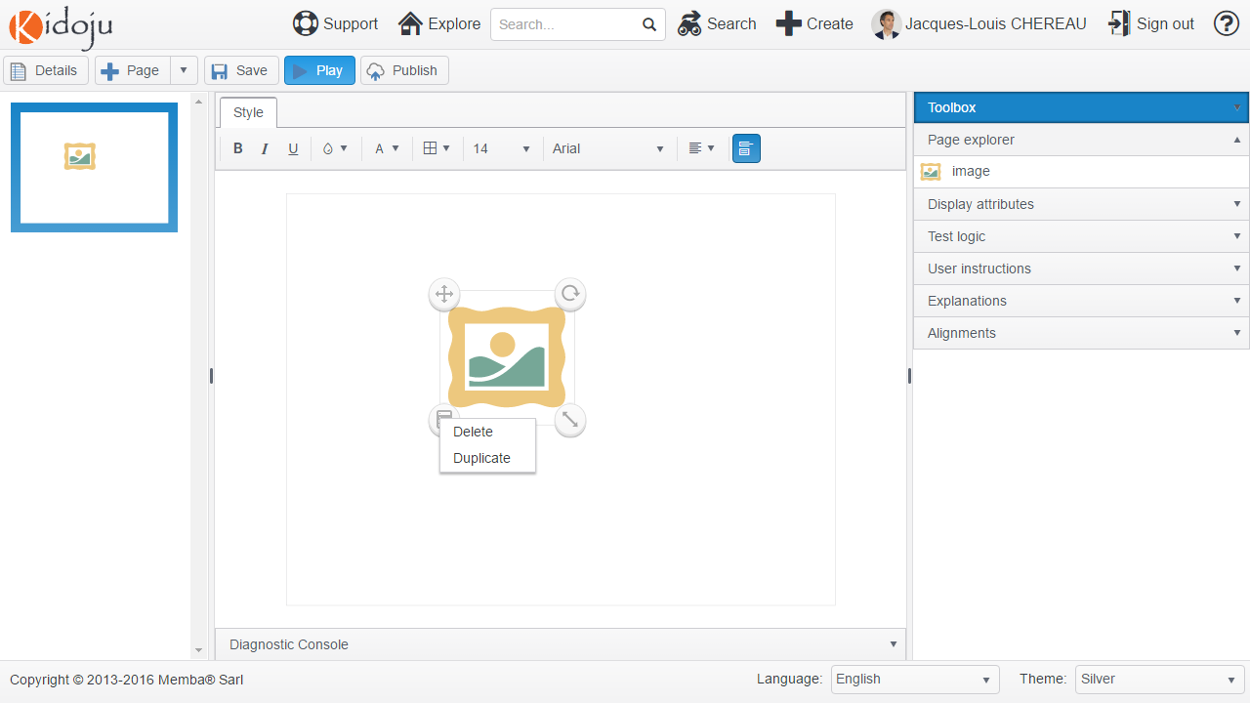

After duplicating the image component, expand the **Page explorer** panel in the tools pane and drag its items to move them forward or backward (one on top of the other). Play with sorting and check which image displays on top of the other.

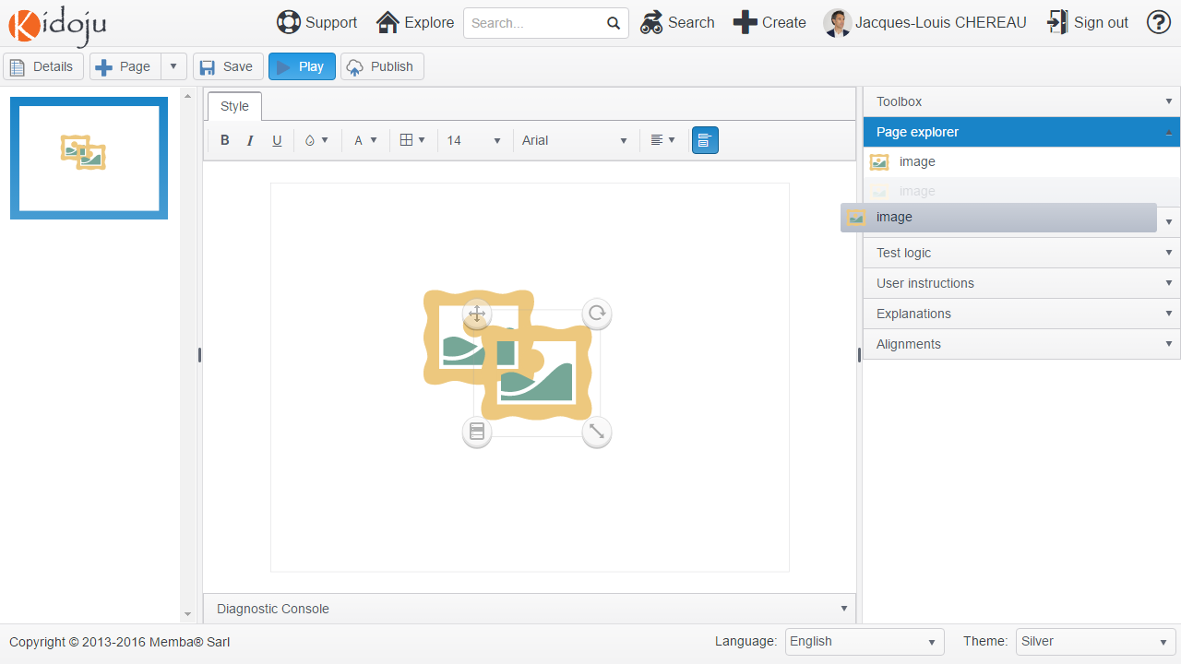

Note: when an image has been added to the stage after a label, it is displayed on top of that label. You need to change the order of components to display the label on top of the image.

## Moving, rotating, resizing and aligning components

First select the image component on the stage by clicking it, then:

* Drag the move handle to move the component,
* Drag the rotate handle to rotate the component,
* Drag the resize handle to resize the component.

Note: image resizing is constrained proportionally.

Alternatively, after selecting the component, expand the **Display attributes** collapsible panel to show the **top**, **left**, **height**, **width** and **rotate** attributes:

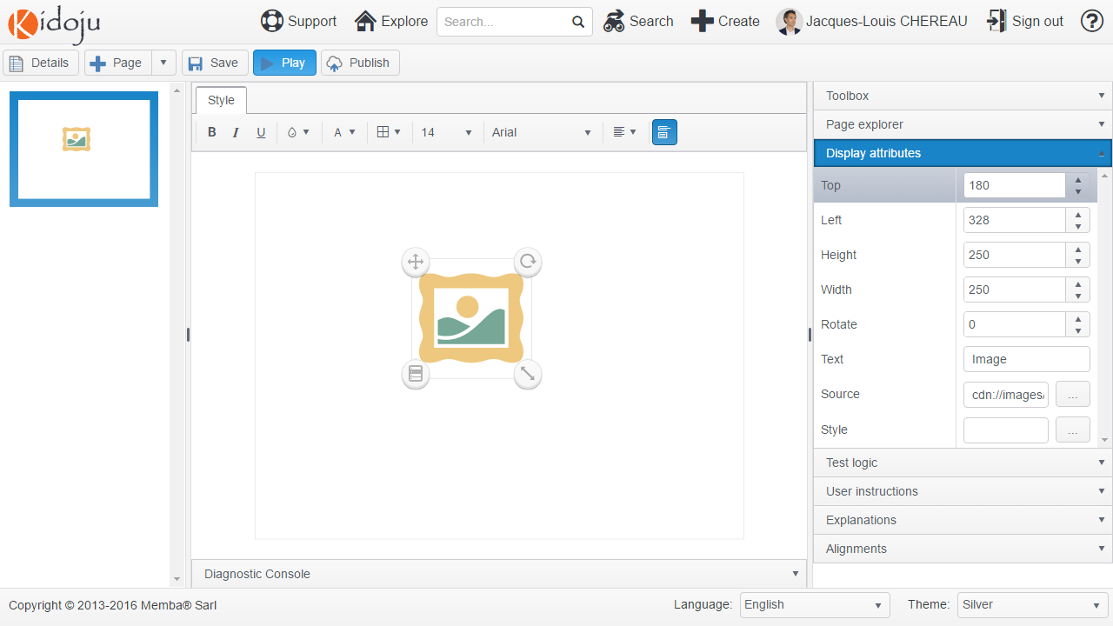

Enter the values you deem appropriate and remember to click the **Save** button often.

Note: The size of a page is 1024px * 768px. A px or pixel is a dot on the screen. The point at coordinates (0, 0) is the top left corner. Therefore, the point at coordinates (1024, 768) is the bottom right corner.

When you need to align components, there is a better option than copying and pasting top and left values across components. Expand the **Alignments** collapsible panel in the tools pane and set the **Grid** slider. This creates what some people call a snap grid.

The value of the **Grid** slider from 0 to 50 sets the step in pixels of acceptable values for positioning (top, left) and resizing (height, width) components, making it much easier to align or distribute evenly components on the stage.

The **Angle** slider, taking values from 0 to 45 degrees, works the same way with rotation.

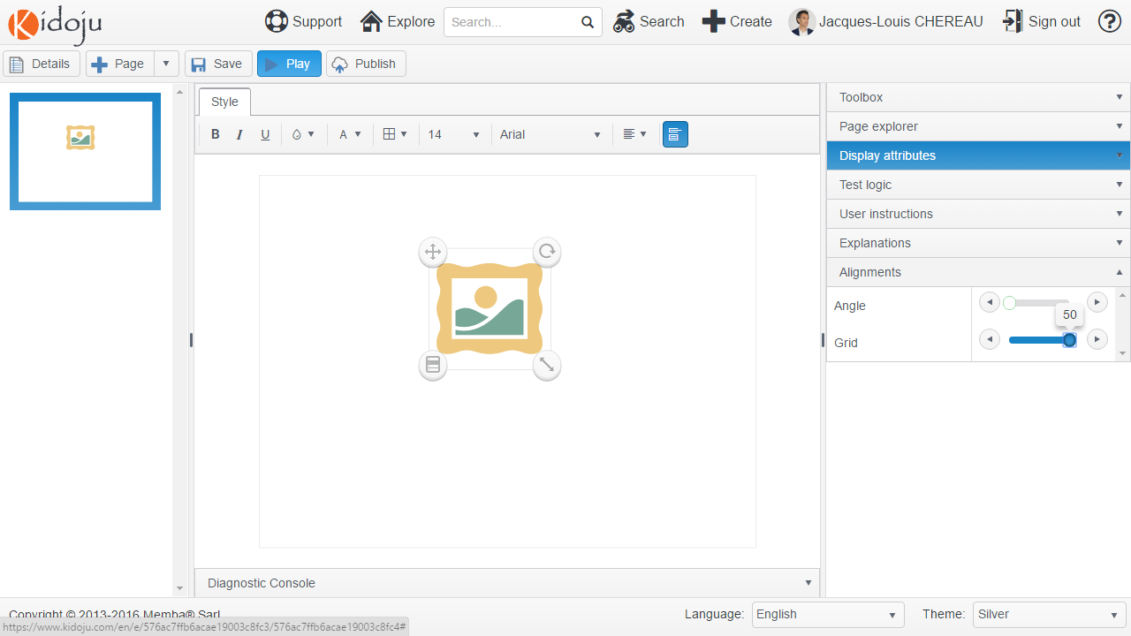

Note: when resizing components that have test logic, consider the Position of correction ticks and crosses in the Advanced Guide.

## Display attributes and test logic

We have divided the properties of a component into display attributes which affect the way components are displayed and test logic which affect the way they contribute to the score of a knowledge test.

### Display attributes

Display attributes essentially include position, size and style. Currently all components have display attributes.



In particular, image, audio and video components designate files which you can upload to our servers. There is currently a limit to the size of uploaded files and you might get an error if the file you are trying to upload is too big. There are good reasons to limit the size of files specially to protect mobile device users consuming knowledge tests on 3G data plans.

Note: there are many free tools to crop and resize images including Paint on Windows® and the image previewer on macOS®.

### Test logic

Components which participate in the answer to a question have test logic properties. Test logic generally comprises a question and a solution displayed in the score grid, a validation rule and points to compute the final score.

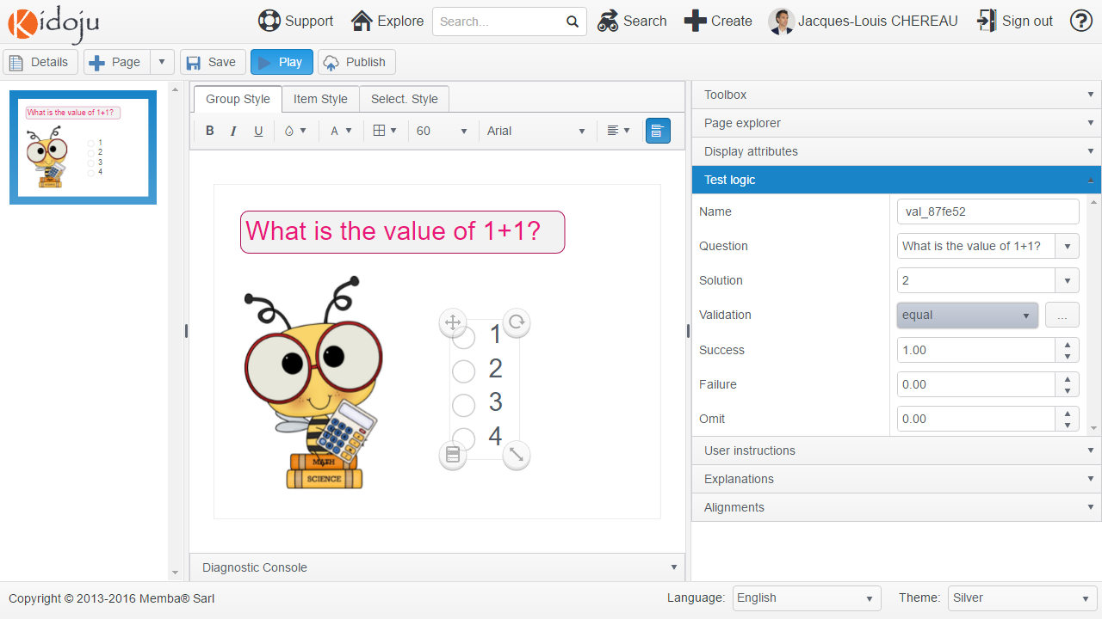

A validation rule can be a predefined algorithm or a custom function. The most common predefined algorithm is “equal” which compares the answer value with the solution value.

Note: more on custom functions in the JavaScript custom validations chapter of the Advanced Guide.

There are points (including negative points) for successfully answering, failing to answer correctly and omitting to answer.

The following screenshot shows how these fields are displayed in the score grid.

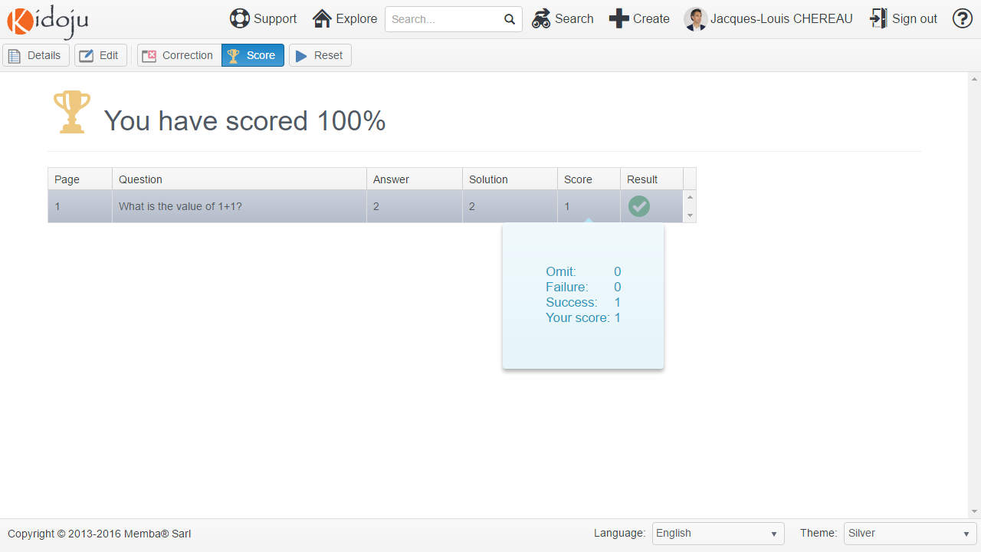

## Styles

In Kidoju, most components have one or more style properties.

The easy way to modify style properties is to use the formatting toolbar above the stage as in the example below.

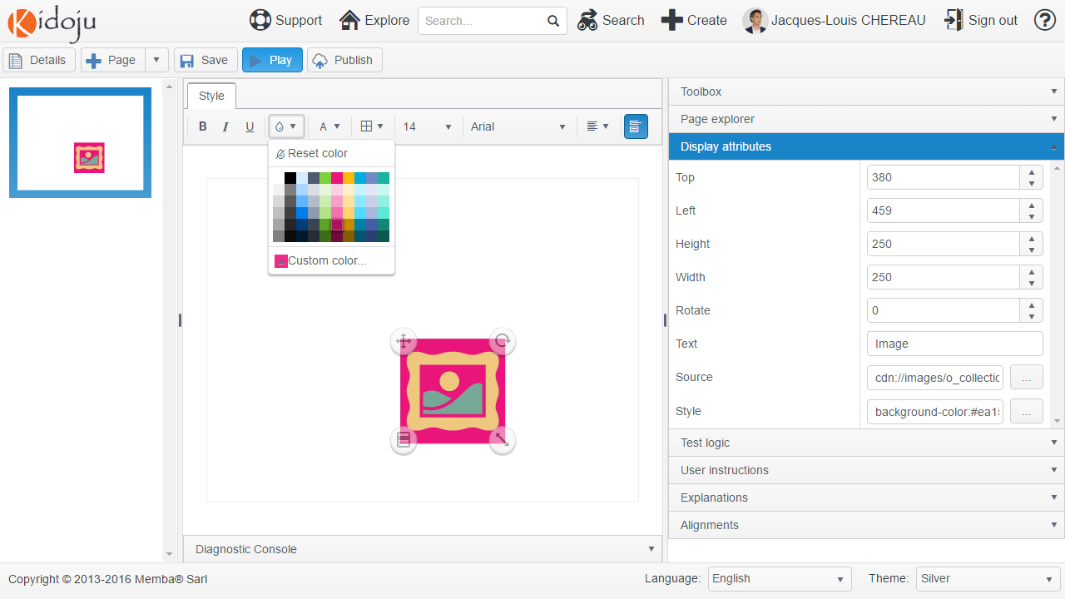

The formatting toolbar only gives access to a limited set of style values. For fine-grained control over styles, expand the **Display attributes** collapsible panel and click the […] button of the **Style** property. Then add or modify any style values.

Note: styles conform to the Cascading Style Sheet (CSS) specifications. More on CSS in the CSS styles chapter of the Advanced Guide.

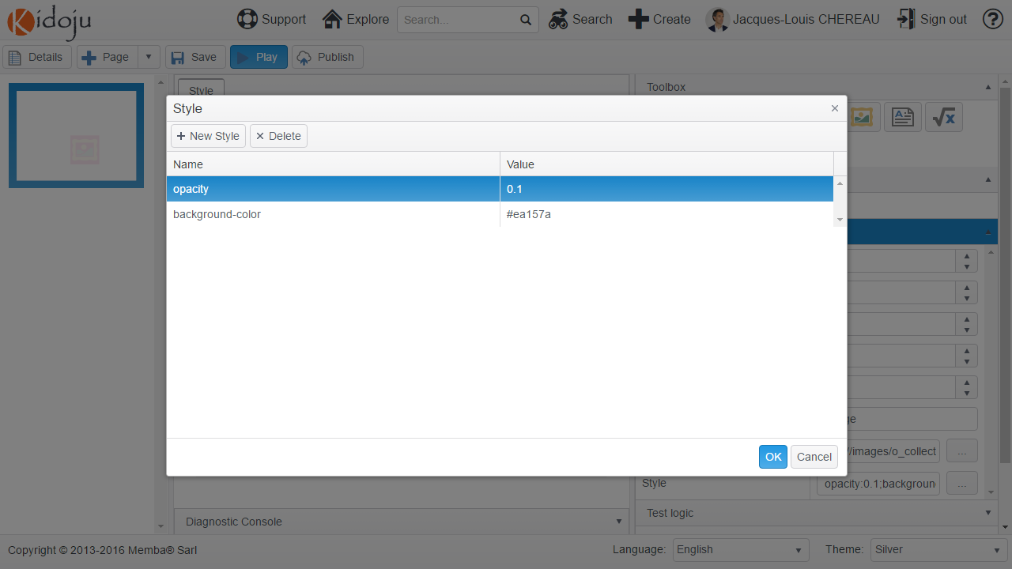

When modifying styles, make sure they display well both with light and dark themes.

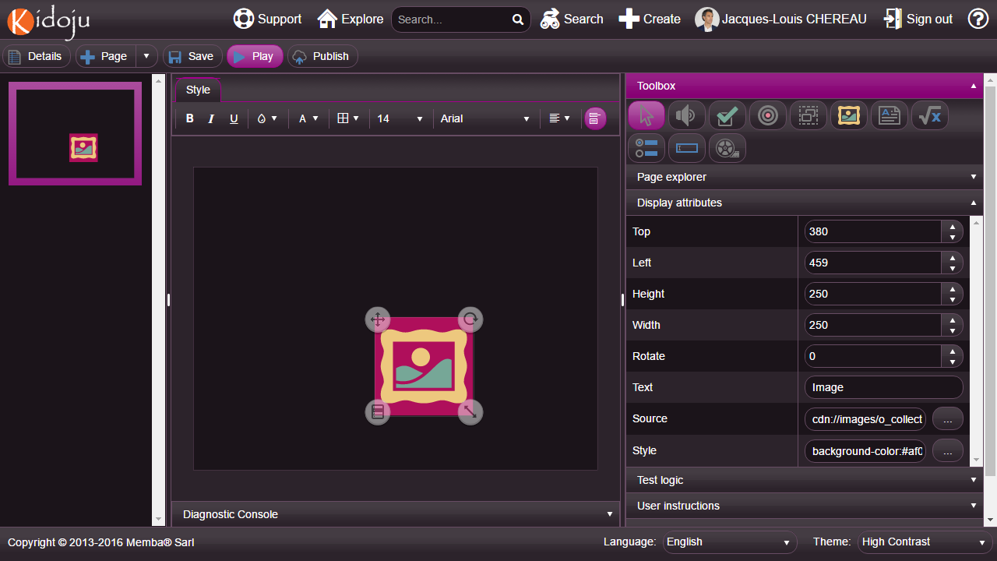

## Labels

Labels are strings of characters displayed with style. To add a label to the stage, select (click) the **Label** tool in the toolbox and click the stage. A new label is added to the page.

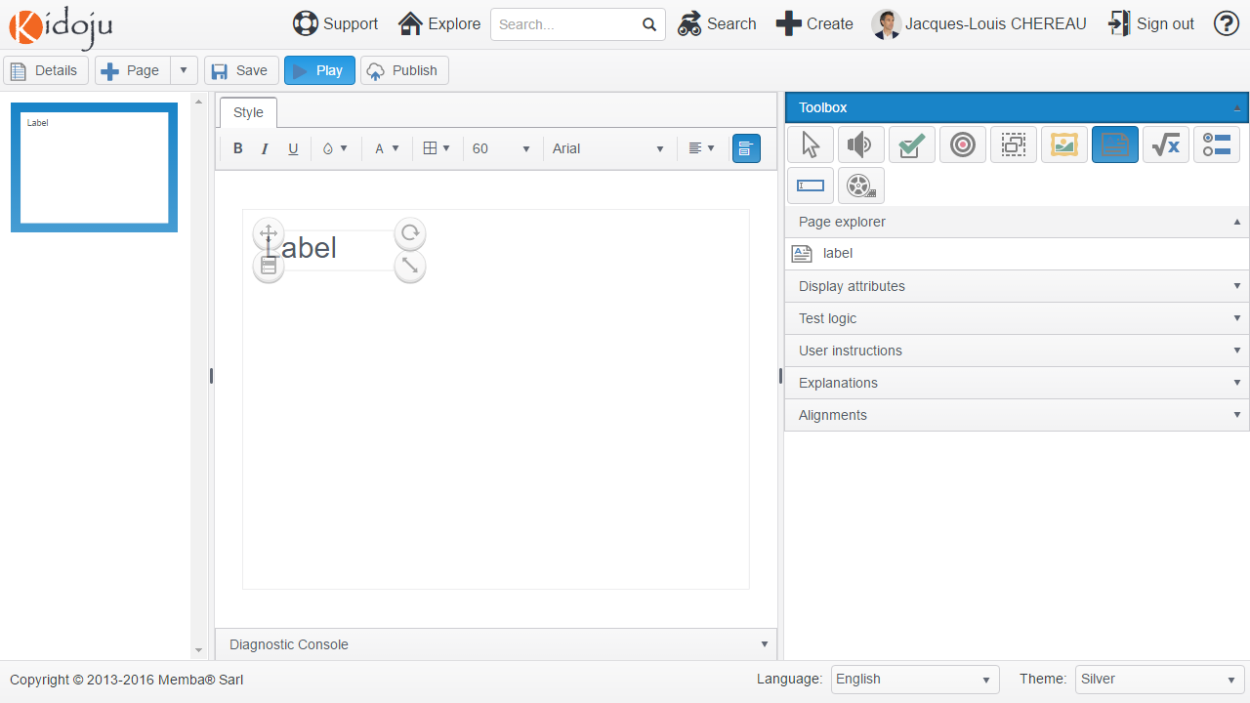

To change the text displayed, expand the **Display attributes** collapsible panel and change the value of the **Text** property.

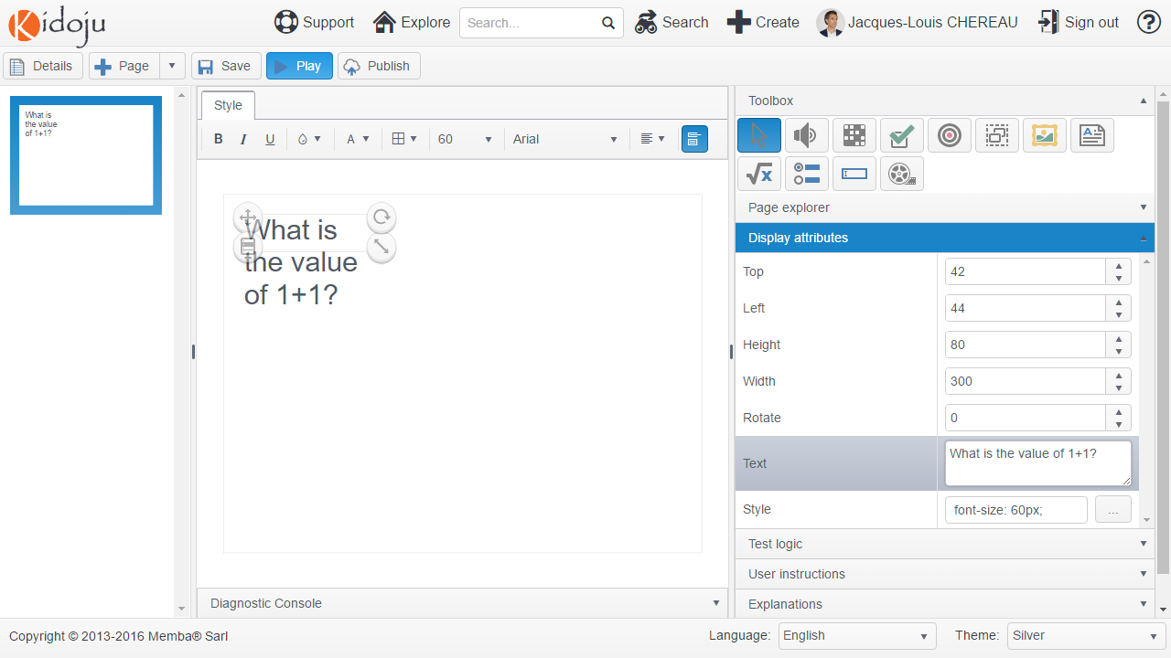

Position and resize the label as explained in the *Moving, rotating, resizing and aligning components* chapter.

By default, labels have a font size of 60px. Modify styles as explained in the *Styles* chapter to obtain the label on the following screenshot after resizing and styling.

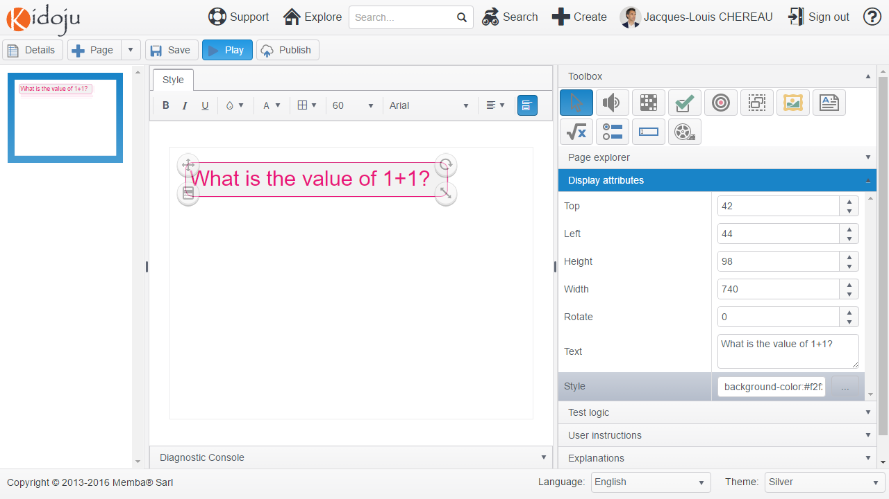

Please check here below the corresponding style attributes:

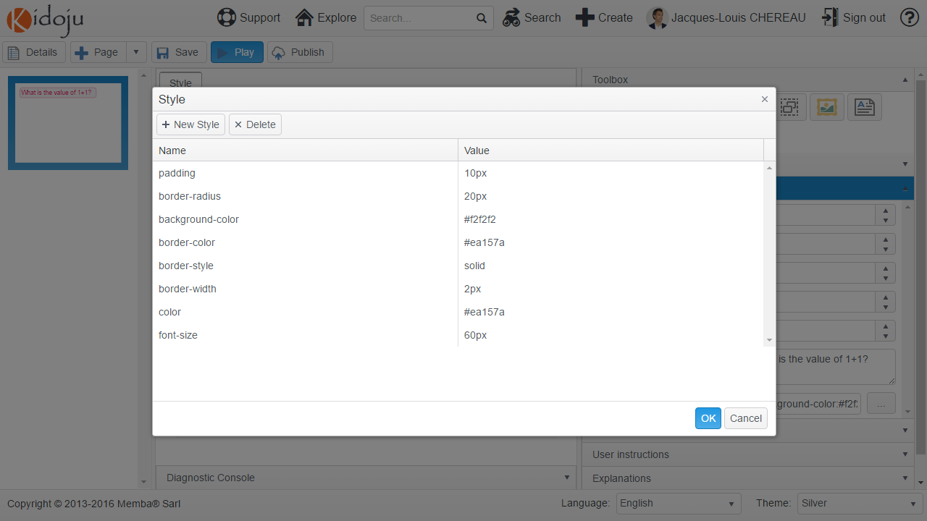

## Images

Images show the content of gif, jpeg, png and svg files on stage. To add an image to the stage, select (click) the **Image** tool in the toolbox and click the stage. A new image is added to the page.

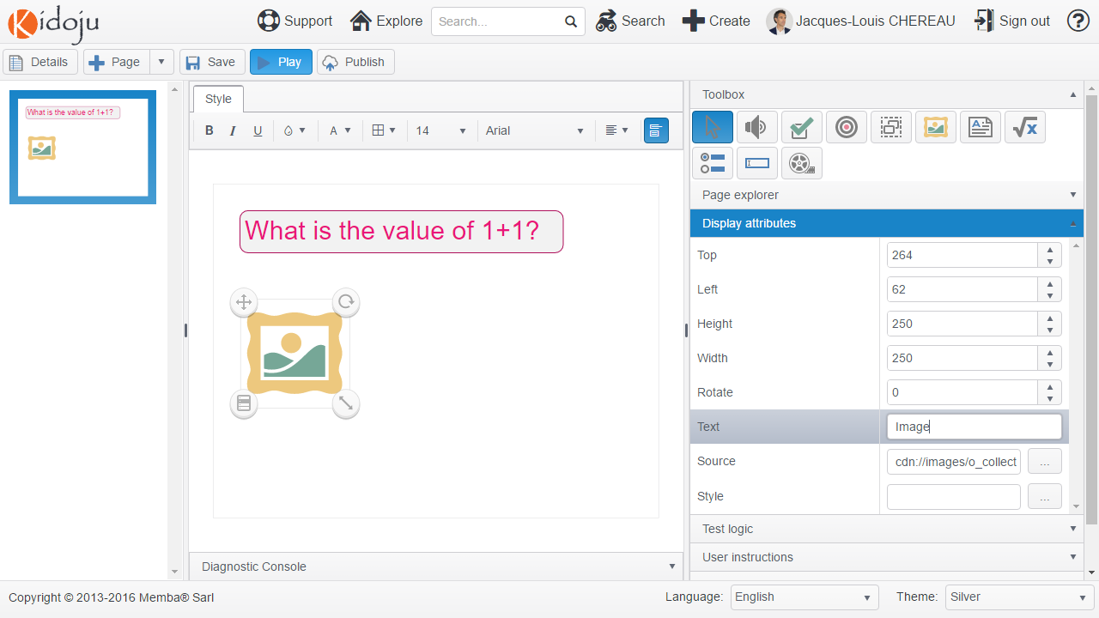

Prepare an image of your choice. We suggest <http://cliparts.co/clipart/223399> which you can download before uploading it to Kidoju.

Select the **Source** property in the **Display attributes** collapsible panel of the tools pane and click the **[…]** button. Click the **Upload** button, select your file on your hard drive and click the **Open** button.

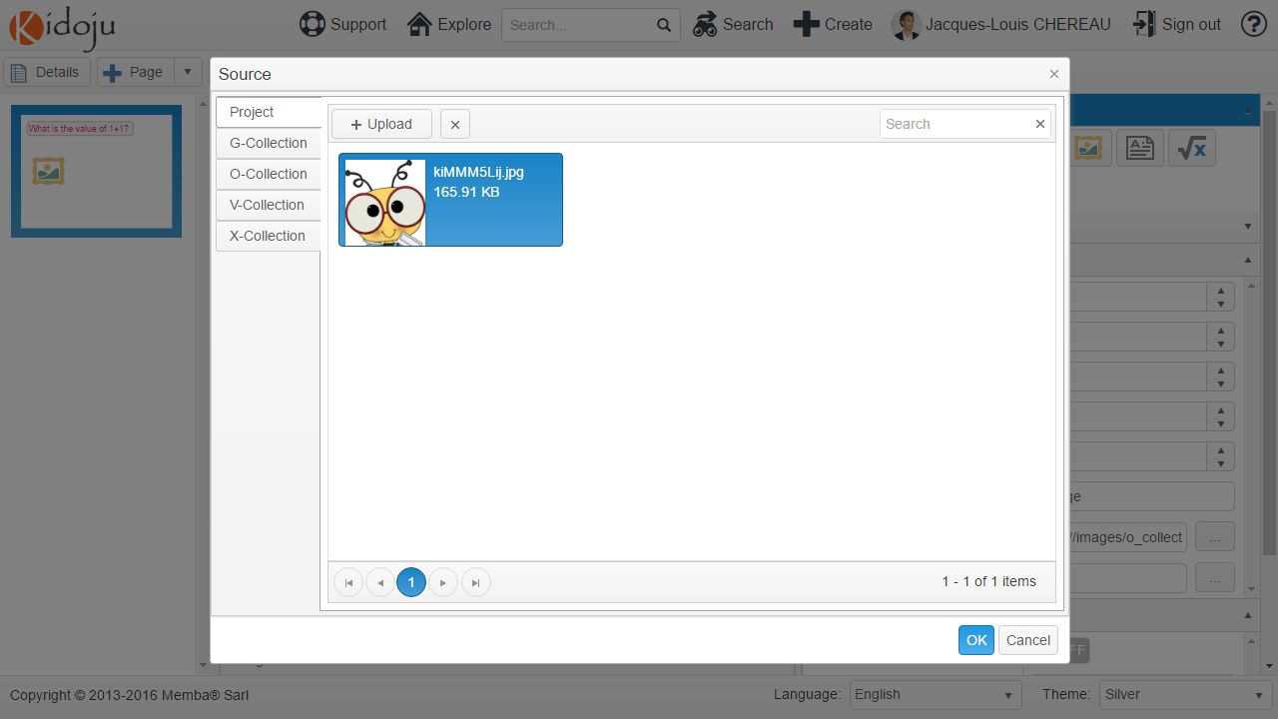

Note: The tabs on the left give access to image collections which have already been uploaded for your perusal.

Note: Considering mobile devices on 3G/4G plans, we limit the size of images you can upload to 400 Kb. Any larger file would trigger an error.

When your image is displayed in the **Source** dialog as above, it has been uploaded onto our servers. Click **OK** to assign this file to the image source. Resize the image component on the stage and consider filling the alternate **Text** property in the display attributes especially for blind people.

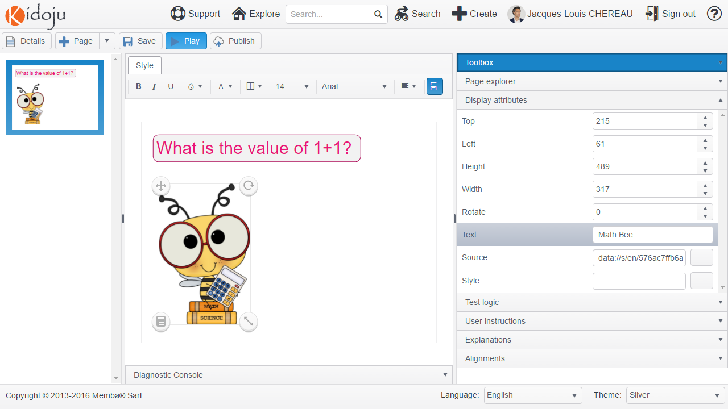

## Quizzes (or multiple choice questions)

The typical quiz is a multiple choice question which can be displayed as a drop down list, a set of radio buttons or a set of toggle buttons.

To add a quiz to the stage, select (click) the **Quiz** tool in the toolbox and click the stage. A new quiz is added to the page as True & False buttons.

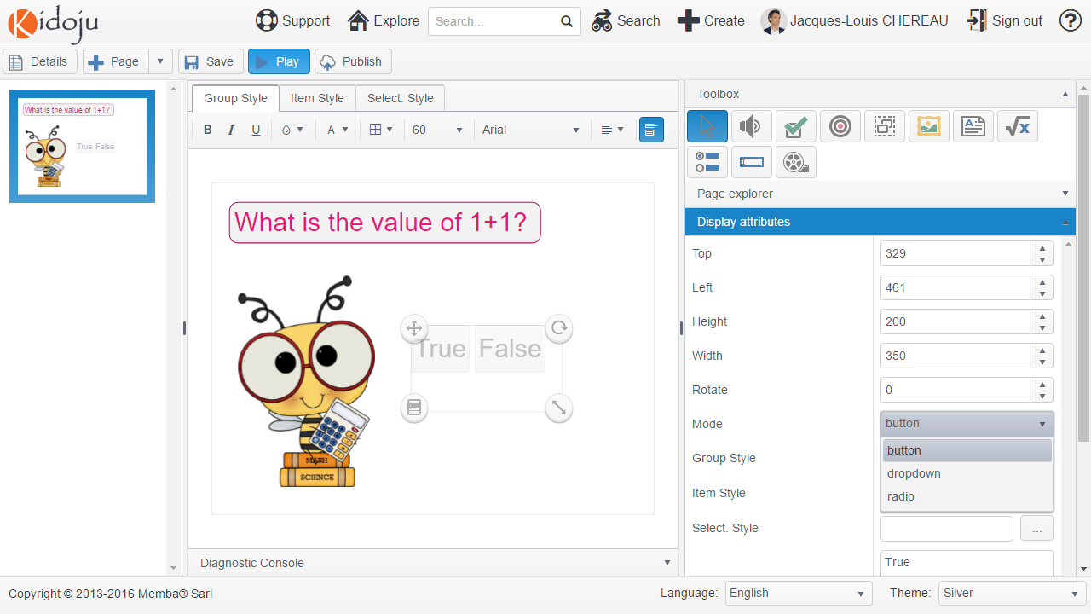

Select the **Mode** property in the **Display attributes** collapsible panel of the tools pane and choose the radio mode.

Then enter all possible values in the **Values** property. Make sure you type each value on a separate line with a carriage return as represented hereafter.

Resize the component bearing in mind the chapter about *Position of correction ticks and crosses* in the *Advanced Guide*.

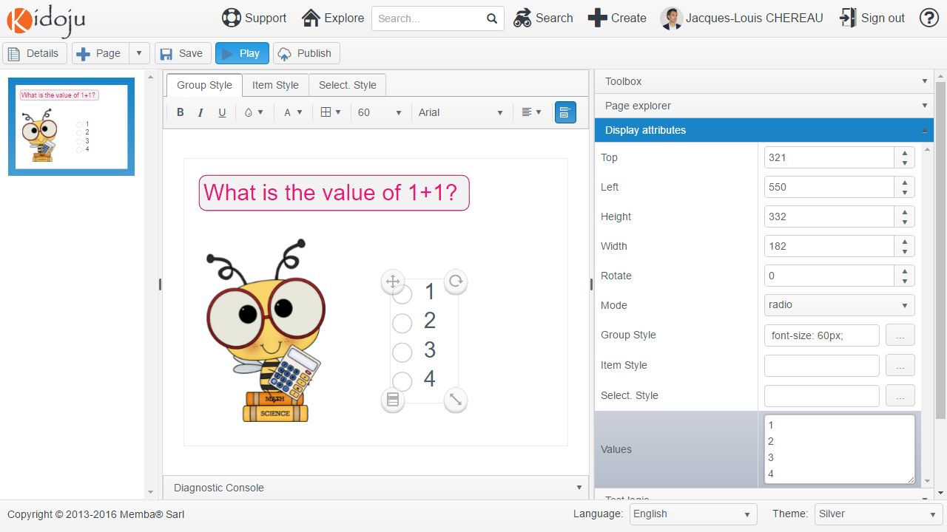

Select the **Question** property in the **Test logic** collapsible panel of the tools pane and choose the text of the label displayed on the page.

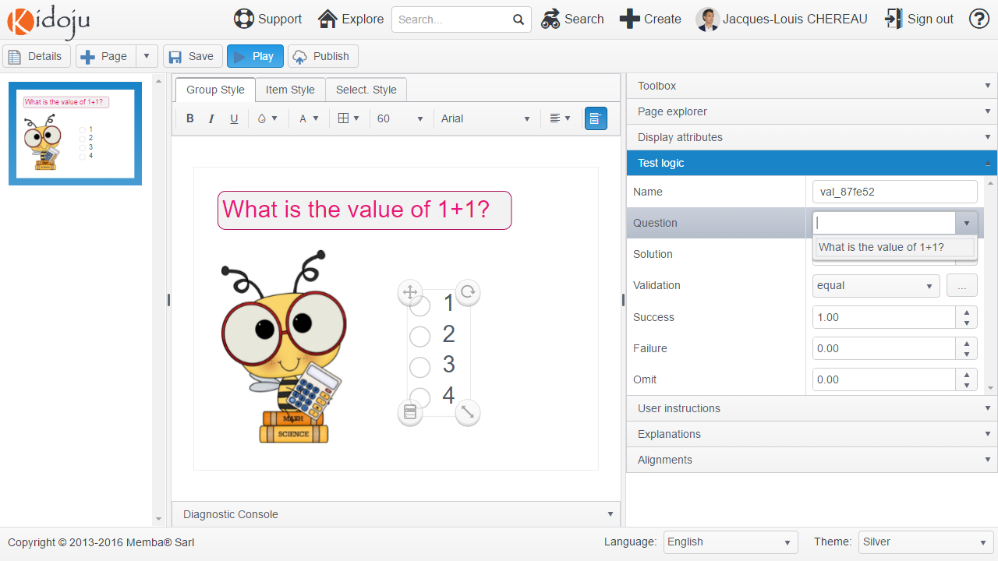

Select the **Solution** property and choose “2”.

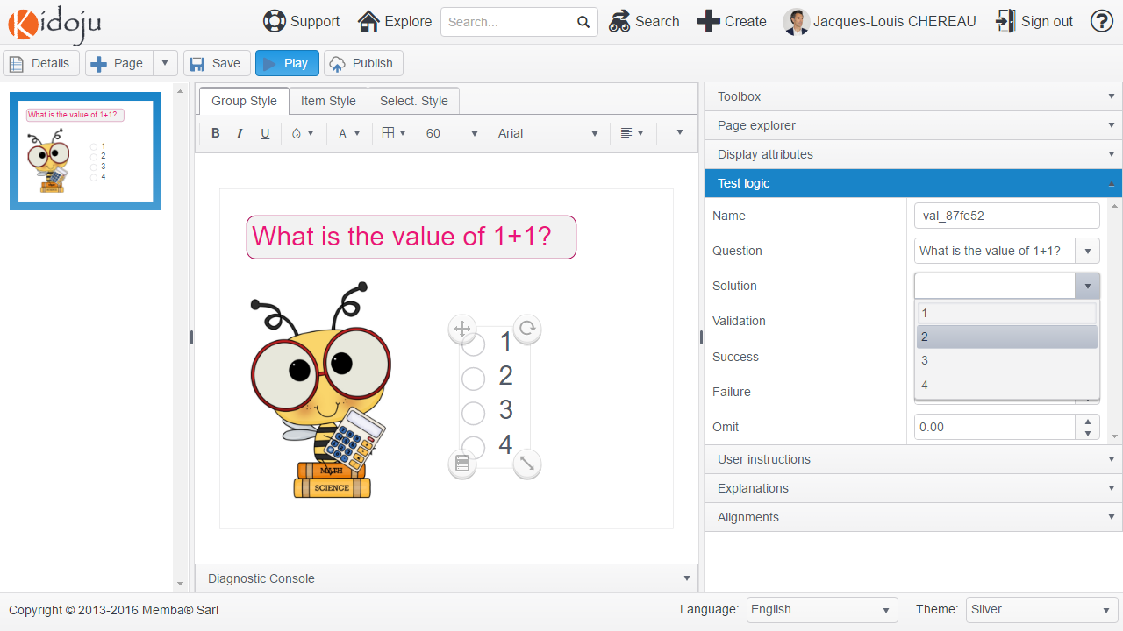

Note: when you modify possible values to choose from, make sure you update the solution.

Keep default values for the **Validation** rule and the **Success**, **Failure** and **Omit** marks.

Note: do not forget to save your work often.

After clicking the **Save** button, **Play** your first Kidoju.



Click the **Edit** button to return to the *Editor*.

## Checkboxes

Checkboxes are multiples choice questions with cumulative choices: the correct answer is constituted of several choices.

Add a second page as explained in the *Adding, removing, duplicating and sorting pages* chapter. Add a label as explained in the *Labels* chapter. Possibly add an image as explained in the *Images* chapter using http://cliparts.co/clipart/37218. Try to complete the following screenshot.

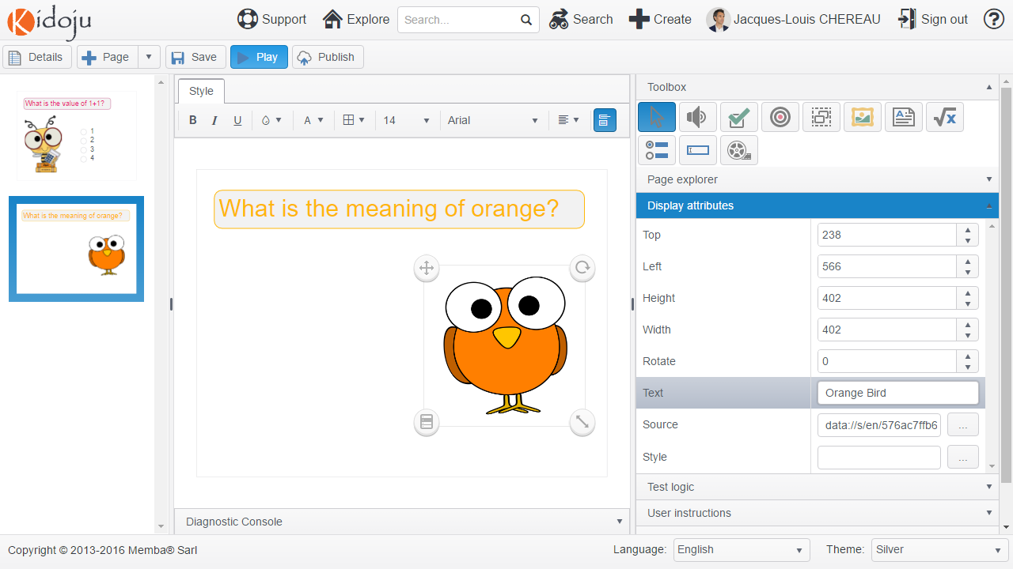

To add checkboxes to the stage, select (click) the **Checkboxes** tool in the toolbox and click the stage. A new set of checkboxes is added to the page.

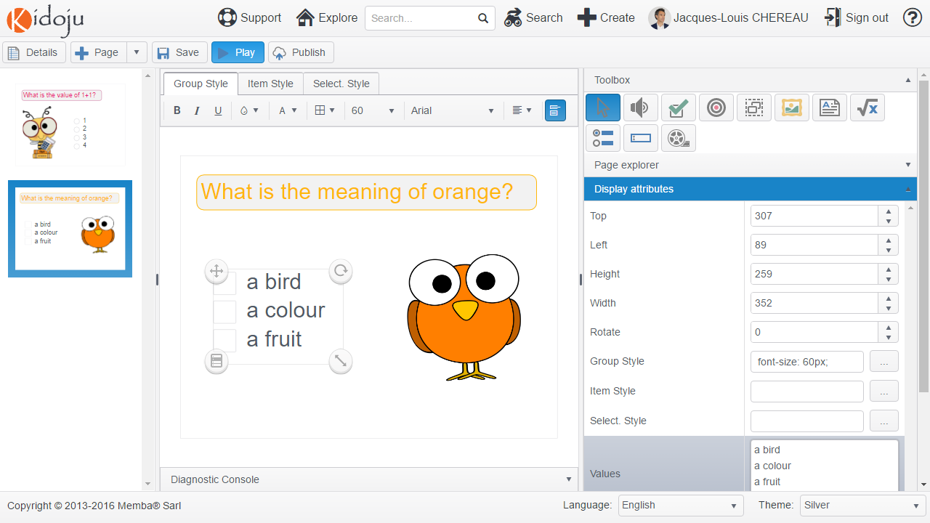

Then enter all possible values in the **Values** property of the **Display attributes** collapsible panel of the tools pane. Make sure you type each value on a separate line with a carriage return as represented hereafter.

Resize the component bearing in mind the preceding chapter about *Position of correction ticks and crosses*.

Select the **Question** property in the **Test logic** collapsible panel of the tools pane and choose the text of the label displayed on the page.

Select the **Solution** property and enter “a colour” and “a fruit” on two lines.

Note: when you modify values, make sure you update the solution.

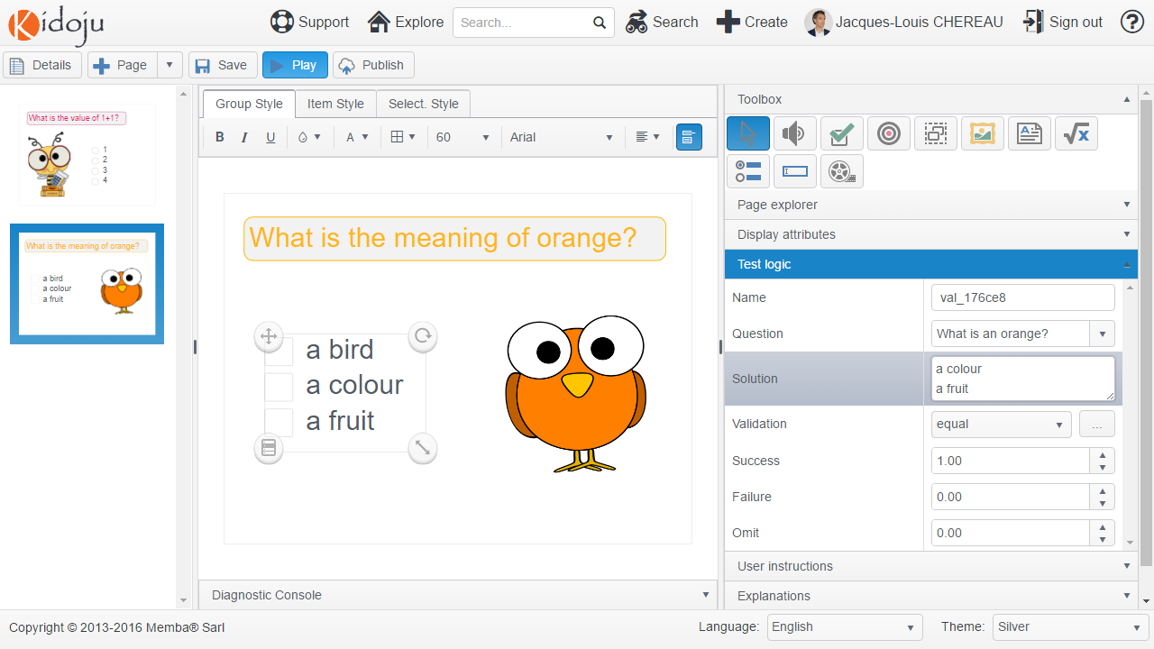

Keep default values for the **Validation** rule and the **Success**, **Failure** and **Omit** points.

Note: do not forget to save your work often.

After clicking the **Save** button, **Play** your Kidoju.

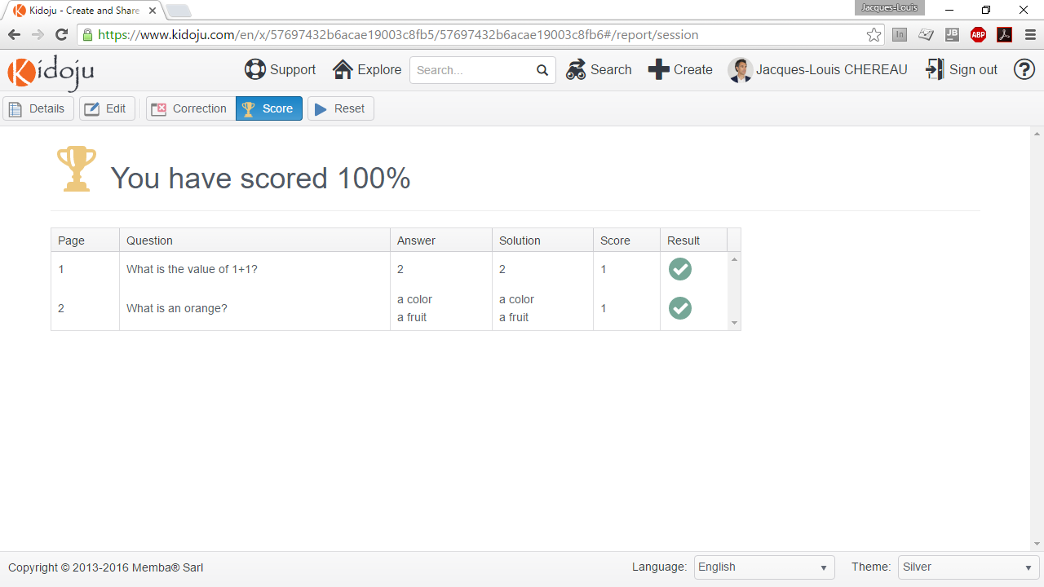

Click the **Edit** button to return to the *Editor*.

## Textboxes

Textboxes are areas for typing text and provide short answers.

Add a third page as explained in the *Adding, removing, duplicating and sorting pages* chapter. Add a label as explained in the *Labels* chapter. Possibly add an image as explained in the *Images* chapter using http://cliparts.co/clipart/1615. Try to complete the following screenshot.

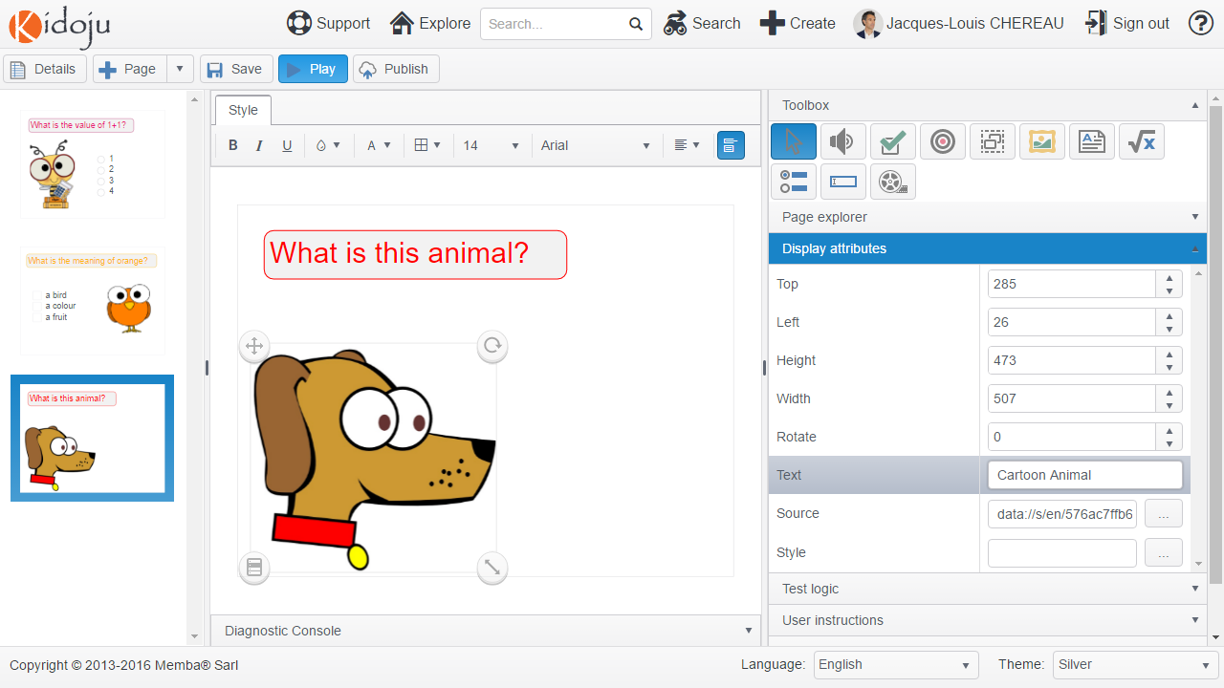

To add a textbox to the stage, select (click) the **Textbox** tool in the toolbox and click the stage. A new textbox is added to the page.

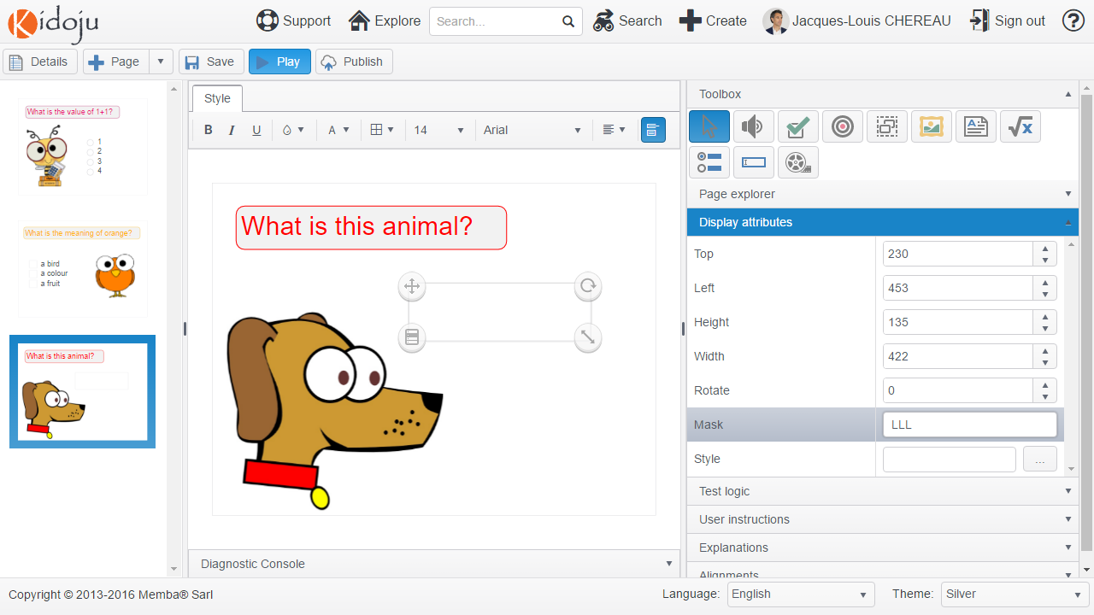

Then type “LLL” in the **Mask** property of the **Display attributes** collapsible panel of the tools pane. A mask of “LLL” constrains the answer to 3 letters and all other characters (digits and symbols) are discarded. Consider the mask as an optional hint.

A mask determines allowed characters and is made of the following rules:

|  |  |  |
| --- | --- | --- |
| 0 | Digit | Accepts any digit between 0 and 9. |
| 9 | Digit or space | Accepts any digit between 0 and 9, plus space. |
| # | Digit or space | Like 9 rule, but allows also (+) and (-) signs. |
| L | Letter | Restricts input to letters a-z and A-Z. This rule is equivalent to [a-zA-Z] in regular expressions. |
| ? | Letter or space | Restricts input to letters a-z and A-Z and to spaces. This rule is equivalent to [a-z A-Z] in regular expressions. |
| & | Character | Accepts any character. The rule is equivalent to \S in regular expressions. |
| C | Character or space | Accepts any character. The rule is equivalent to . (dot) in regular expressions. |
| A | Alphanumeric | Accepts letters and digits only. |
| a | Alphanumeric or space | Accepts letters, digits and space only. |
| . | Decimal placeholder | The decimal separator will be get from the current culture. |
| , | Thousands placeholder | The display character will be get from the current culture. |

You might find the following examples useful

|  |  |  |
| --- | --- | --- |
| Mask | Accepts | Rejects |
| LLL | Abc | 123  Abcd  #*$% |
| LL?LL | Ab cd  abcde | 123  Abcd  #*$% |
| LL LL | Ab cd | 123  Abcd  #*$% |
| 0000 | 1234 | 123  Abcd  #*$% |
| 00-00 | 12-34 | 12-3  Ab-cd  ££-$$ |

Resize the component bearing in mind the preceding chapter about *Position of correction ticks and crosses*.

Select the text of the label displayed on the page for the **Question** property in the **Test logic** collapsible panel of the tools pane.

Type “dog” in the **Solution** property.

Select “ignoreCaseEqual” for the **Validation** property. This validation algorithm ignores case and accepts “DOG”, “dog” and even “DoG” as correct answers.

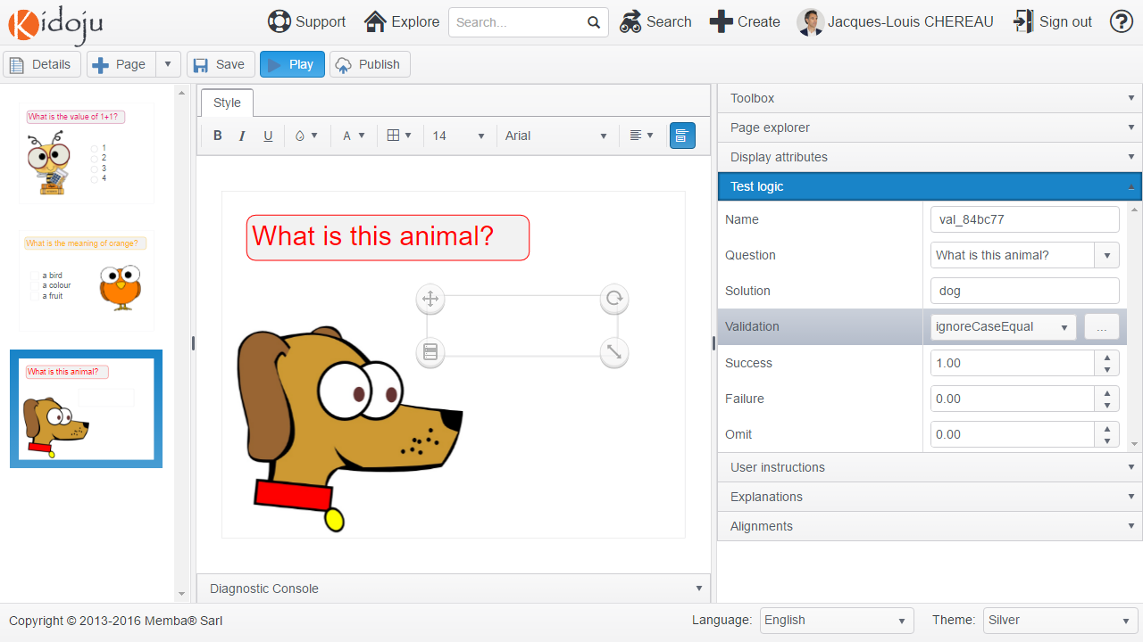

Textboxes provide the following validation algorithms:

|  |  |
| --- | --- |
| equal | Strict comparison: résumé = résumé. |
| ignoreCaseEqual | Comparison ignoring case: RéSuMé = résumé. |
| ignoreCaseMatch | See the chapter about *Regular Expressions* in the *Advanced Guide.* |
| ignoreDiacriticsEqual | Comparison ignoring case and diacritics: rEsUmE = résumé. |
| match | See the chapter about *Regular Expressions* in the *Advanced Guide.* |
| metaphone | Phonetic comparison based on the metaphone algorithm: RAISUMER = résumé. |
| soundex | Phonetic comparison based on the soundex algorithm: RAISUMER = résumé. |

Note: more information on metaphone and soundex can be found at https://en.wikipedia.org/wiki/Phonetic_algorithm. These algorithms work best in English and soundex is more permissive than metaphone.

Keep default values for the **Success**, **Failure** and **Omit** points.

Note: do not forget to save your work often.

After clicking the **Save** button, **Play** your Kidoju.

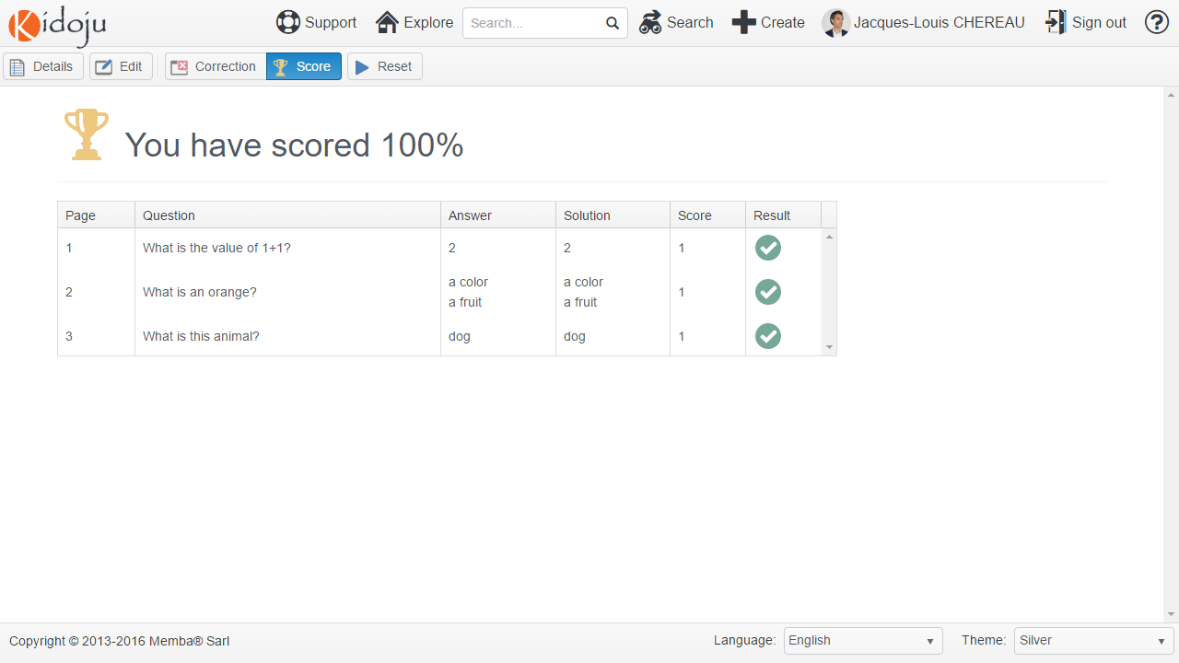

Click the **Edit** button to return to the *Editor*.

## Connectors

Connectors are used to draw connections especially between images and legends.

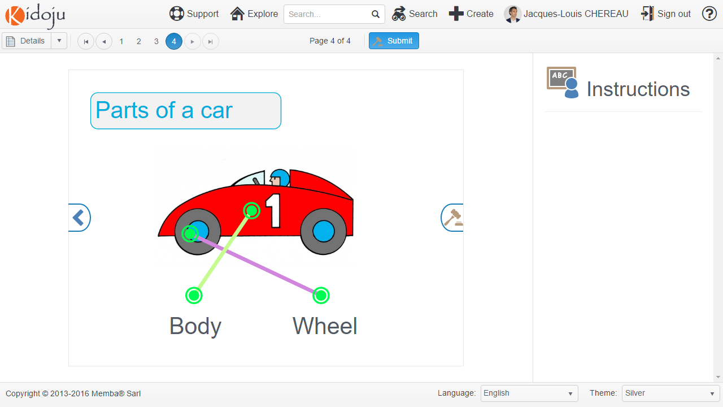

Add a fourth page as explained in the *Adding, removing, duplicating and sorting pages* chapter. Add a label as explained in the *Labels* chapter. Add an image as explained in the *Images* chapter using http://cliparts.co/clipart/17129. Try to complete the following screenshot.

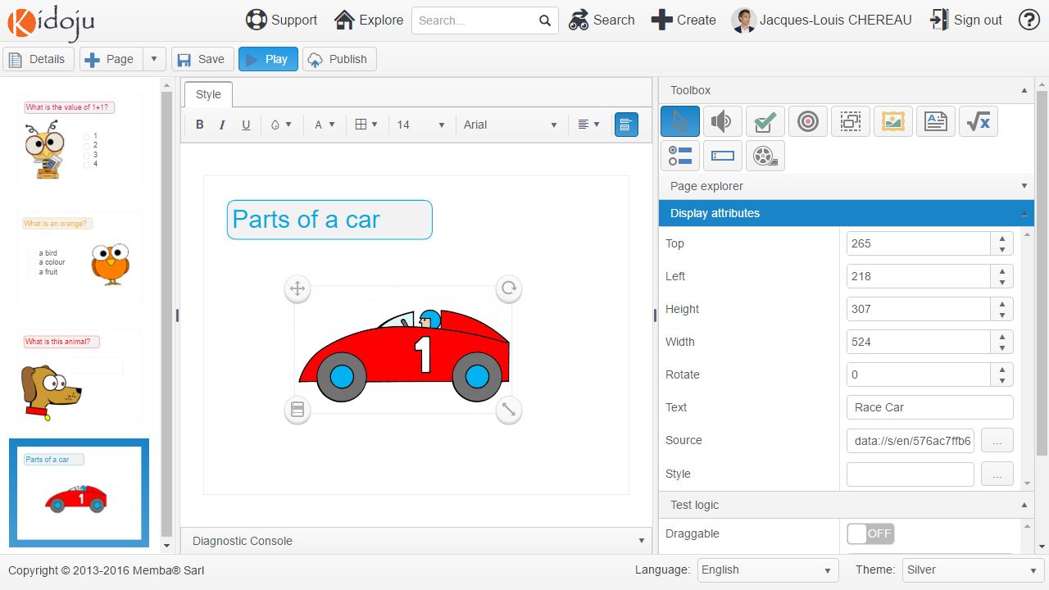

To add a connector to the stage, select (click) the **Connector** tool in the toolbox and click the stage. A new connector is added to the page.

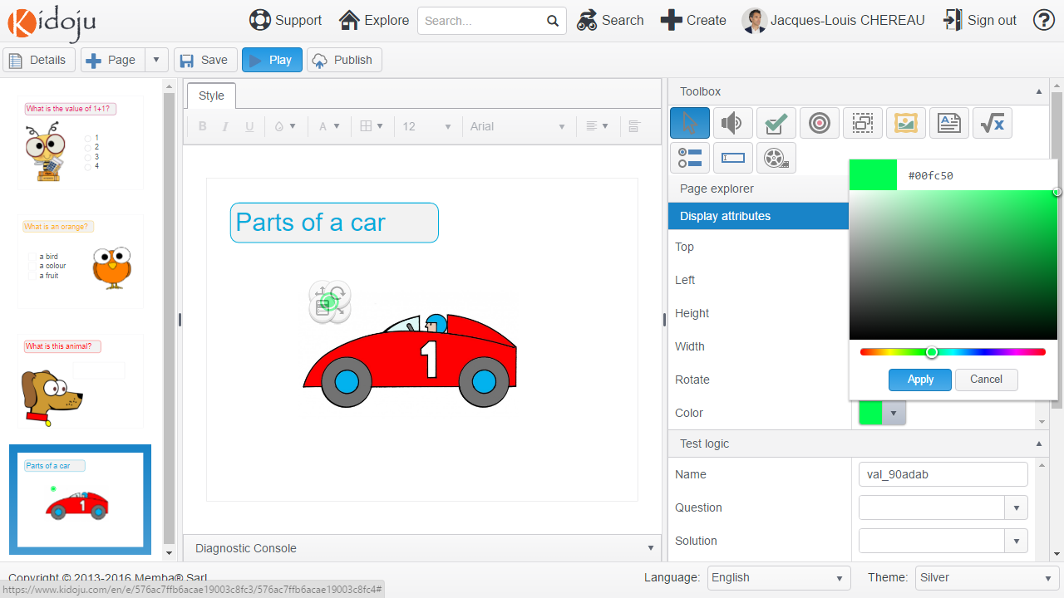

Select a contrasted colour in the **Colour** property of the **Display attributes** collapsible panel of the tools pane. Make sure this colour fits with light and dark themes.

Click the menu handle and the **Duplicate** command to create 4 connectors and position them as represented below:

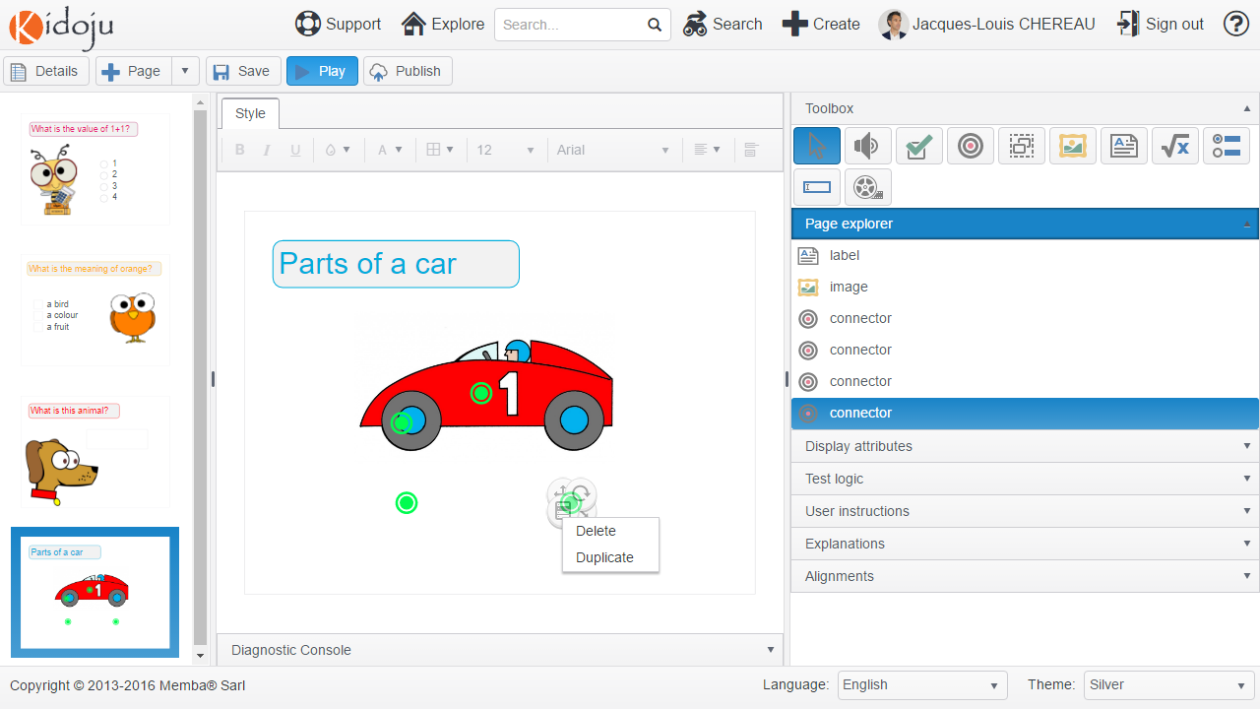

Fill the test logic of all four connectors as follows:

|  |  |  |  |
| --- | --- | --- | --- |
|  | Question | Solution | Validation |
| #1 | Connect the wheel on the image with the wheel label? | Wheel | equal |
| #2 | Connect the wheel on the image to the wheel label? | Wheel | equal |
| #3 | Connect the body on the image to the body label? | Body | equal |
| #4 | Connect the body on the image to the body label? | Body | equal |

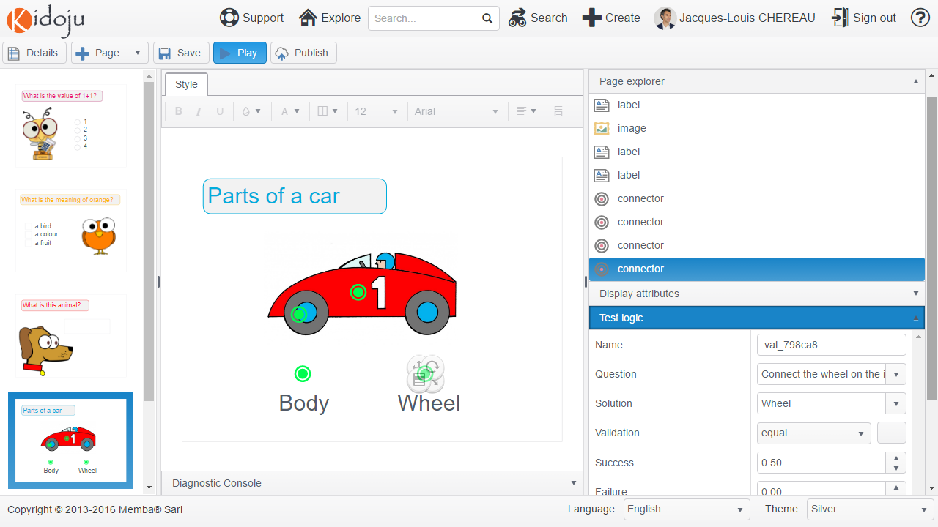

Keep default values for the **Success**, **Failure** and **Omit** points.

Add two labels respectively for “Body” and “Wheel” and position them as above.

IMPORTANT! Sort your connectors in the page explorer so that they are all listed at the bottom. The reason is you want connections to be displayed on top of images and labels.

Note: do not forget to save your work often.

After clicking the **Save** button, **Play** your Kidoju.

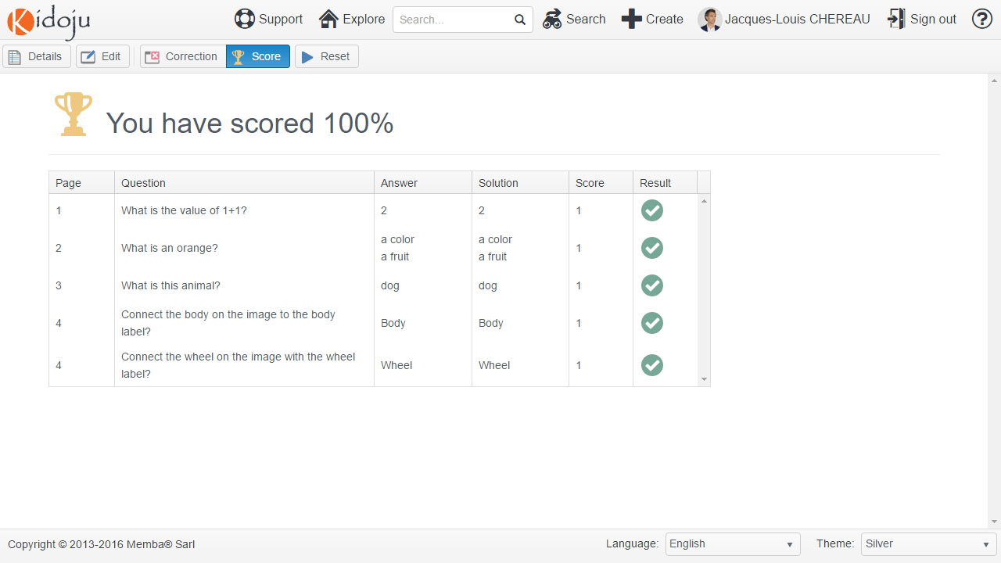

Click the **Edit** button to return to the *Editor*.

## Drop zones

Drop zones provide a surface to drop images and/or labels and validate their value.

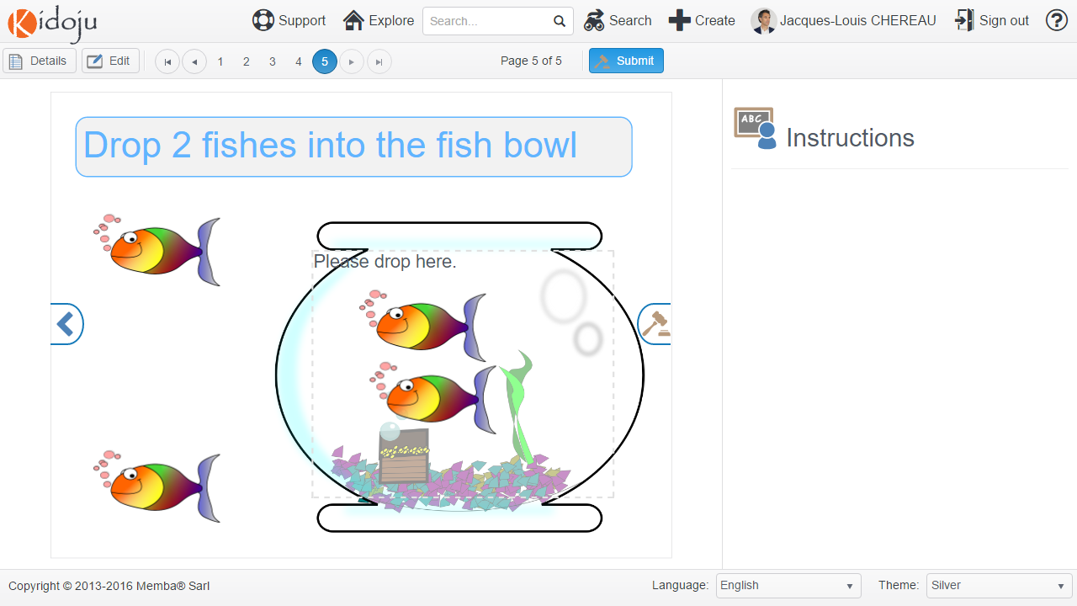  
  
Add a fifth page as explained in the *Adding, removing, duplicating and sorting pages* chapter. Add a label as explained in the *Labels* chapter. Add two image as explained in the *Images* chapter using http://cliparts.co/clipart/23725 and http://cliparts.co/clipart/3120348. Try to complete the following screenshot.

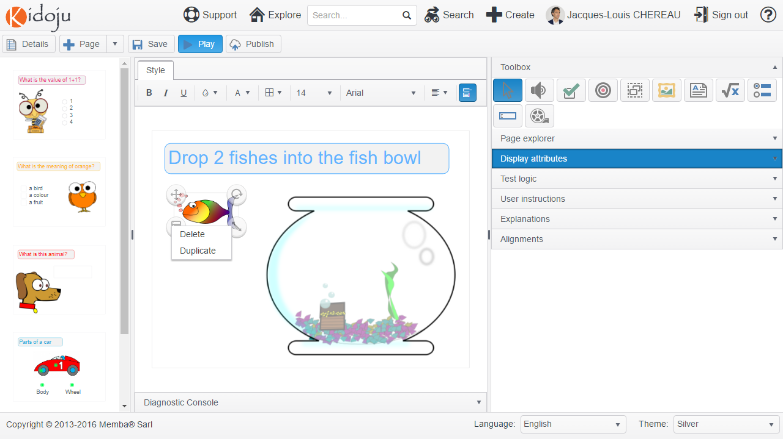

Duplicate the fish images by clicking the menu handle and selecting the **Duplicate** option as shown above. Then define the test logic on each fish by turning draggable on and assigning a value of 1. The drop zone will ensure that the user will have dropped 1 + 1 = 2.

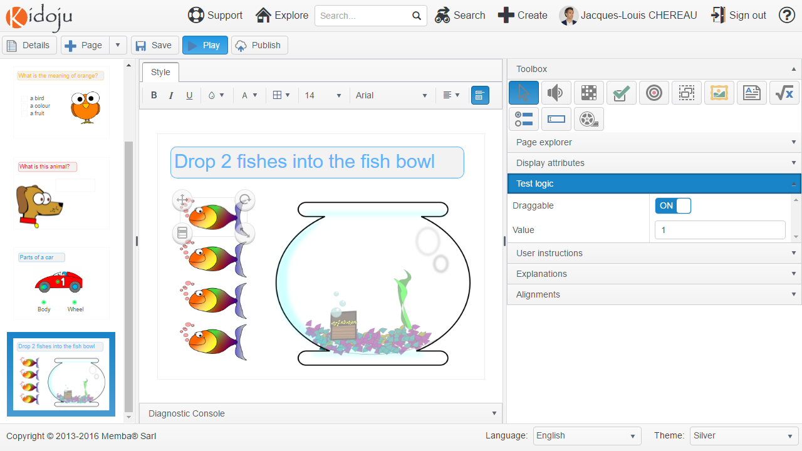

To add a drop zone to the stage, select (click) the **Drop Zone** tool in the toolbox and click the stage. A new drop zone is added to the page with a dashed border and a “Please drop here” invitation which you can change.

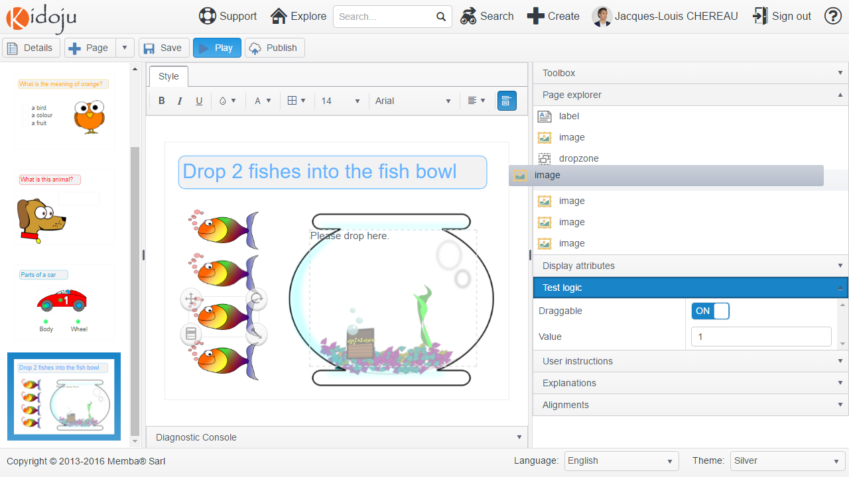

IMPORTANT! Sort your drop zone and draggable images and labels in the page explorer so that all draggable images are listed at the bottom, just after the drop zone. The reason is you want draggable images on top of everything else.

Select the text of the label displayed on the page for the **Question** property in the **Test logic** collapsible panel of the tools pane.

Type “2” in the **Solution** property.

Select “sumEqual” for the **Validation** property.

Textboxes provide the following validation algorithms:

|  |  |
| --- | --- |
| equal | Strict comparison: résumé = résumé. |
| sumEqual | Comparison ignoring case: RéSuMé = résumé. |

Note: more information on metaphone and soundex can be found at https://en.wikipedia.org/wiki/Phonetic_algorithm. These algorithms work best in English and soundex is more permissive than metaphone.

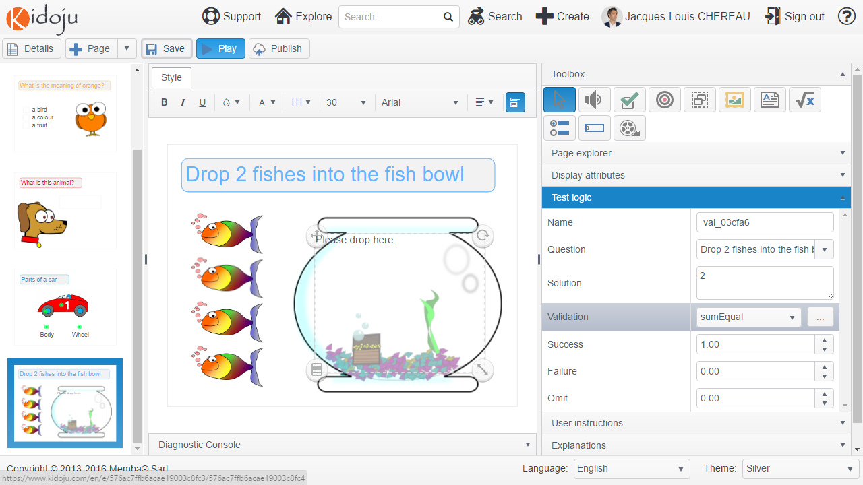

Keep default values for the **Success**, **Failure** and **Omit** points.

Note: do not forget to save your work often.

After clicking the **Save** button, **Play** your Kidoju.

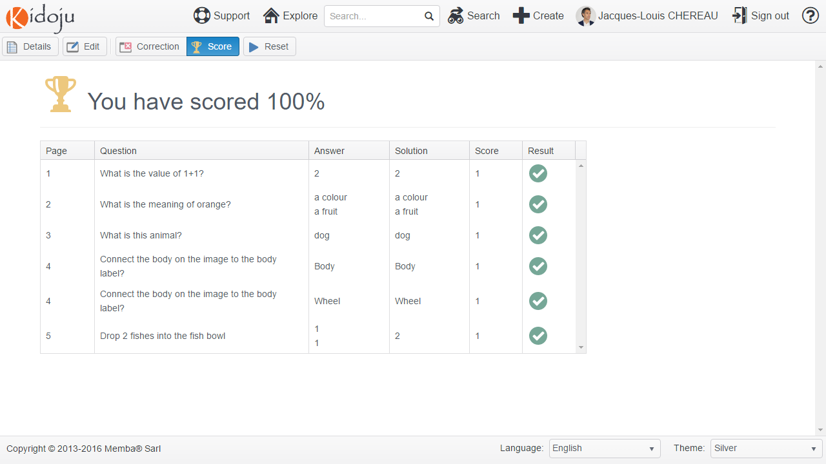

Click the **Edit** button to return to the *Editor*.

## Diagnostics and publication

Now, let us suppose your test is ready for publishing. Click the **Publish** button.

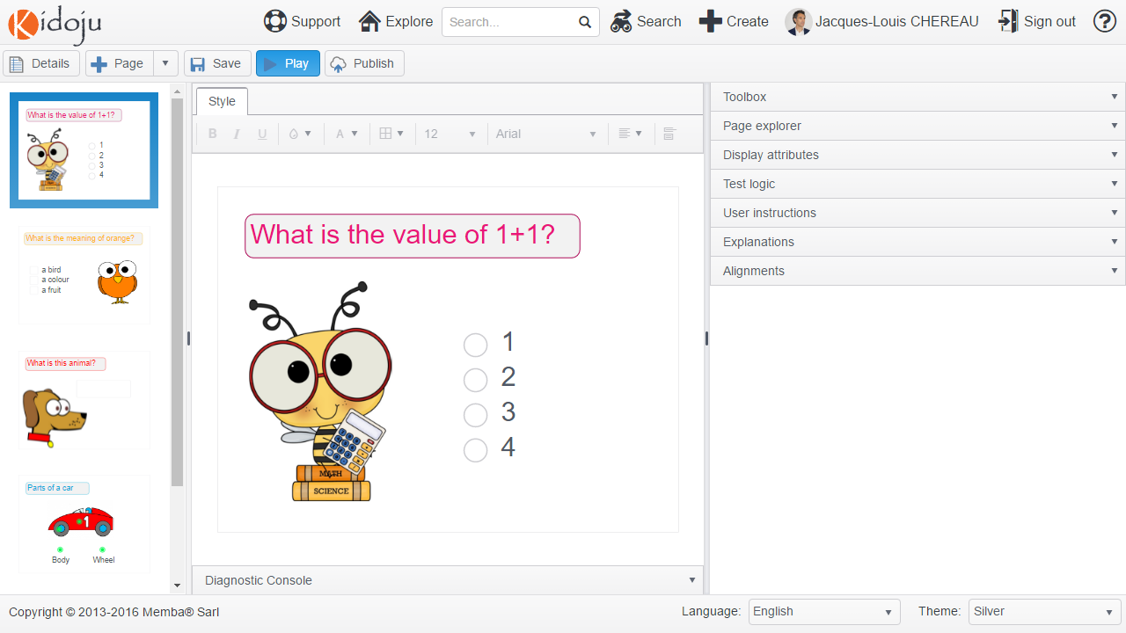

Assuming you have followed the instructions in this User Guide, you should get the following error message:

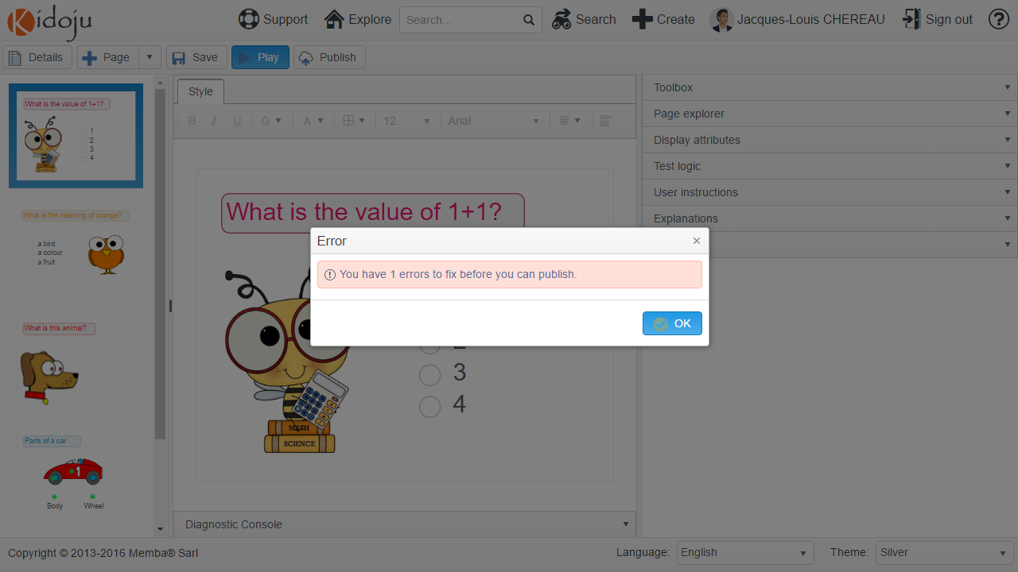

Discarding the error message by clicking the **OK** button reveals the Diagnostic Console with warnings and errors.

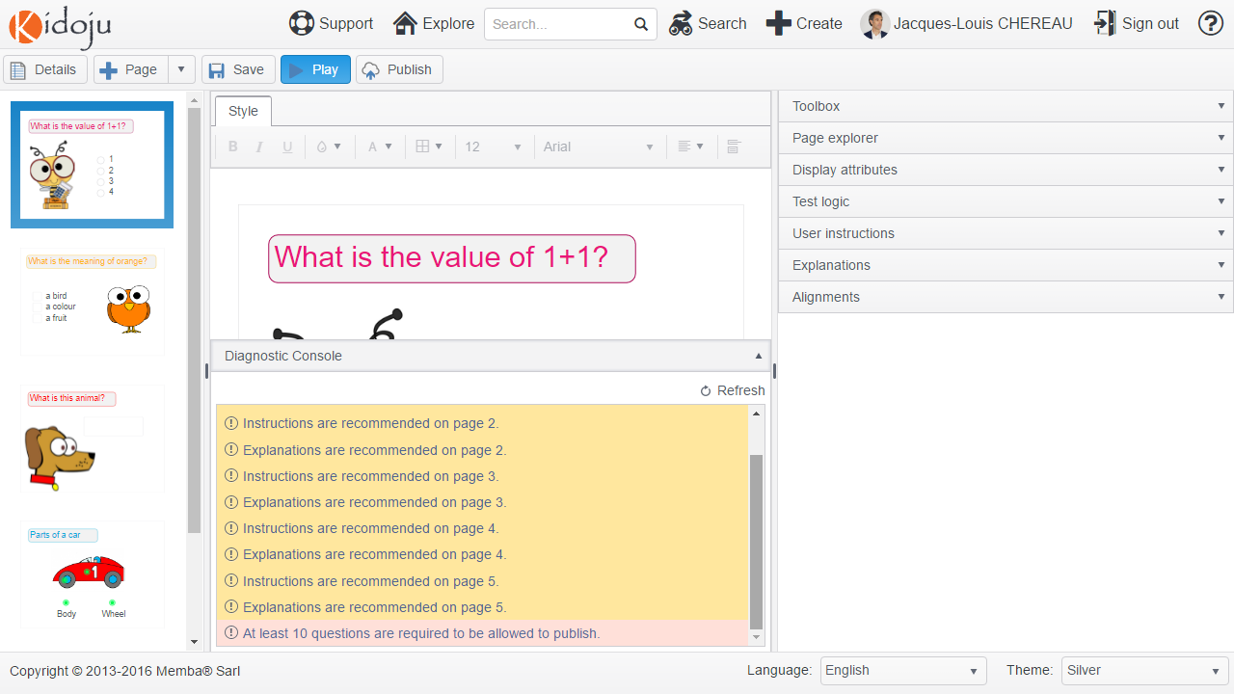

In this instance, you have 10 warnings and 1 error. Warnings (in yellow) are recommendations which do not prevent from publishing. Errors need to be fixed before publishing.

Amongst warnings, the software recommends adding *User instructions and explanations* on all pages. Simply click a warning in the Diagnostic Console to navigate to the corresponding page and make the required correction.

There should only be one error: “At least 10 questions are required to be allowed to publish”. Each component has a weight:

* *Labels* and *Images* have a weight of 0: they do not make questions;
* *Quizzes (or multiple choice questions)*, *Checkboxes* and *Textboxes* have a weight of 1, as each of them make a question;
* *Connectors* have a weight of 0.25, as we consider you need at least 4 connectors to make a question;
* *Character Grids* have a weight of 10, as any grid would require several cells to fill, constituting several questions.

In order to prevent the publication of unfinished user trials, we require that Kidoju quizzes you publish have at least 10 questions, i.e. that the sum of all weights from all page components is at least 10.

Note: “with great power comes great responsibility”. Please be responsible and only publish contributions you are proud of and keep your trials as private drafts.

## Character Grids

Let us do a 3x3 magic square as explained at <http://www.dr-mikes-math-games-for-kids.com/3x3-magic-square.html>.

In a 3x3 magic square:

* All digits from 1 to 9 are used;
* The sum of digits on each line, column and diagonal is 15.

We shall disclose two numbers to ensure a unique solution.

Create a new Kidoju quiz as explained at the beginning of the *Teacher Guide* and add a Label as explained in the *Labels* section.

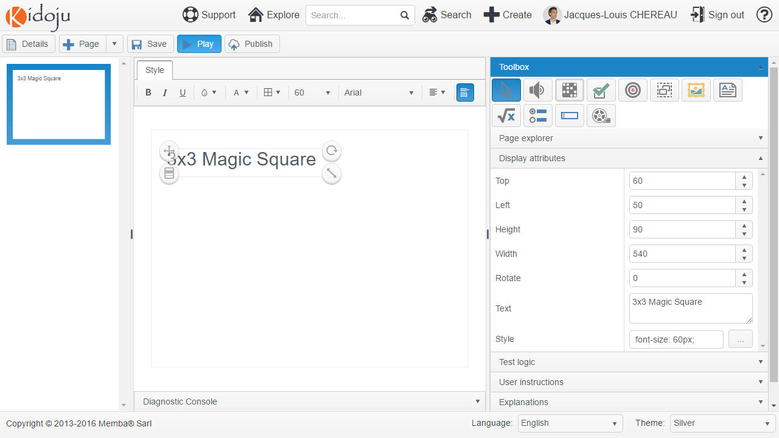

To add a character grid to the stage, select (click) the **Character Grid** tool in the toolbox and click the stage. A new character grid is added to the page with a default size of 9*9, that is the size of a sudoku.

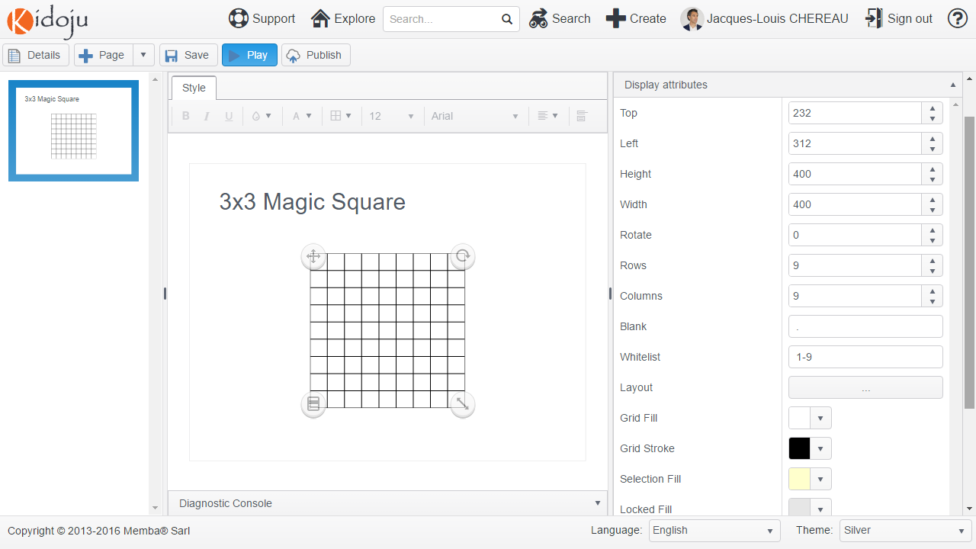

Expand the **Display attributes** collapsible panel of the tools pane.

Keep the . (dot) sign to **Blank** out cells like the black cells in crosswords, but we won’t use it here.

Keep the **Whitelist** 1-9 constituted of any numbers from 1 to 9. Another possible whitelist is A-Z. The expected value is actually what you would put between square brackets to make a regular expression. The whitelist is the list of authorized characters in the grid. Any character that does not match the whitelist is discarded.

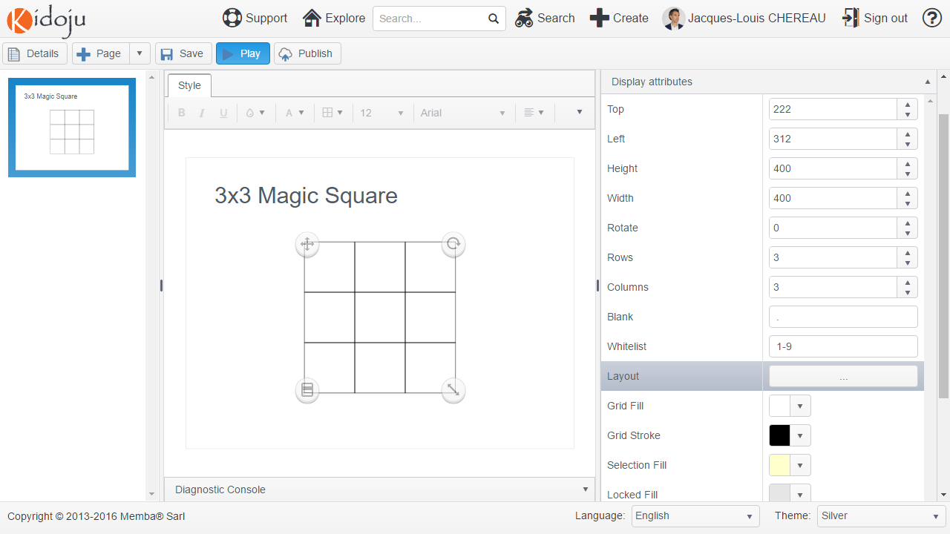

Click the **Layout** button and enter part of the grid as shown here below, then click the **OK** button.

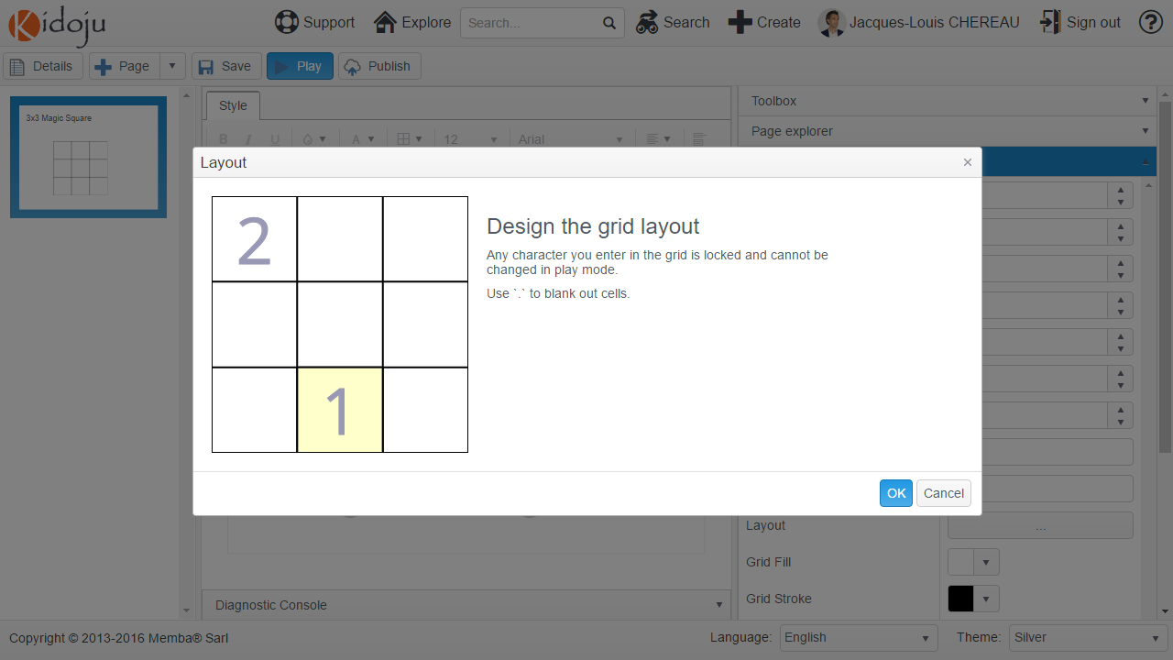

Note: the whitelist does not apply to the Layout. You can have characters in the initial layout which are not whitelisted.

The cells you have filled with values in the initial layout are locked and cannot be changed when playing your Kidoju, which is shown by a grey background.

Select the text of the label displayed on the page for the **Question** property in the **Test logic** collapsible panel of the tools pane.

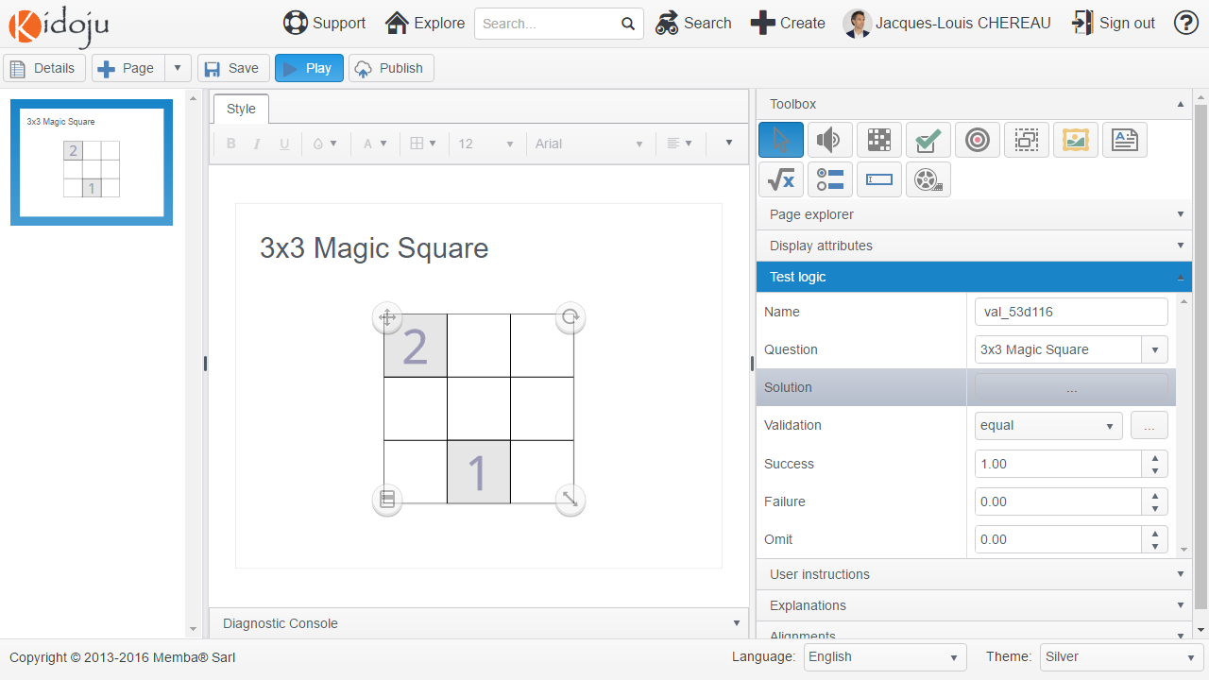

Keep the default value for the **Validation** algorithm and click the **Solution** button to edit the solution as reproduced here below:

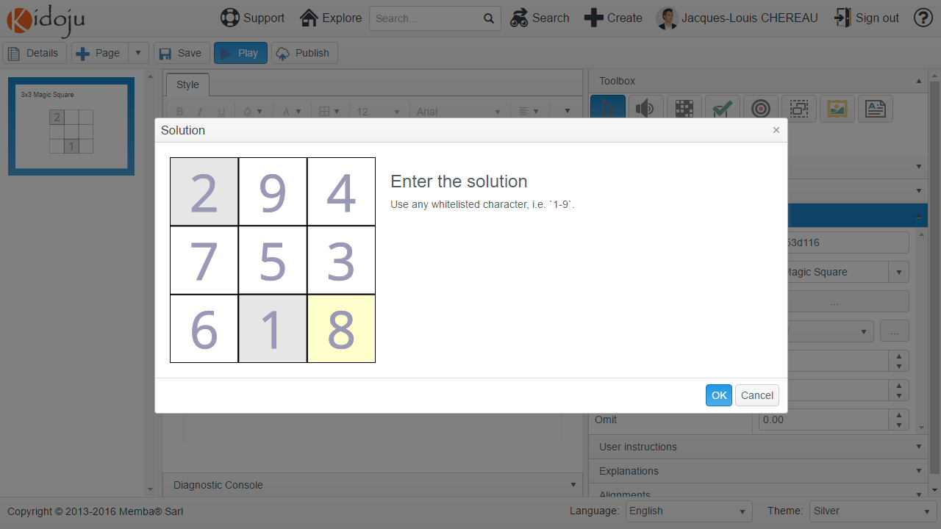

Click **OK**, then click **Save** and **Play** your Kidoju.

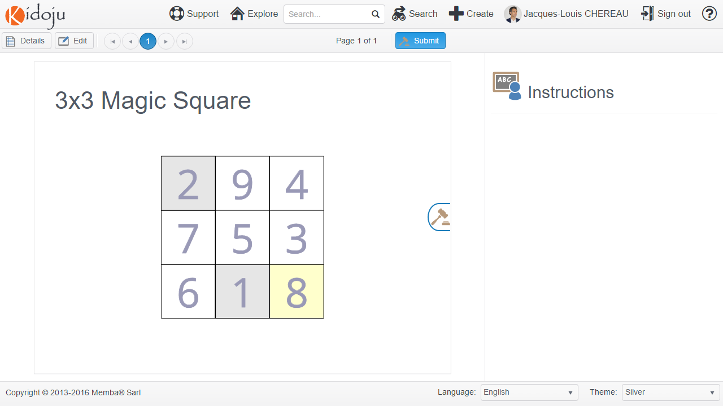

Once the character grid is filled, click the **Submit** button to obtain the score and correction.

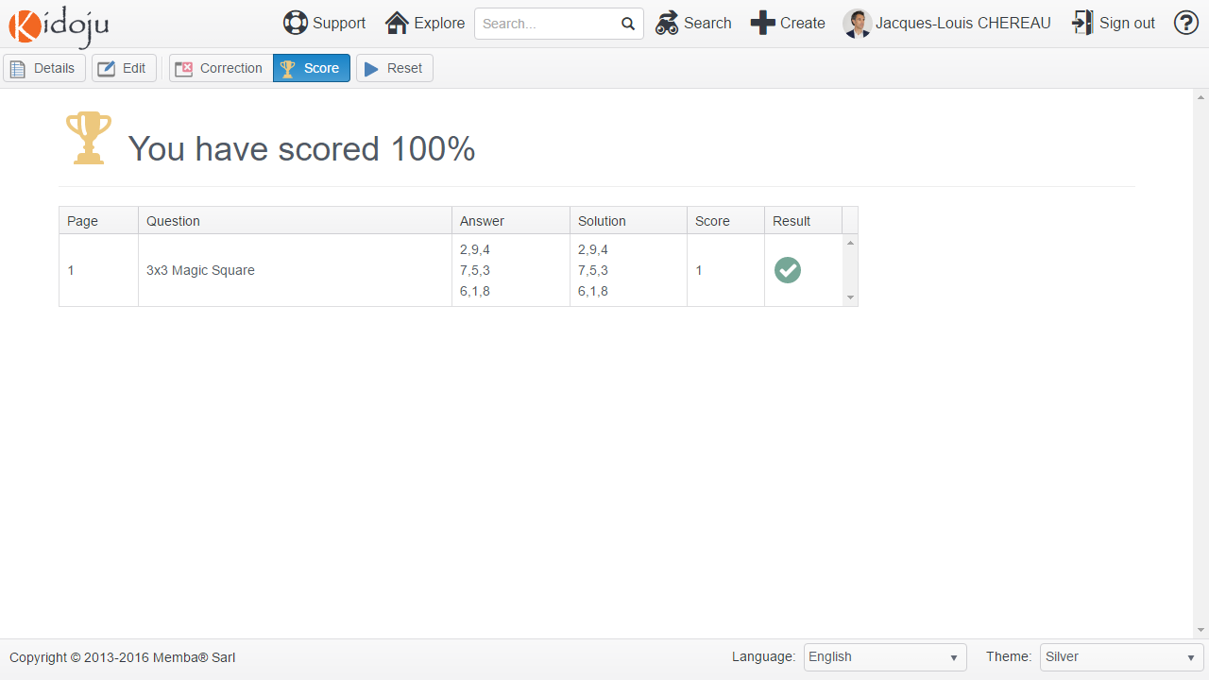

Click the **Edit** button to return to the *Editor*.

## Audio and video

Audio and video are very similar to images from a workflow perspective. Like images, you add the component on the stage and upload and link the files to play.

Audio play the content of mp3 and ogg files. Video play the content of mp4, ogv and wbem files. You can read more about file formats in the *Audio and video file formats* section of the *Advanced Guide*. Audio and video being very similar, the following step-by-step instructions focus on audio. You can try adding videos by yourself.

To add an audio player to the stage, select (click) the **Audio** tool in the toolbox and click the stage. A new audio player is added to the page.

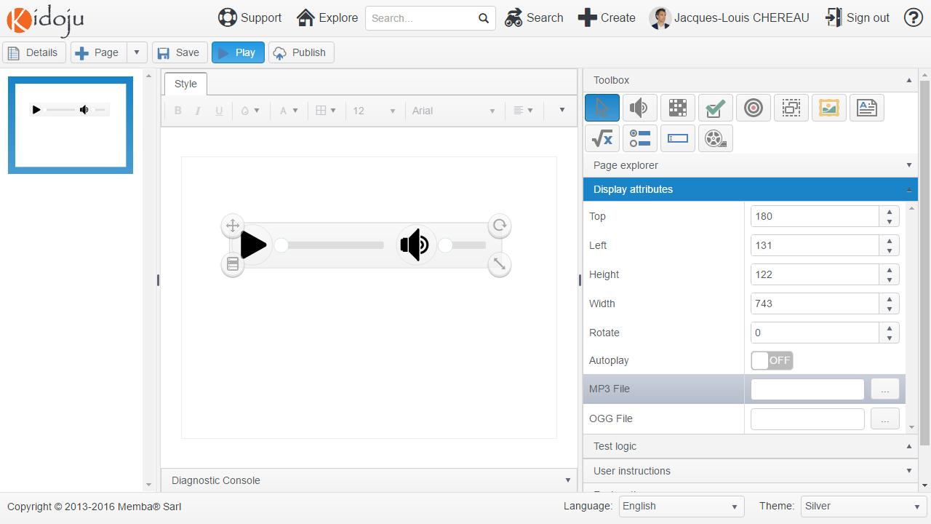

Prepare audio files of your choice. We suggest <http://www.moviesoundclips.net/sound.php?id=151> which you can download before uploading both the mp3 and ogg formats to Kidoju.

Select respectively the **MP3 File** and **OGG File** properties in the **Display attributes** collapsible panel of the tools pane and click the […] button. Click the **Upload** button, select your file on your hard drive and click the **Open** button.

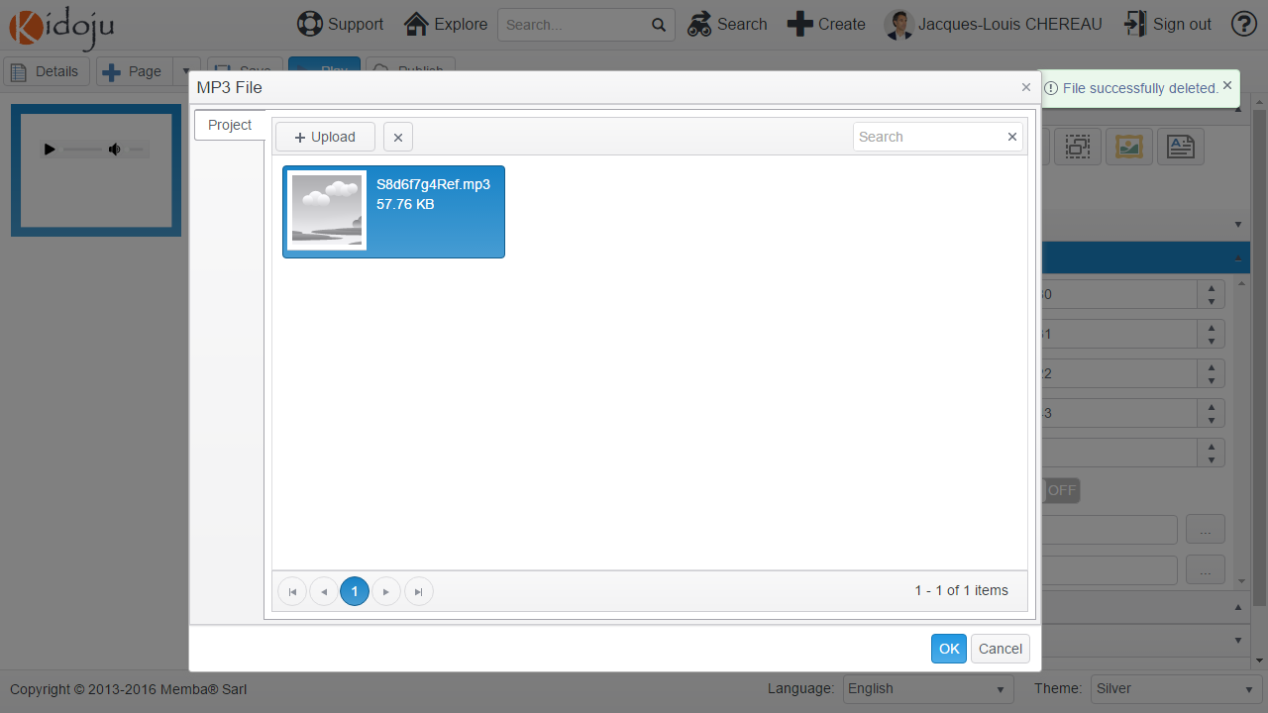

When your audio file is displayed in the **MP3 File** dialog as above, it has been uploaded onto our servers. Click **OK** to assign this file to the audio player.

Note: while uploading your file, you might get the following error: “There was an error obtaining a secure upload url. Make sure your file size is reasonable and your file name has a well-known extension”.

In this case, most probably your file is too big. Considering mobile devices on 3G/4G plans, we limit the size of files you can upload. These limits are currently 400 Kb for images and audio files and 4 Mb for video files.

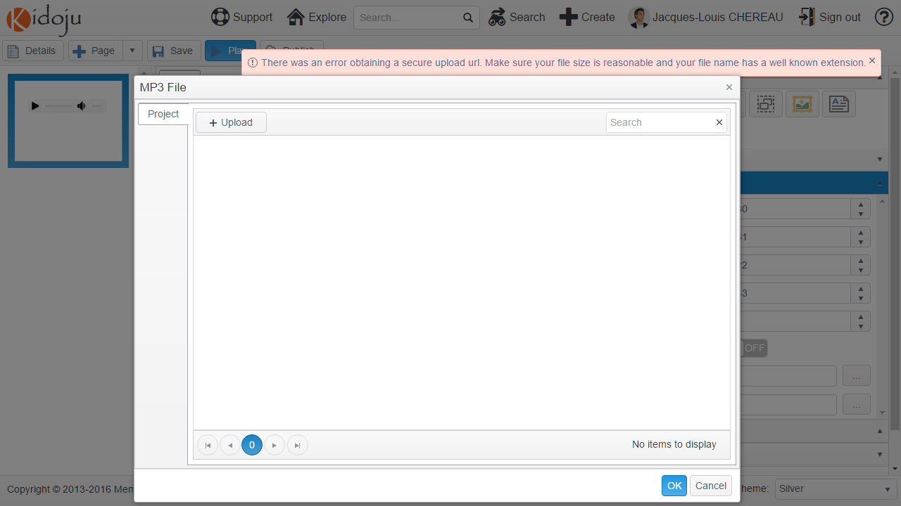

After assigning an MP3 File and an OGG File, your audio player is now ready to be played. After clicking the **Save** button, **Play** your Kidoju and your audio files.

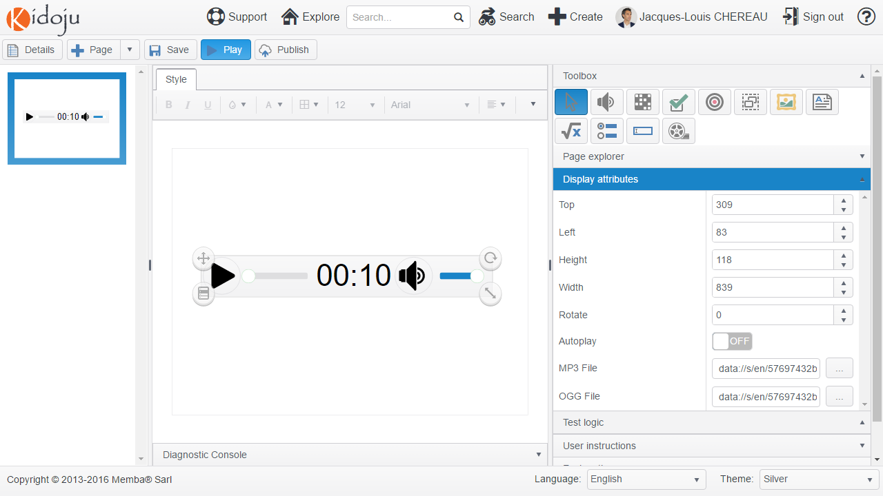

## Mathematic expressions

Mathematic expressions are similar to labels, expect they have the capability to interpret a textual expression into a better graphic representation of a formula.

To add a mathematic expression to the stage, select (click) the **Mathematic Expression** tool in the toolbox and click the stage. A new mathematic expression is added to the page.

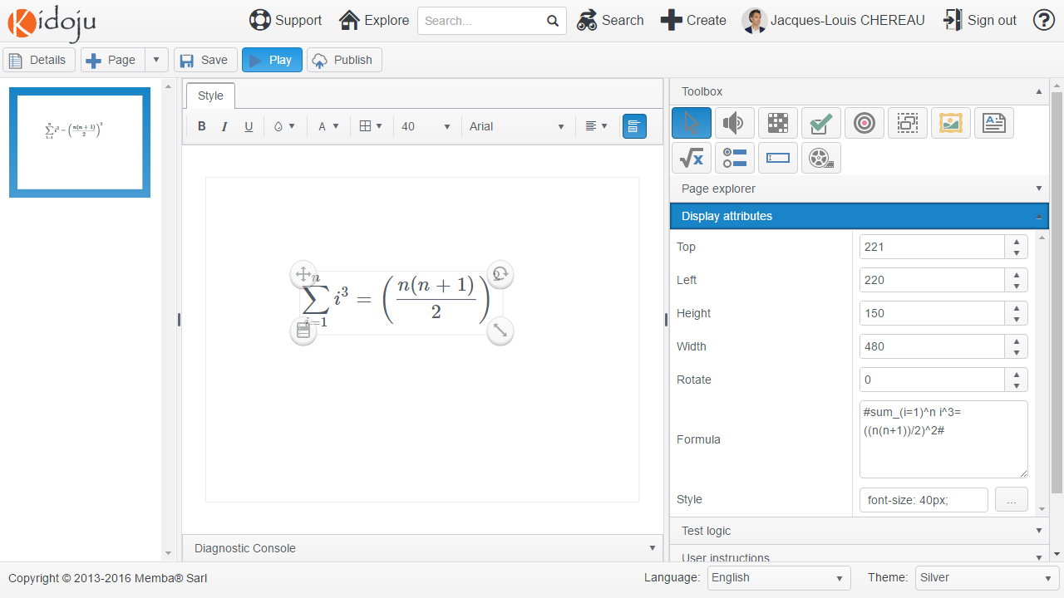

Position and resize the label as explained in the *Moving, rotating, resizing and aligning components* chapter.

To change the formula displayed, expand the **Display attributes** collapsible panel and change the value of the **Formula** property for #int_0^1 f(x)dx#.

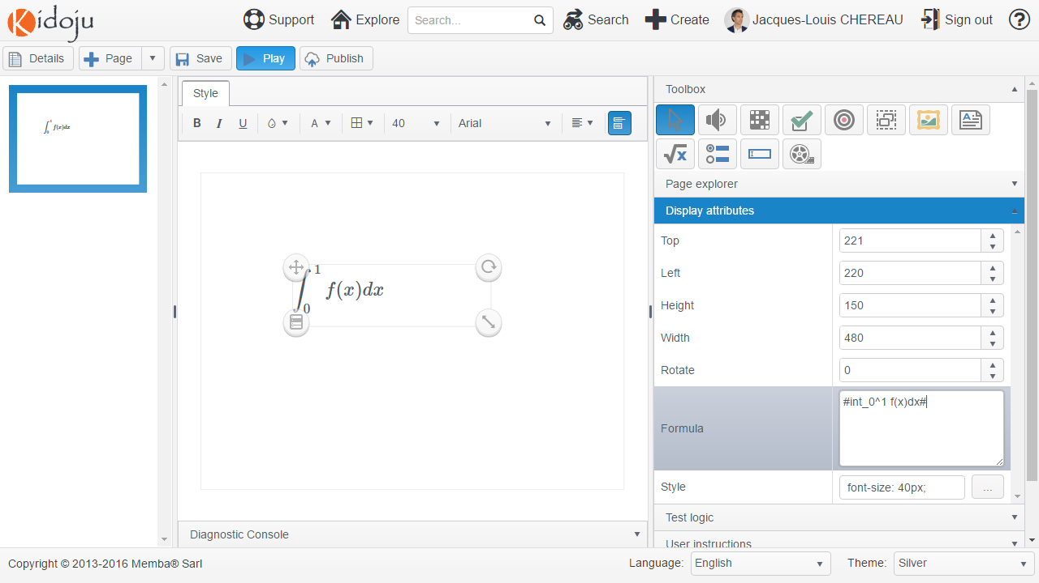

To learn more about formulas please refer to the LaTeX and AsciiMath section of the Advanced Guide.

## What other tools are coming next?

Although we do not commit to any deadline, we are working hard to expand this toolset with:

* A vector drawing tool,
* A code editor targeted at software programming quizzes,
* Spreadsheets and tables,
* Charts and plots,
* Interactive maps,
* A chemical formula editor;
* A math geometry editor.

Please make suggestions or vote for existing suggestions at <https://kidoju.uservoice.com/forums/152569-general>.

## SEO indexing and social sharing

It is important you understand the value of properly describing your Kidoju quiz on the *Details page*. For this purpose, we show you here after the **Title** (surrounded in red) and the **Description** (surrounded in green) in various environments.

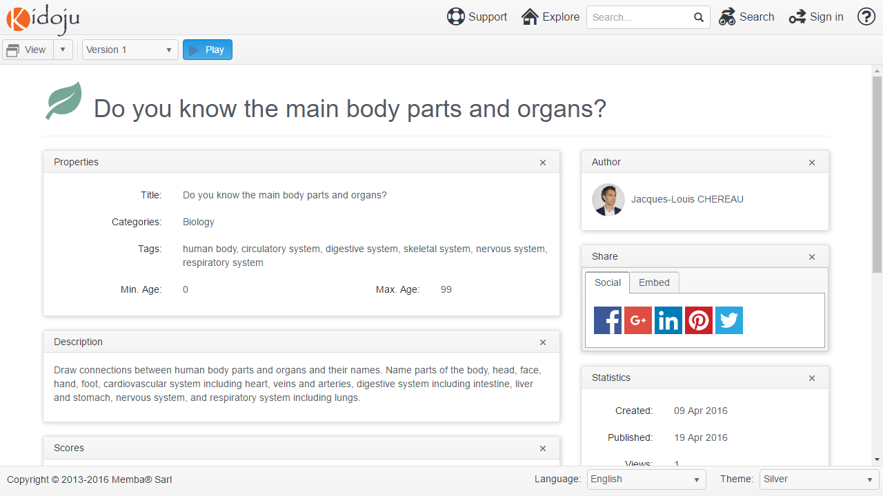

For improved performances, only the title is displayed in the *Explorer*.

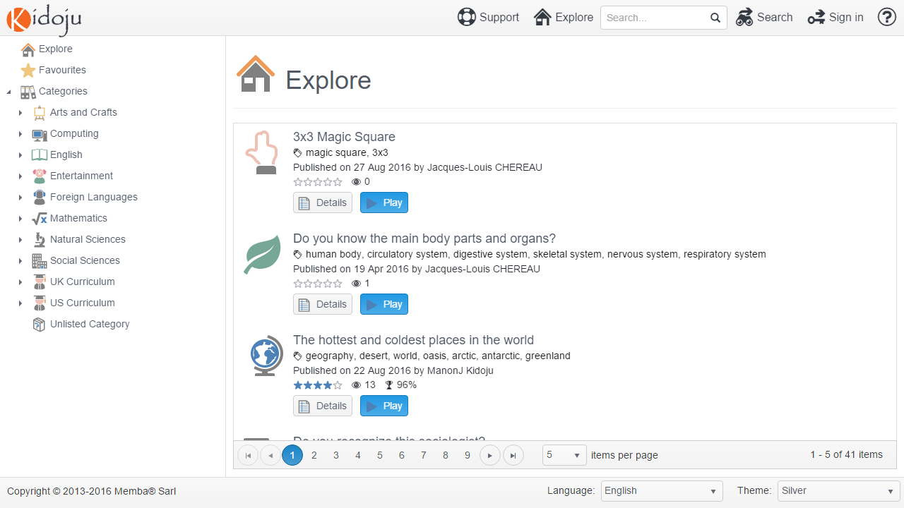

Google search displays the title and description as shown below:

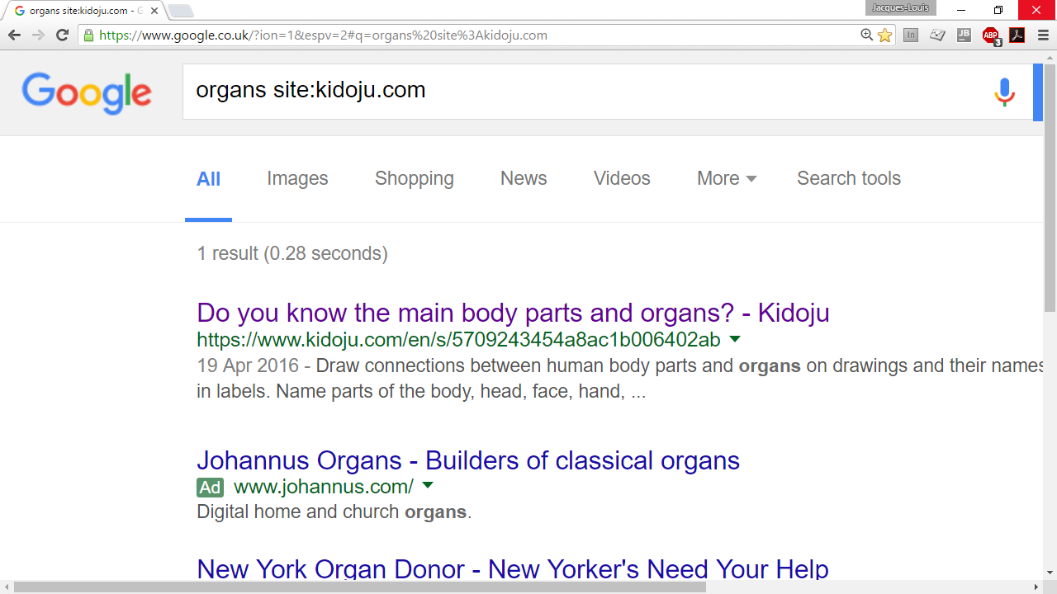

The Facebook share dialog displays the title and description as shown below:

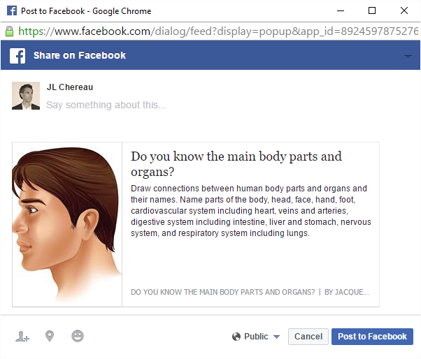

Note: The image used in social network share dialogs is the largest image uploaded for the related Kidoju quiz.

# Advanced Guide

## Position of correction ticks and crosses

In the *Student* Guide, you have discovered the *Player* in play mode and review (correction) mode. Review mode shows ticks and crosses as in the following example:

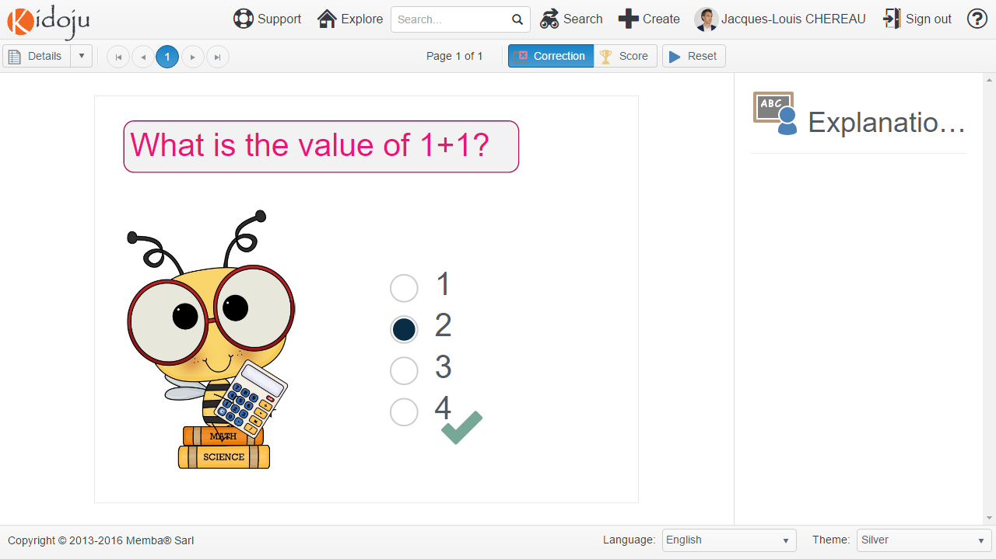

The position of the correction tick or cross is actually determined by the position of the resize handle as represented here below.



In the following screenshot, we have moved the resize handle away from the content of the quiz component (1, 2, 3, 4) to the bottom right corner of the stage.

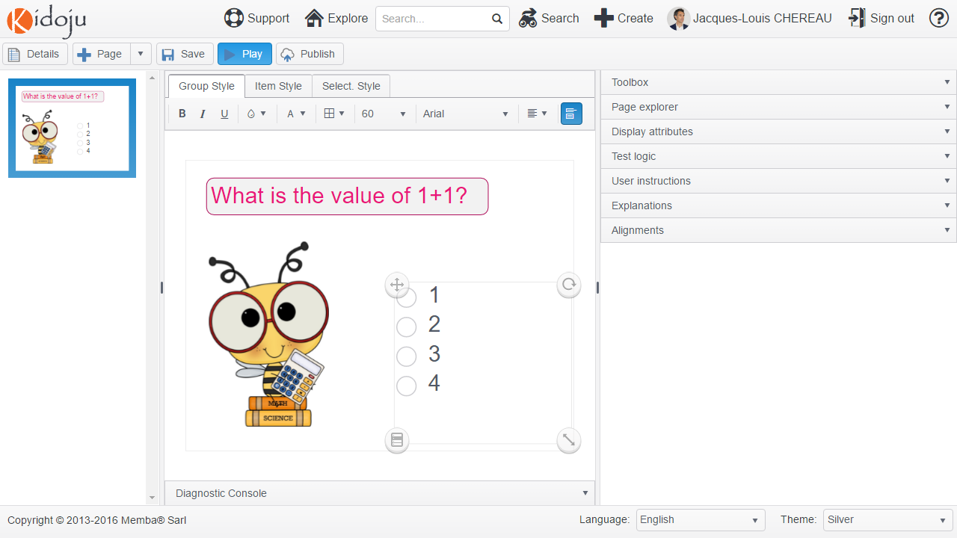

The correction tick or cross follows the position of the resize handle as shown on the following screenshot.

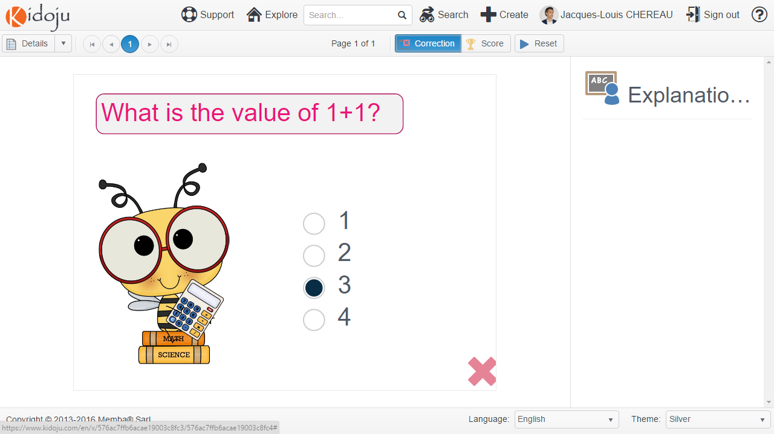

Therefore, consider carefully where you position the resize handle of the components which participate in the test logic:

* You do not want a resize handle too close to the content because font sizes are not consistent across devices and you need to allow some space;
* You do not want a resize handle too far away from the content because the tick or cross might interfere with other components and become ambiguous.

## Audio and video file formats

Audio and video file formats (and codecs) are a complex issue to run across all types of devices and browsers.

### Audio

There are two main audio file formats required to run audio across devices and browsers: MP3 and OGG.

|  |  |  |  |  |  |
| --- | --- | --- | --- | --- | --- |
| Extension | Chrome | Edge/IE | Firefox | Opera | Safari |
| MP3 | ✓ | ✓ | ✓ |  | ✓ |
| OGG | ✓ |  | ✓ | ✓ |  |

Currently:

1. If you only upload one format, use MP3 which has the largest support.
2. For even better support, you need to also upload the OGG format to our servers (we plan to convert files automatically in the future but in the meantime please consider using cloudconvert.com, zamzar.com or any other file conversion services);
3. Some browsers may restrict the upload of file formats they cannot identify, which is the reason why we recommend using Chrome.

Note: we might replace MP3 with M4A (AAC) in the near future.

### Video

There are three main video file formats required to run video across devices and browsers: MP4 and either OGV or WEBM.

|  |  |  |  |  |  |
| --- | --- | --- | --- | --- | --- |
| Extension | Chrome | Edge/IE | Firefox | Opera | Safari |
| MP4 | ✓ | ✓ | ✓ | ✓ | ✓ |
| OGV | ✓ |  | ✓ | ✓ |  |
| WEBM | ✓ |  | ✓ | ✓ |  |

Currently:

1. If you only upload one format, use MP4 which has the largest support.
2. For even better support, you need to also upload the OGV or WEBM format to our servers (we plan to convert files automatically in the future but in the meantime please consider using cloudconvert.com, zamzar.com or any other file conversion services);
3. Some browsers may restrict the upload of file formats they cannot identify, which is the reason why we recommend using Chrome.

## Markdown

Markdown is a simple and ­secure way to add formatting to text in web applications. Kidoju uses markdown syntax for descriptions including *User instructions and explanations*.

| Formatted text | Markdown |
| --- | --- |
| *Italic* | Text surrounded by * or _:  *Italic* |
| **Bold** | Text surrounded by ** or __:  **Bold** |
| **Heading** | Line starting with hashtags (#) where the number of # defines the heading level:  ##Heading |
| 1. Numbered 2. List | Set of successive lines preceded by any number and a period:   1. Numbered 2. List |
| * Bulleted * List | Set of successive lines preceded by *, + or –:  - Bulleted  - List |
| Hyperlink | Text between square brackets followed by url between parentheses:  [Hyperlink](http://www.kidoju.com) |
| https://www.iconexperience.com/_img/g/style128.png | Exclamation mark followed by alternate text between square brackets followed by source url between parentheses:  ![Alt. Text](http://www.kidoju.com/image.jpg) |

A character can always be enforced by preceding it with a backslash. For example, \*Italic\* will actually display the word Italic between two stars in regular style (without emphasis).

## LaTeX and AsciiMath

*Mathematic expressions* are displayed using MathJax. MathJax converts a LaTeX or AsciiMath representation of a mathematic expression into complex HTML or an image.

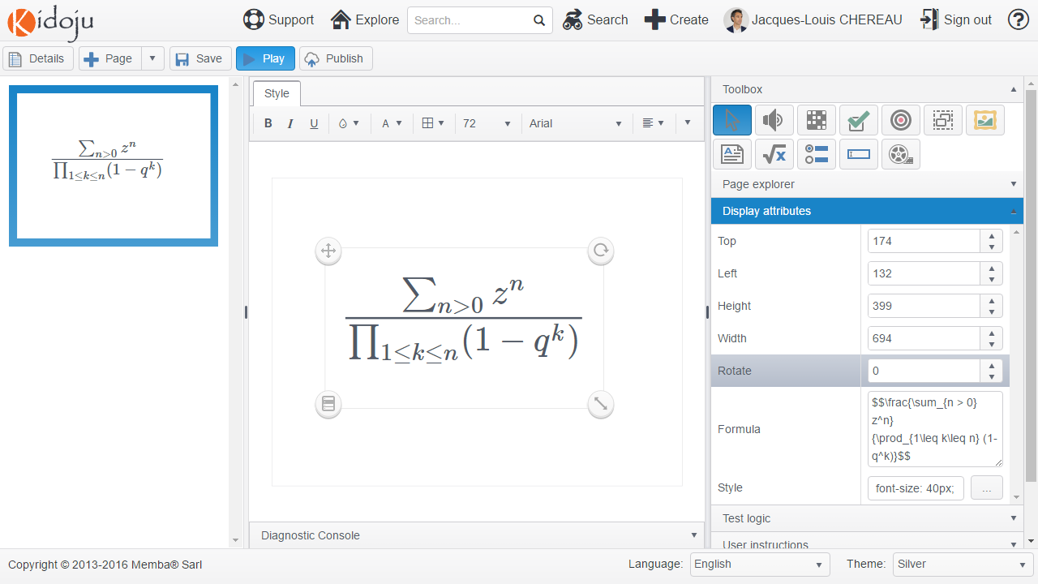

AsciiMath expressions need to be surrounded by hashtags (#) to be parsed properly like in:

#sum_(i=1)^n i^3=((n(n+1))/2)^2#

LaTeX expressions need to be surrounded by double dollar signs ($$) to be parsed properly like in:

$$\frac{\sum_{n > 0} z^n}{\prod_{1\leq k\leq n} (1-q^k)}$$

A LaTeX or AsciiMath tutorial goes beyond the scope of this user guide. AsciiMath is simpler. LaTeX is more powerful. We recommend the following resources among other resources you can find on the web:

1. <https://www.mathjax.org/>
2. <http://asciimath.org/>
3. <ftp://ftp.ams.org/pub/tex/doc/amsmath/short-math-guide.pdf>
4. <http://www.math.harvard.edu/texman/>

## CSS styles

We cannot cover the diversity of Cascading Style Sheets (CSS) attributes to define styles. A CSS style is a collection of attributes and values where each attribute is separated from its value by a colon (:) and pairs of “attribute:value” are separated from each other by semi-colons (;), like in background-color:#ffffff; color:#000000.

Note: colors are only used to help you distinguish attributes in green from values in blue from separators in red.

TEXT

margin

padding

A label similar to the above can be achieved with the following style attributes which are self-explicit:

|  |  |
| --- | --- |
| Attribute | Value |
| background-color | #bdd7ee |
| border-color | #2e75b6 |
| border-radius | 25px |
| border-style | Solid |
| border-width | 4px |
| Color | #ffffff |
| font-family | Times New Roman |
| font-size | 60px |
| Padding | 30px |

Note: colors are expressed as hexadecimal values where each couple of digits represents respectively the amount of red, green and blue (RGB).

Note: sizes are expressed in pixels where a pixel is a dot on the screen. A typical monitor resolution is either 72 ppi or 96 ppi (pixels per inch). Retina monitors have higher ppi. A typical printer prints at 300 dpi (dots per inch).

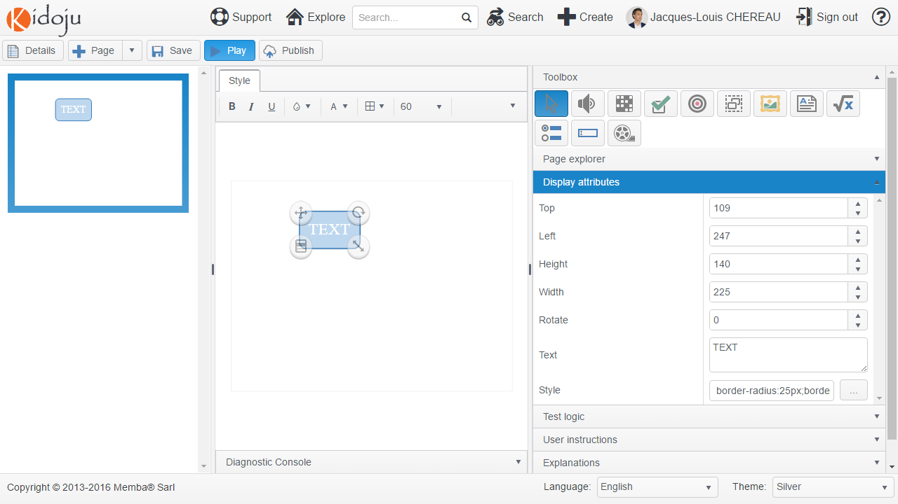

If you want to know more about CSS, please consider visiting <http://www.w3schools.com/css/>.

## Regular Expressions

The “match” and “ignoreCaseMatch” validation algorithms of *Textboxes* use regular expressions to validate a user answer typed in a textbox.

Regular expressions are extensively documented at <http://www.regular-expressions.info/> and this chapter can only be considered an introduction. We recommend that you test your regular expressions at <http://www.regexr.com/>.

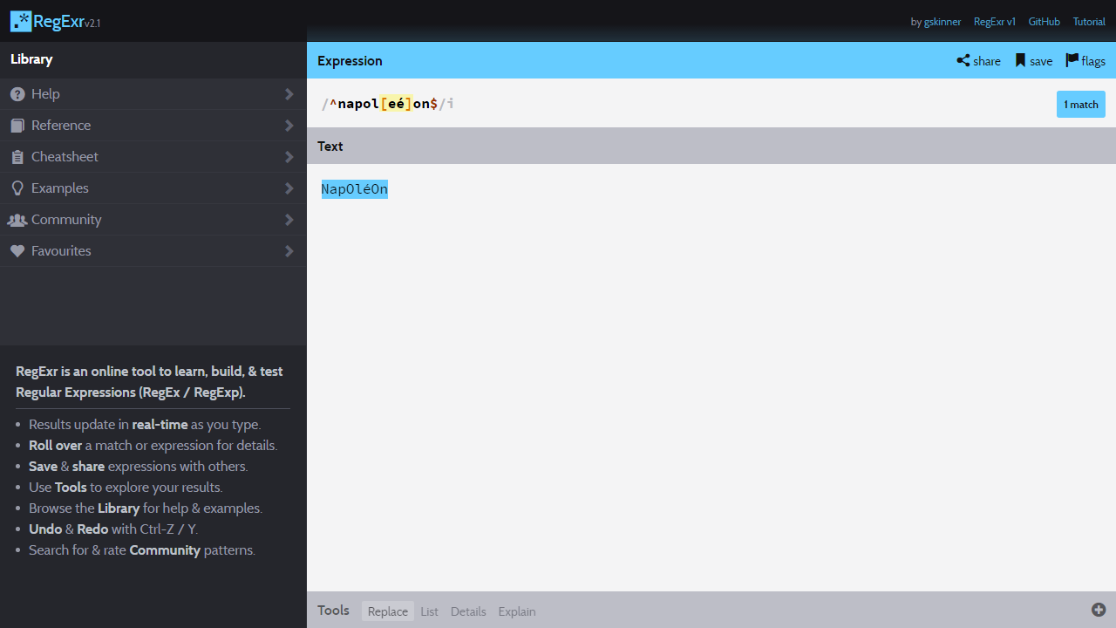

The /i option at the end of the regular expression “^napol[eé]on$” corresponds to “ignoreCaseMatch”. It matches both “napoleon” and “NAPOLEON”.

^ and $ are anchors which work has follows:

* The regular expression “napoleon” matches any value that contains the word “napoleon”.
* The regular expression “^napoleon” matches any value that starts with the word “napoleon”.
* The regular expression “napoleon$” matches any value that ends with the word “napoleon”.
* The regular expression “^napoleon$” only matches the exact word “napoleon”.

[eé] matches any character in the set delimited by square brackets. In this case, [eé] matches both “e” and “é”. Accordingly, “^napol[eé]on$” matches both “napoleon” and “napoléon”.

[a-z] matches any alphabetical character from a to z.

[0-9] matches any digit from 0 to 9.

[a-z]{2} matches any combination of exactly 2 alphabetical character from a to z. Therefore [a-z]{1} is equivalent to [a-z].

[0-9]{2,4} matches any combination of 2 to 4 digits.

[a-z]* matches 0 or more alphabetical characters.

[a-z]+ matches 1 or more alphabetical characters.

[a-z0-9A-Z_], that is any alphabetical character (lower case or upper case) or any digit or underscore can be shortened as \w.

^(napol[eé]on|bonaparte)$ matches both NapOléOn and BOnApArte.

Because a dash (-) designates a range, dashes need to be escaped as \- in regular expressions. The same applies to square brackets and dollar signs which need to be escaped respectively as \[, \] and \$ if used literally in regular expressions.

\s is used to match a space, a tab (\t) or a line feed (\n).

We are only scratching the surface to get you started. Regular expressions are extremely powerful and allow complex validations without writing any programming code.

## JavaScript custom validations

For even more complex custom validation rules, Kidoju offers the possibility to write your own code. For the security of our users:

* Your code is sandboxed in a web worker which does not have access to the document object model and unsafe objects including xmlHttpRequest and localStorage are disabled;
* Your code is limited to 1000 characters;
* The execution of your code is limited to 100ms after which the web worker that runs your custom validation code is killed.

In the first example, you will validate that the value entered in a Textbox is between 100 and 110 inclusive.

Design your page as represented here below. After selecting the Textbox on the page, expand the **Display attribute** collapsible panel of the tools pane and add a **Mask** of 000 to constrain any user entry to 3 digits as explained in the *Textboxes* chapter.

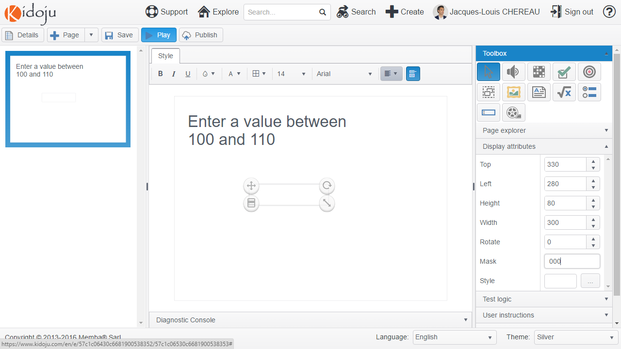

Then expand the **Test logic** collapsible panel of the tools pane and enter a **Question** and a **Solution** to be displayed in the score report. The solution will only be used as an example of correct value and will not be part of the validation algorithm.

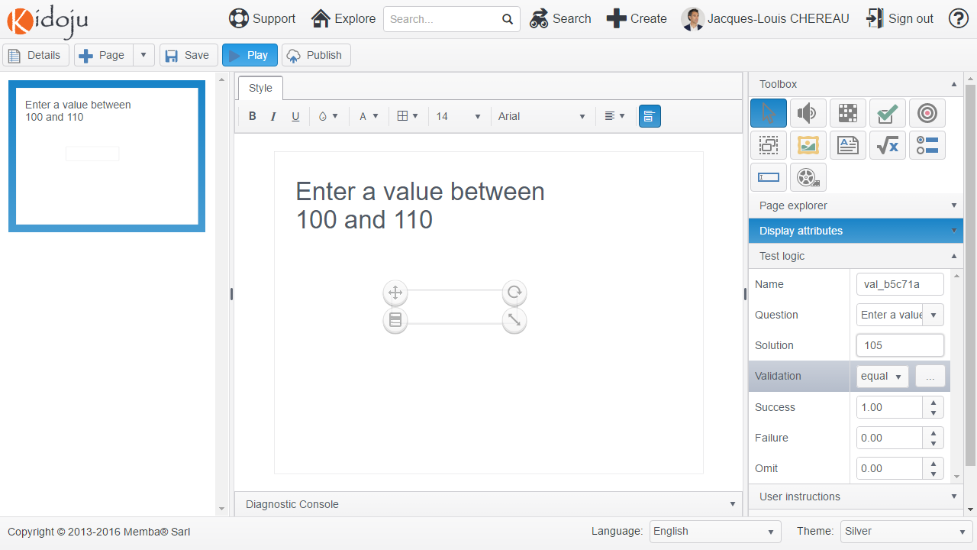

Then click the **[…]** button corresponding to the **Validation** property to open the script editor. Teaching JavaScript is beyond the scope of this User Guise and we assume you have a basic knowledge of JavaScript programming.

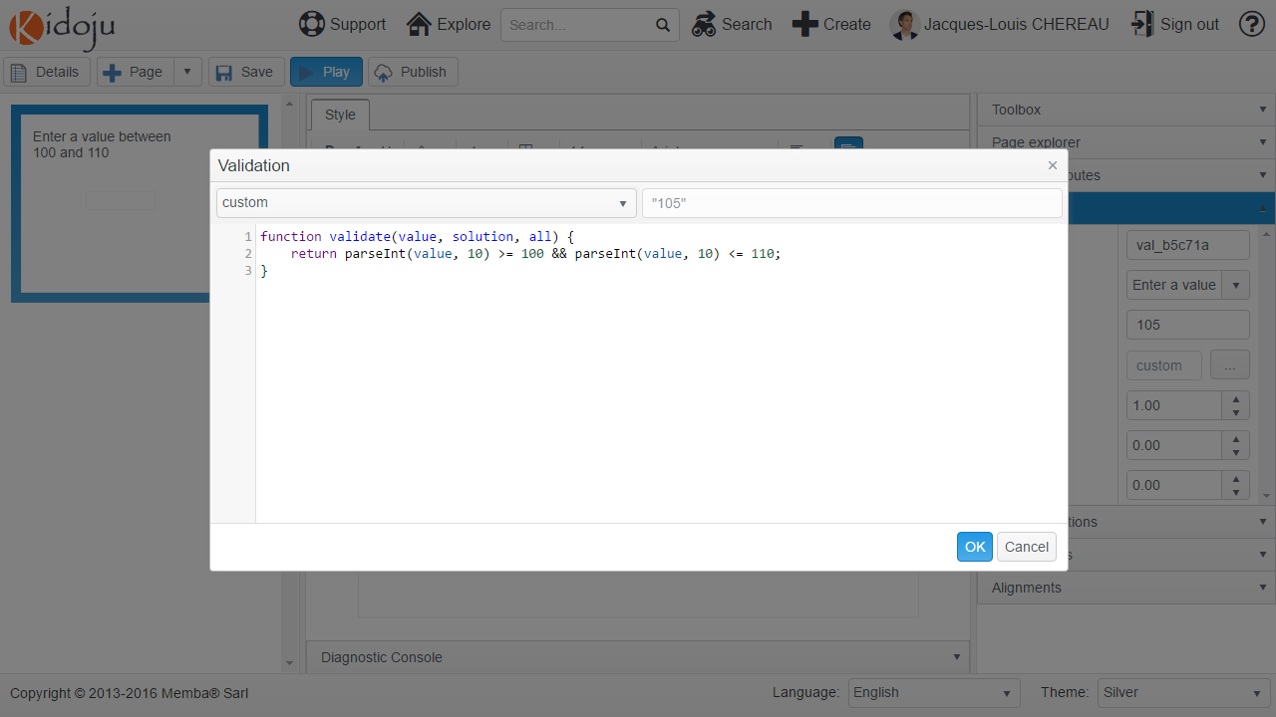

Enter the following function:

function validate(value, solution, all) {  
 return parseInt(value, 10) >= 100 && parseInt(value, 10) <= 110;  
}

This function validates that the value entered parses as an Integer comprised between 100 and 110 included.

Click **OK**, then click **Save** and **Play** your Kidoju.

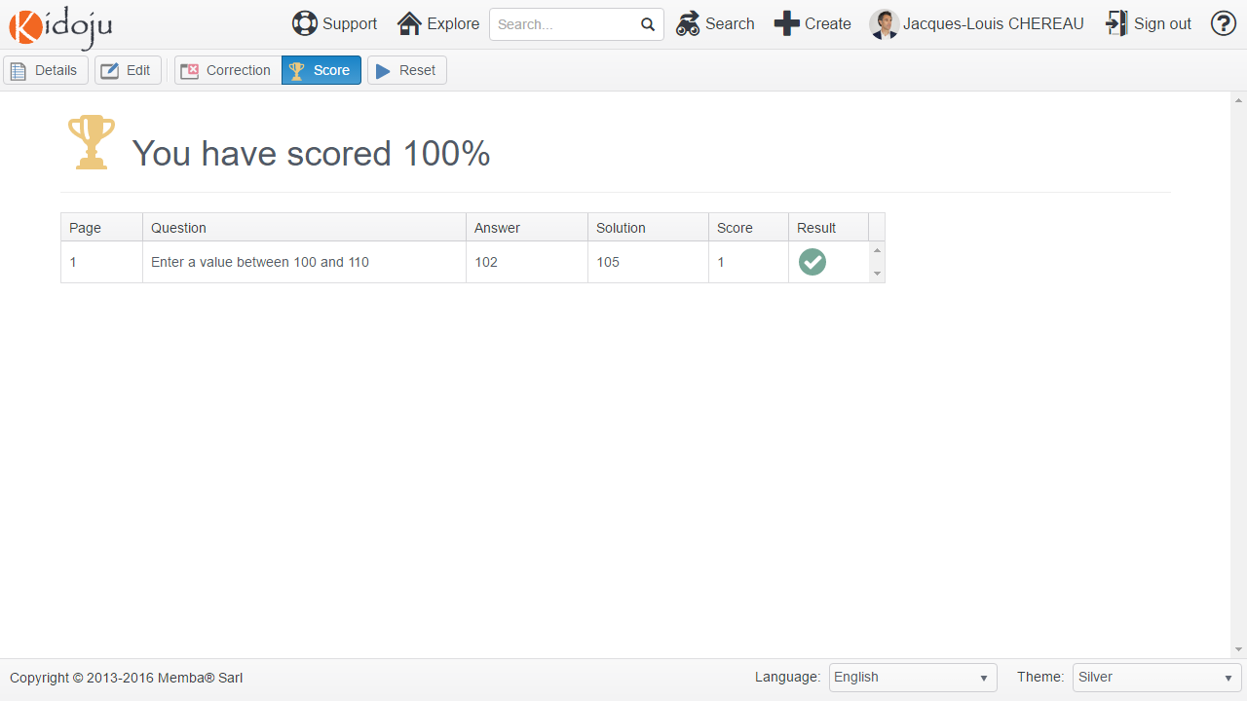

Note: Note that the solution is only given as an example and Kidoju validates a different value as a correct answer.